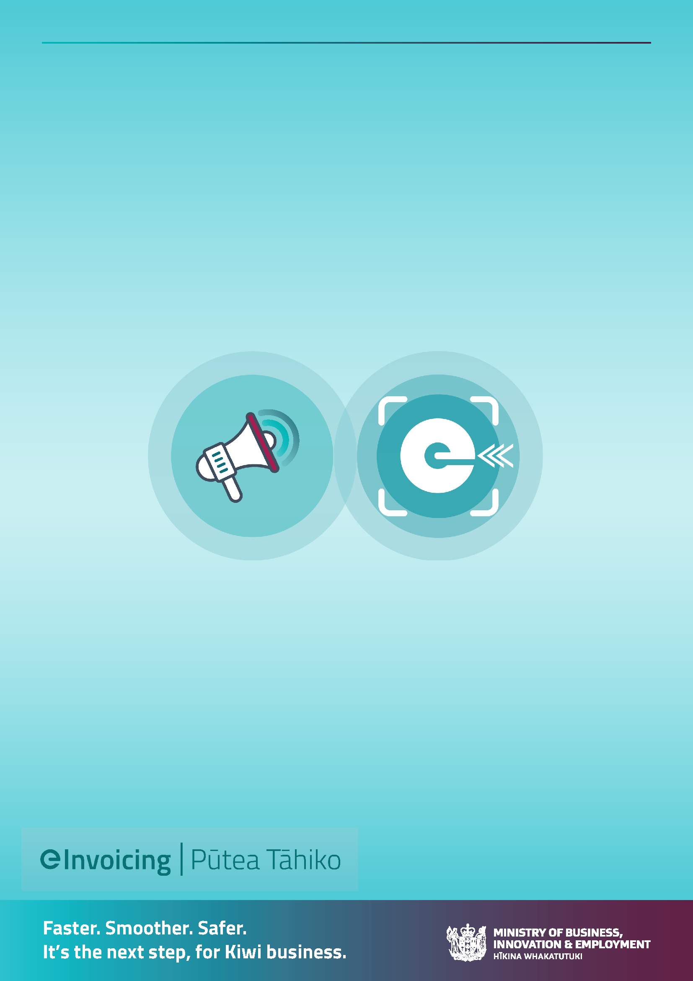
eInvoicing Communications Toolkit for accountants, bookkeepers and advisors
Getting your clients ready for eInvoicing.

Table of Contents
How to use this toolkit 3
Communications resources 4
Email templates – summary …………………………………………………………………………………………………5
Segmentation of your clients’ suppliers ……………………………………………………………………………….6
Email 1 7
Email 2 ……………………………………………………………………………………………………………………..11
Email 3 13
Email 4……………………………………………………………………………………………………………..………..18
Email 5…………………………………………………………………………………………………………………… …20
Helpful links and additional resources………………………………………………………………………………………………………………………………..21

How to use this toolkit
This communication toolkit aims to support accountants, bookkeepers and other advisors to help their small-business clients:
- understand eInvoicing,
- get set up to send and receive eInvoices,
- let their trading partners know they’d like to send and/or receive eInvoices.
The toolkit includes sample emails to send to your clients, sample emails for your clients to send to their trading partners and recommended ongoing communications from your clients to their trading partners yet to transition from PDFs to eInvoices.
Also, feel free to adapt these for your own business use, to get your own trading partners to send or receive eInvoices once you have eInvoicing capability.

Pro tip:
If your organisation has specialist communications or data analysis people, engage them early to help with getting you and your clients’ trading partners on board with eInvoicing.
Communication resources
Here you will find:
- A summary of the various email options to let your clients know about eInvoicing
- How to identify which clients’ suppliers can easily send and receive eInvoices
- Email templates to adapt and use to communicate and engage with your clients
- Email templates for your clients to adapt and use to communicate with their trading partners (utilising the supplier segmentation and analysis)
- Helpful links and additional resources.

Email templates
The email templates provided here are based on most small businesses using Xero or MYOB.
It is expected that you’ll know what software your clients use for generating or receiving invoices.
Tailored messages are signposted in each of the email templates, and you can choose to use or adapt them as you see fit.

Email version | Short description
1 | Email to your clients telling them about eInvoicing and how they can get started to send and receive eInvoices.
2 | Or, an email to your clients letting them know about eInvoicing and that you’ve set it up for them.
3 | Email your clients can send to their suppliers, encouraging them to send them eInvoices instead of PDFs. This email is for clients that you know are registered to receive eInvoices.
4 | An annual (or every 6 months) email your clients can send to their suppliers who are still sending PDF invoices and haven’t yet transitioned to eInvoices.
5 | Email clients can send to their buyers, encouraging them to receive their invoices as eInvoices instead of PDFs. If your client doesn’t know if their buyers can accept eInvoices from your client, ask them.

Identifying which clients’ suppliers can easily send and receive eInvoices
You or your clients should identify and group your clients’ suppliers to prioritise those that should be approached first to be encouraged to send eInvoices.
Grouping suppliers also allows you or your client to tailor the messages so they are relevant to that supplier group’s situation.
There are many ways you could group or prioritise customers. The easiest suppliers to bring on board to send and/or receive eInvoices are those that:
- Use eInvoicing-enabled software. Most small businesses already have easy, affordable access to eInvoicing capability (e.g. Xero, MYOB, WorkflowMax), with many business and accounting software products progressively adding the functionality throughout 2023 (e.g. Reckon). See the ‘How to guide – Identifying Xero and MYOB suppliers on Outlook’. It’s easy and quick for these suppliers to start eInvoicing. Even though these suppliers may send a low volume of invoices, there may be many suppliers so the volume of eInvoices can add up.
- Are already eInvoicing (because they’ve advised you they can send eInvoices or you know that they send eInvoices to other customers) – let them know you can receive eInvoices now.
- Are already registered to receive eInvoices – this indicates they may be using software that can easily send eInvoices, too.
- Do business with central government agencies. These agencies are required to be able to receive eInvoices and will be asking their suppliers to send eInvoices.

Email 1: Encouraging your clients to get set up to send and receive eInvoices
Dear [name]
It’s time to move to eInvoicing
Have you heard of eInvoicing? It’s rolling out across New Zealand with many businesses and the wider government sector progressively becoming enabled to send and receive eInvoices.
There are already thousands of businesses registered to receive eInvoices and hundreds registering every month.
We recommend you get set up to send eInvoices (instead of PDFs) to your buyers (businesses only) and register to receive eInvoices from your suppliers.
What is eInvoicing
eInvoicing is the digital exchange of invoice information directly between buyers’ and suppliers’ financial systems, even if these systems are different.
With eInvoicing, you no longer need to generate paper-based or PDF invoices that have to be printed, posted or emailed to your buyers, and you no longer need to enter these manually into your <Xero/name of accounting system> system.
Removing manual handling of invoices means your sent eInvoices get to the right place (and don’t get lost) and prevents errors from happening – all helping to reduce delays in processing and payment of your invoices. And for eInvoices you receive directly into your accounting system – for example your ACC, phone, power or other bills - it’ll reduce admin coding time and improve accuracy. It also:
- improves security,
- speeds up payments and
- makes it much easier at end-of-year time.
Because eInvoicing allows you to connect to any financial system, you can connect to all buyers from your invoicing system through the open network.
Getting started
Now’s the time to get started with eInvoicing so you can send eInvoices instead of PDFs to your buyers. Here’s how:
Choose the following content depending on what accounting or invoicing system your client uses

It’s easy to get started with Xero
Xero can send and receive eInvoices, so it’s really easy to get set up to send eInvoices if you’re on a Xero Starter, Standard or Premium plan. And if you use Xero Practice Manager or Workflow Max you can send your draft invoices to Xero and send your eInvoices from there.
Simply follow their quick and easy instructions and you’re good to go. Watch their video or check out their website for instructions.
Register to receive eInvoices- Xero
Receiving eInvoices- Xero
Sending eInvoices- Xero

Then:
- Find and load up your buyers’ New Zealand Business Numbers (NZBNs).
- Ask your buyers if they can receive eInvoices.
- Send eInvoices to buyers who can receive them.
- Let your suppliers know you can receive eInvoices (instead of PDFs) and provide them with your NZBN.
--------------------------------------
It’s easy to get started to send eInvoices with MYOB
MYOB can send and receive eInvoices, so it’s really easy to get set if you use MYOB Essentials (also called MYOB Business) or you access your AccountRight company file in a web browser.
Simply follow their quick and easy instructions and you’re good to go. Check out their website for instructions.
eInvoicing - MYOB Business - MYOB Help Centre
Then:
- Find and load up your buyers’ New Zealand Business Numbers (NZBNs).
- Ask your buyers if they can receive eInvoices.
- Send eInvoices to buyers who can receive them.
- Let your suppliers know you can receive eInvoices (instead of PDFs) and provide them with your NZBN.

------------------------------

For clients using other software – check the eInvoicing website for software that can send and receive eInvoices and links to their websites. Use the suggested email text below

<name of software> software can send eInvoices so it’s really easy to get set up to send eInvoices from your <name of software> accounting package. Simply follow their instructions and you’re good to go. <link to software provider’s website instructions>
- Find and load up your buyers’ New Zealand Business Numbers (NZBNs).
- Ask your buyers if they can receive eInvoices.
- Send eInvoices to buyers who can receive them.
- Let your suppliers know you can receive eInvoices (instead of PDFs) and provide them with your NZBN. (We’ve attached an email template you can use to send to your suppliers).
---------------------------------------
To send your buyers an eInvoice, you need to know their New Zealand Business Number (NZBN). You can search for their NZBN at Home | New Zealand Business Number (nzbn.govt.nz) Or match your buyers and suppliers to their NZBNs with the free and secure NZBN Business Match service.
Add eInvoicing to your email signature
Once you’re set up to send and receive eInvoices we recommend you add eInvoicing to your email signature. The more businesses that send and receive eInvoices, the more you’ll get the benefits such as admin time-savings and faster payments.
Let your trading partners know that your business can send or receive eInvoices – in your business conversations, in your contracts or within your email signature.
Download the ‘eInvoicing capable’ badge.
Download eInvoicing capable badge for email signature
Guide for using eInvoicing capable badge
If you can receive eInvoices add the following to your business’s email signature for relevant roles (such as accounts payable team members or auto responses for AP enquiries):
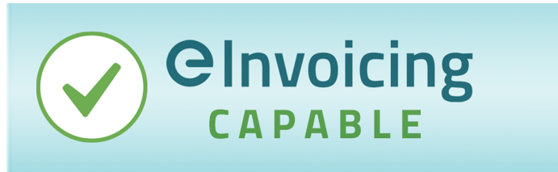
‘We prefer to receive eInvoices instead of PDFs. Our NZBN is xxxxxxxxx’
If you can send eInvoices, add the following to your business’s email signature for relevant roles (such as accounts receivable and procurement team members) and PDF invoices:
‘We prefer to send eInvoices instead of PDFs. It’ll make it faster and easier for you to process our invoices. Let us know your NZBN and if your business can receive eInvoices’

A combined email signature message:
We prefer to send and receive eInvoices instead of PDFs. It’ll make it faster and easier for you to process our invoices. Let us know your NZBN and if your business can receive eInvoices.
Our NZBN is xxxxxxxxxxxxxxxxx

eInvoicing is a no-brainer – it’ll be THE way to do invoicing, so we recommend you get started now.
[Your name and Position]

Email 2: to let your clients know about eInvoicing and that you’ve set it up for them
Dear [name]
It’s time to move to eInvoicing
Have you heard of eInvoicing? It’s rolling out across New Zealand with many businesses and the wider government sector progressively becoming enabled to send and receive eInvoices.
There are already thousands of businesses registered to receive eInvoices and hundreds registering every month.
We recommend you get set up to send eInvoices (instead of PDFs) to your buyers (businesses only) and register to receive eInvoices from your suppliers. But don’t worry we’ve done it all for you.
What is eInvoicing
eInvoicing is the digital exchange of invoice information directly between buyers’ and suppliers’ financial systems, even if these systems are different.
With eInvoicing, you no longer need to generate paper-based or PDF invoices that have to be printed, posted or emailed to your buyers, and you no longer need to enter eInvoices you receive manually into your <Xero/name of accounting system> system.
Removing manual handling of invoices means your sent eInvoices get to the right place (and don’t get lost) and prevents errors from happening – all helping to reduce delays in processing and payment of your invoices. And for eInvoices you receive directly into your accounting system – for example your ACC, phone, power or other bills - it’ll reduce admin coding time and improve accuracy. It also:
- improves security,
- speeds up payments and
- makes it much easier at end-of-year time
Because eInvoicing allows you to connect to any financial system you can connect to all buyers from your invoicing system through the open network.

Choose the following content depending on what accounting or invoicing system your client uses

We’ve set you up to send and receive eInvoices
You can send and receive eInvoices from Xero, so we’ve set you up and registered you to be able to receive eInvoices. And if you use Xero Practice Manager or Workflow Max you can send your draft invoices to Xero and send your eInvoices from there.
We’ve also updated your customers’ records to include the NZBNs of all your buyers. The New Zealand Business Number (NZBN) is the unique identifier that ensures your invoices reach your buyer’s accounting or invoicing system.
Sending eInvoices- Xero Central
Send eInvoices instead of PDFs where you can
Ask your buyers if they can receive eInvoices instead of PDFs. Send eInvoices to buyers who can receive them.
Encourage your suppliers to send you eInvoices instead of PDFs
Let your suppliers know you can receive eInvoices (instead of PDFs) and provide them with your NZBN.
--------------------------------------
We’ve set you up to send eInvoices
MYOB can send and receive eInvoices, so we’ve set you up.
We’ve also updated your customers’ records to include the NZBNs of all your buyers. The New Zealand Business Number (NZBN) is the unique identifier that ensures your invoices reach your buyer’s accounting or invoicing system.
Send eInvoices instead of PDFs where you can
Ask your buyers if they can receive eInvoices instead of PDFs. Where you can, send eInvoices to buyers who can receive them.

------------------------------

For clients using other software – check the eInvoicing website for software that can send and receive eInvoices and links to their websites

We’ve set you up to send eInvoices
<name of software> software can send eInvoices so it’s really easy to get set up to send eInvoices from your <name of software> accounting package.
We’ve also updated your customers’ records to include the NZBNs of all your buyers. The New Zealand Business Number (NZBN) is the unique identifier that ensures your invoices reach your buyer’s accounting or invoicing system.
Send eInvoices instead of PDFs where you can
Ask your buyers if they can receive eInvoices instead of PDFs. Where you can, send eInvoices to buyers who can receive them.

---------------------------------------
Choose the content depending on whether the client can send, or can send and receive

Opt 1 – send eInvoices only:
Add eInvoicing to your email signature
Now that you’re set up to send eInvoices, we recommend you add eInvoicing to your email signature. The more businesses that send and receive eInvoices, the more you’ll get the benefits such as admin time-savings and faster payments.
Let your trading partners know that your business can send eInvoices – in your business conversations, in your contracts or within your email signature.
Download the ‘eInvoicing capable’ badge.
Download eInvoicing capable badge for email signature
Guide for using eInvoicing capable badge
Add the following to your business’s email signature for relevant roles (such as accounts receivable and procurement team members) and PDF invoices:
‘We prefer to send eInvoices instead of PDFs. It’ll make it faster and easier for you to process our invoices. Let us know your NZBN and if your business can receive eInvoices’
eInvoicing is a no-brainer – it’ll be THE way to do invoicing, so we recommend you get started now.
[Your name and Position]
PS: Rest assured you can still send and receive PDF invoices while businesses transition to eInvoicing.

Opt 2 - Send and receive eInvoices:
Add eInvoicing to your email signature
Now that you’re set up to send and receive eInvoices, we recommend you add eInvoicing to your email signature. The more businesses that send and receive eInvoices, the more you’ll get the benefits such as admin time-savings and faster payments.
Let your trading partners know that your business can send or receive eInvoices – in your business conversations, in your contracts or within your email signature.
Download the ‘eInvoicing capable’ badge.
Download eInvoicing capable badge for email signature
Guide for using eInvoicing capable badge
Receive: add the following to your business’s email signature for relevant roles (such as accounts payable team members or auto responses for AP enquiries):
‘We prefer to receive eInvoices instead of PDFs. Our NZBN is xxxxxxxxx’
Send: add the following to your business’s email signature for relevant roles (such as accounts receivable and procurement team members) and PDF invoices:
‘We prefer to send eInvoices instead of PDFs. It’ll make it faster and easier for you to process our invoices. Let us know your NZBN and if your business can receive eInvoices’
Or, a combined email signature message:
We prefer to send and receive eInvoices instead of PDFs. It’ll make it faster and easier for you to process our invoices. Let us know your NZBN and if your business can receive eInvoices.
Our NZBN is xxxxxxxxxxxxxxxxx

eInvoicing is a no-brainer – it’ll be THE way to do invoicing, so we recommend you get started now.

[Your name and Position]
PS: Rest assured you can still send and receive PDF invoices while businesses transition to eInvoicing.

Email 3 – From your client to their suppliers – tailoring based on supplier analysis.

We’ve moved to eInvoicing – you can too
eInvoicing is rolling out across New Zealand, with many businesses and the wider government sector progressively becoming enabled to send and receive eInvoices. There are already thousands of businesses registered to receive eInvoices and growing monthly.
We’re able to receive eInvoices and we’d like you to consider sending us eInvoices instead of PDF or paper invoices.
To ensure we can receive and process your eInvoices, you’ll need your finance or accounting system to be able to send eInvoices and include our New Zealand Business Number (NZBN) with the other invoice information you send us. The NZBN is the unique global identifier that ensures the eInvoices you send, reach us.
Our NZBN is <enter NZBN here>.
To help us ensure smooth processing and payment of your invoices, we’d like to remind you to make sure your eInvoices includes:
<a purchase order number>
<a cost centre and natural account number>
<a contract number>
So, check with your <name of organisation>’s contact person >
<Delete or add list of other requirements specific to your organisation.>

If you have specific requirements, e.g. information purchase order, cost centre, contract number or other reference number.

What is eInvoicing and how does it benefit you?
eInvoicing is the digital exchange of invoice information directly between buyers’ and suppliers’ financial systems, even if these systems are different.
With eInvoicing, businesses no longer need to generate paper-based or PDF invoices that have to be printed, posted or emailed, and buyers no longer need to enter these manually into their financial system.
Removing manual handling of your invoices means they get to the right place (and don’t get lost) and prevents errors from happening – all helping to reduce delays in processing and payment of your invoices. It:
- improves accuracy and security,
- reduces processing time and
- speeds up payments.
Because eInvoicing allows you to connect to any financial system you can connect to all buyers from your invoicing system through the open network.
Getting started
Now’s the time to get started with eInvoicing. Here’s how:
Choose the following content depending on the supplier analysis you or your client has done

It’s easy to get started if you’re using Xero
Our records indicate you may currently be using Xero to generate and email PDF invoices to your buyers. Good news, Xero can send and receive eInvoices, so it’s really easy to get set up to send eInvoices if you’re on a Xero Starter, Standard or Premium plan. And if you use Xero Practice Manager or Workflow Max you can send your draft invoices to Xero and send your eInvoices from there.
Simply follow their quick and easy instructions and you’re good to go. Watch their video or check out their website for instructions.
Register to receive eInvoices- Xero
Receiving eInvoices- Xero
Sending eInvoices- Xero

It’s easy to get started if you’re using MYOB
Our records indicate you may currently be using MYOB to generate and email PDF invoices to your buyers. Good news, MYOB’s software can send and receive eInvoices so it’s really easy to get set up if you use MYOB Essentials (also called MYOB Business) or you access your AccountRight company file in a web browser.
Simply follow their quick and easy instructions and you’re good to go.
eInvoicing - MYOB Business - MYOB Help Centre

For infrequent invoices, paper invoices or NGOs
Most small businesses already have easy, affordable access to eInvoicing capability. Many business and accounting software products can already send or receive eInvoices with many more progressively adding the functionality throughout 2022.

Check out the ‘how to’ guides on the eInvoicing website to get started to send and/or receive eInvoices.
- eInvoicing: Getting your business up to speed
If you don’t use finance or accounting systems, or don’t issue many invoices, there are free online portals available for sending eInvoices. This means businesses can access eInvoicing capabilities without the need to buy eInvoicing-capable accounting or invoicing software. Check the eInvoicing website for the list of eInvoicing online portals available.
Software providers | eInvoicing
For all other suppliers:
Most small businesses already have easy, affordable access to eInvoicing capability. Many business and accounting software products are already eInvoicing-capable with many more progressively adding the functionality throughout 2023.

Below are three steps to get you started to send eInvoices:
- Check your accounting or invoicing software provider‘s website to see if your system is eInvoicing capable. Or check the growing list of eInvoicing-enabled software providers on the eInvoicing website: eInvoicing enabled software providers,
- Find and load up your buyers’ New Zealand Business Numbers (NZBNs) into their customer record in your invoicing software.
- Send eInvoices to buyers who can receive them – like us. Ask your buyers for their NZBN and if they can receive eInvoices.
Check out these ‘how to’ guides to get started to send and/or receive eInvoices.
- eInvoicing: Getting your business up to speed
Remember you can start sending your eInvoices to us as soon as you’re ready. Don’t worry, you can still send us PDF invoices until you’re ready to send eInvoices.

[Your name and Position]

Email 4: 6-monthly or annual email from your clients to their suppliers who continue to send PDF invoices.
____________________________________________________________________________
We’re accepting eInvoices
eInvoicing continues to be adopted across New Zealand, with many businesses and the wider government sector able to send and receive eInvoices.
There are already thousands of businesses registered to receive eInvoices and growing monthly - including us.
We notice you’re still sending us PDF invoices. Please consider sending us eInvoices instead -it will help us process your invoice faster.
You’ll need your finance or accounting system to be able to send eInvoices and include our New Zealand Business Number (NZBN) with the other invoice information you send us. The NZBN is the unique global identifier that ensures the eInvoices you send reach us.
Our NZBN is <enter NZBN here>.
To help us ensure smooth processing and payment of your invoices, we’d like to remind you to make sure your eInvoices includes:
<a purchase order number>
<a cost centre and natural account number
<a contract number>
So, check with your <name of organisation>’s contact person.>
<Delete or add list of other requirements specific to your organisation.>

If you have specific requirements, e.g. purchase order, cost centre, contract number or other reference number.

What is eInvoicing and how does it benefit you?
eInvoicing is the digital exchange of invoice information directly between buyers’ and suppliers’ financial systems, even if these systems are different.
With eInvoicing, businesses no longer need to generate paper-based or PDF invoices that have to be printed, posted or emailed, and buyers no longer need to enter these manually into their financial system.
Removing manual handling of your invoices means they get to the right place (and don’t get lost) and prevents errors from happening – all helping to reduce delays in processing and payment of your invoices. It:
- improves accuracy and security,
- reduces processing time and
- speeds up payments.
Because eInvoicing allows you to connect to any financial system you can connect to all buyers from your invoicing system through the open network.
Getting started
Now’s the time to get started with eInvoicing. Here’s how:
Insert relevant content from email 3
Remember you can send eInvoices to us as soon as you’re ready.

[Name and title]

Email 5: Email for clients to send to their buyers. If your client doesn’t know if their buyers can accept eInvoices from your client, use this email to ask them.
We’ve moved to eInvoicing – have you?
Have you heard about eInvoicing? It’s rolling out across New Zealand, with many businesses and the wider government sector able to send and receive eInvoices. There are already thousands of businesses registered to receive eInvoices and growing monthly.
We want to send you eInvoices
We prefer to send (and receive) eInvoices and we’d like you to consider receiving eInvoices from us instead of PDF invoices in an email. eInvoices are received directly into your accounting software, so you save time on manual data entry and processing.
Please let us know your NZBN and confirm if you’re connected to the eInvoicing network. Then we’ll start sending you an eInvoice instead of a PDF.
Check out the eInvoicing website (www.einvoicing.govt.nz) if you want to find out more.

We can send you eInvoices as soon as you’re ready. Rest assured; we can still send you PDF invoices until you’re ready to receive eInvoices from us.
I look forward to hearing from you.
[Your name and Position]

Helpful links and additional resources
Check the eInvoicing website where you’ll find:
- How to get set up to send and receive eInvoices (PDF and video)
- Government agencies’ eInvoicing status with NZBN numbers
- List of eInvoicing ready software providers including free eInvoicing portals available
- “How to” guide – Identifying Xero and MYOB suppliers in Outlook
- Government agencies’ eInvoicing status with NZBN numbers
- ‘How to’ guide – Identifying Xero and MYOB suppliers in Outlook
- A list of NZ businesses already registered to receive eInvoices
- Case studies of businesses adopting and using eInvoices
NZBN Business Match service – a free and secure government service to match a list of businesses to their New Zealand Business Numbers (NZBNs)

MYOB website – eInvoicing page: https://help.myob.com/wiki/display/myob/EInvoicing
Xero website – eInvoicing page: https://www.xero.com/nz/resources/eInvoicing/

