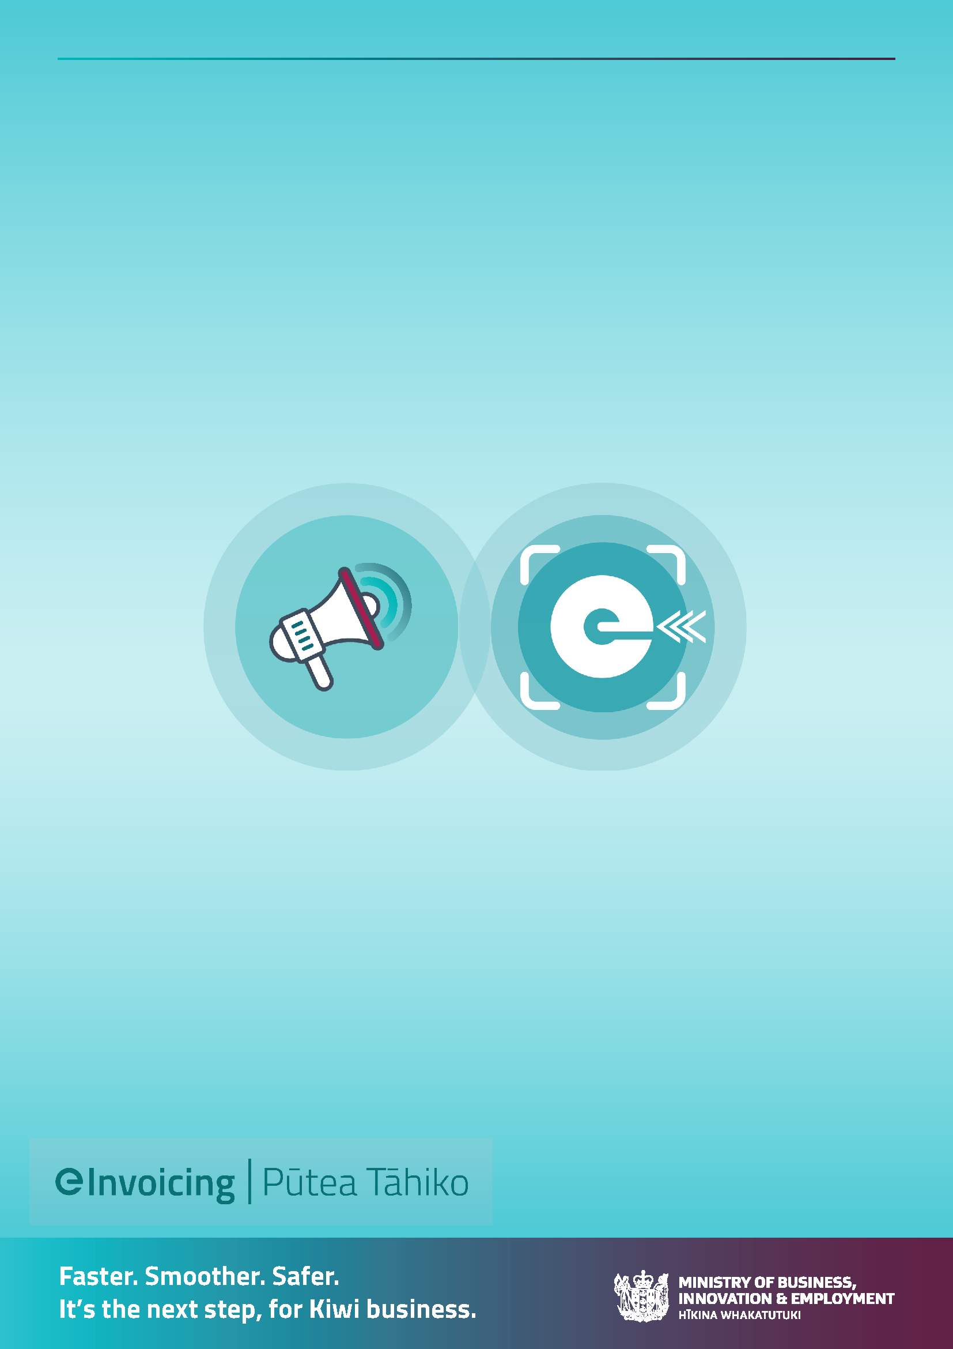
eInvoicing Communications Toolkit
Getting your suppliers ready for eInvoicing.

Table of Contents
How to use this toolkit 3
Communications resources 4
Segmentation options…………………………………………………………………………………………………………. 4
Email templates
Email 1 Advise you can receive eInvoices 6
Email 2 Reminder you can receive eInvoices 10
Email 3 Six monthly or annual reminder to suppliers sending PDF invoices….………… 11
Email 4 Let your buyers know if you can send eInvoices …………………….……..…..…. 13
Phone out scripts
Phone script 1 to suppliers using Xero or MYOB…………………………………………………….. 14
Phone script 2 to other high volume invoice suppliers…………………………………………… 15
No-touch way to encourage Xero and MYOB suppliers to send you eInvoices……………….. 17
Internal communications
Email template to internal teams (eg cost centre approvers and those engaging with suppliers……………………………………………………………………………………………………………….. 18
Content for your email signature………………………………………………………………………………………… 20
Helpful links and additional resources………………………………………………………………………………. 21

How to use this toolkit
This communication toolkit aims to support businesses and government eInvoicing implementation. More specifically, to aid in encouraging suppliers to register for eInvoicing and to begin sending eInvoices to your organisation; and letting your buyers know you can send eInvoices.
The toolkit includes communication tools you can adapt and use such as supplier analysis tips (segmentation and prioritisation), sample emails, phone out scripts, ‘no-touch’ way to encourage Xero and MYOB users, and copy for email signatures.

Pro tip:
If your organisation has specialist communications or data analysis people, engage them early to help with getting your trading partners on board with eInvoicing.
Communication resources
Here you will find:
- Segmentation options and considerations
- Email templates to adapt and use to communicate and engage with your suppliers and buyers
- Template content for email signatures
- Helpful links and additional resources
Segmentation options
Analysis of your suppliers will help you identify and group suppliers to prioritise those that should be approached first to be encouraged to send you eInvoices. Grouping suppliers also allows you to tailor the messages so they are relevant to that supplier group’s situation. There are many ways you could group or prioritise customers.
The easiest suppliers to bring on board to send and/or receive eInvoices are those that:
- Use eInvoicing enabled software. Most small businesses already have easy, affordable access to eInvoicing capability already (e.g. Xero, MYOB), with many business and accounting software products progressively adding the functionality throughout 2023 (e.g. Reckon). See the ‘How to guide – Identifying Xero and MYOB suppliers on Outlook’. It’s easy and quick for these suppliers to start eInvoicing. Even though these suppliers may send a low volume of invoices, there may be many suppliers so the volume of eInvoices can add up
- Are already registered to receive eInvoices: this indicates they may be using software that can easily send eInvoices, too. Check the eInvoicing website for the latest list of NZ businesses registered to receive eInvoices.
- Send high volumes of invoices.
If you have an existing closed EDI or portal solution you might want to exclude suppliers using these for the moment but think about a future transition process for those suppliers currently using the EDI channel.
Reaching the right people in your supplier’s organisation
To start with you’ll want to reach accounts receivable and payable teams or office managers.
As well as using your supplier relationship/contract managers to spread the word about eInvoicing, they may also help get the contact details (i.e., email address) of the right person to reach with eInvoicing communications.

Email templates
To tailor or not to tailor messages may depend on your supplier analysis and your supplier readiness approach. You may wish to include personalised and tailored messages based on:
- Those identified as registered on the Peppol (eInvoicing) network to receive eInvoices. Chances are they can also send eInvoices. Check eInvoicing.govt.nz for the latest list
- Knowing which suppliers send an email with a PDF invoice via their MYOB system
- Knowing which suppliers send an email with a PDF invoice via their Xero system
- Knowing which suppliers send paper invoices (in the post) and/or send very few a year (a free online eInvoicing portal option may suit them)
- Estimated size of business – i.e., medium to large are likely to be using different technology for their accounts receivable and/or have more complex systems. The steps to get started are slightly different.
Tailored messages are indicated in each of the email templates. You can choose to use as is, adapt them or simply delete.

Email version | Short description | When to send
1 | Advising that you can receive eInvoices | As soon as you’re able to receive eInvoices
2 | Reminder that you can receive eInvoices | 3 months after go-live
3 | Follow-up reminders to suppliers still sending PDFs | Six-monthly or annually
4 | Email to send to your buyers. If you don’t know if your buyers can accept eInvoices from you, use this email to ask them. | As soon as you’re able to send eInvoices

Email 1: Advising you can receive eInvoices.
Dear [name]
We’re accepting eInvoices
eInvoicing is rolling out across New Zealand, with many businesses and the wider government sector progressively becoming enabled to send and receive eInvoices. There are thousands of businesses registered to receive eInvoices and hundreds registering every month.
<name of department/your business name> <has/ We’ve> moved to eInvoicing too and prefer to receive eInvoices instead of PDFs <Receiving eInvoices means we’ll be able to process and pay your invoice faster. In most cases we’ll be able to pay your invoice within <x> working days.>
Optional sentences if payment time is reduced from current payment terms.

To ensure we can receive and process your eInvoices you’ll need your finance or accounting system to be able to send eInvoices and include our New Zealand Business Number (NZBN) with the other invoice information you send us.
Our NZBN is <enter NZBN here>
< To help us ensure smooth processing and payment of your invoices, we’d like to remind you to make sure your eInvoices include:
<a purchase order number>
<a cost centre and natural account number>
<a contract number>
So, check with your <name of organisation>’s contact person.>
<Delete or add list other requirements specific to your organisation>

If you have specific requirements, e.g. reference information e.g. purchase order, contract number or reference number.

What is eInvoicing and how does it benefit you?
eInvoicing is the digital exchange of invoice information directly between buyers’ and suppliers’ financial systems, even if these systems are different.
With eInvoicing, businesses no longer need to generate paper-based or PDF invoices that have to be printed, posted or emailed, and buyers no longer need to enter these manually into their financial system.
Removing manual handling of your invoices means they get to the right place (and don’t get lost) and prevents errors from happening – all helping to reduce delays in processing and payment of your invoices. It:
- improves accuracy and security,
- reduces processing time and
- speeds up payments.
Because eInvoicing allows you to connect to any financial system you can connect to all buyers from your invoicing system through the open network.
Getting started
Get started with eInvoicing so you can send us eInvoices instead of PDFs. Here’s how:
Choose the following content depending on the supplier analysis identifying which software your supplier is using

………………………………………….
Where you have identified the supplier is already registered on the Peppol (eInvoicing) Directory
We understand you’re already registered to receive eInvoices. So, chances are you may also be able to send eInvoices. Just make sure you record our NZBN and then send any future invoices to us as eInvoices.
………………………………….
It’s easy to get started if you’re using Xero
It’s easy to get set up for eInvoicing if you’re on a Xero Starter, Standard or Premium plan.
Simply follow their quick and easy instructions and you’re good to go. Check out their website for instructions.
Register to receive eInvoices- Xero
Sending eInvoices- Xero

……………………………...
It’s easy to get started if you’re using MYOB
It’s easy to get set up for eInvoicing if you use MYOB Essentials (also called MYOB Business) or access your AccountRight company file in a web browser.
Simply follow their quick and easy instructions and you’re good to go. Check out their website for instructions.
eInvoicing - MYOB Business - MYOB Help Centre
……………………………………………..
For infrequent invoices/paper invoices
Most small businesses already have easy, affordable access to eInvoicing capability. Many business and accounting software products can already send or receive eInvoices with many more progressively adding the functionality throughout 2023.
If you don’t use finance or accounting systems, or don’t issue many invoices, there are free online portals available for sending eInvoices. This means businesses can access eInvoicing capabilities without the need to buy eInvoicing-capable accounting or invoicing software. Check the eInvoicing website for the list of eInvoicing online portals available.
Software providers | eInvoicing
Check out the ‘how to’ guides on the eInvoicing website to get started to send and/or receive eInvoices.
- eInvoicing: Getting your business up to speed
………………………………………..
For all other suppliers:
Most small businesses already have easy, affordable access to eInvoicing capability. Many business and accounting software products are already eInvoicing capable with many more progressively adding the functionality throughout 2023.

Below are three steps to get you started to send eInvoices:
- Check your accounting or invoicing software provider’s website to see if your system is eInvoicing capable. Or check the growing list of eInvoicing-enabled software providers on the eInvoicing website. eInvoicing-enabled software providers
- Find and load up your buyers’ New Zealand Business Numbers (NZBNs) into their customer record in your invoicing software.
- Ask your buyers for their NZBN and if they can receive eInvoices. Send eInvoices to buyers who can receive them.
Check out our ‘how to’ guides to get started to send and receive eInvoices.
- eInvoicing: Getting your business up to speed
………………………………………………
Top tip: match your buyers and suppliers to their New Zealand Business Numbers (NZBNs) with the free and secure NZBN Business Match service.
NZBN Business Match service
Remember to send us eInvoices instead of PDFs as soon as you’re ready.

[Your name and Position]

Email 2: Reminder - you can receive eInvoices from suppliers. Send only to suppliers not yet sending eInvoices.
Dear [name]
Reminder - we’re accepting eInvoices
You may recall we were recently in contact to let you know we’ve moved to eInvoicing. This is a reminder for you to send us eInvoices if you can instead of PDF invoices. <Receiving eInvoices means we’ll be able to process and pay your invoice faster. In most cases we’ll be able to pay your invoice within <x> working days.>
Are you ready?
Don’t worry if you’re not ready yet. You can still send us your PDF invoice until you’re ready to send eInvoices. Remember you’ll need your finance or accounting system to be able to send eInvoices and include our New Zealand Business Number (NZBN) with the other invoice information you send us.
Our NZBN is <enter NZBN here>
To help us ensure smooth processing and payment of your invoices, we’d like to remind you to make sure your eInvoices include:
<a purchase order number>
<a cost centre and natural account number>
<a contract number>
So, check with your <name of organisation>’s contact person.>
<Delete or add list other requirements specific to your organisation>

There’s still time to get started
Now’s the time to get started with eInvoicing. Take the first step today.
Insert relevant copy from email 1
Remember when you’re ready to send eInvoices, we’re ready to receive them.

[Your name and Position]

Email 3: Six monthly or annual email to suppliers who continue to send PDF invoices
We’re accepting eInvoices
eInvoicing continues to be adopted across New Zealand, with many businesses and the wider government sector ready to send and receive eInvoices.
There are thousands of businesses registered to receive eInvoices and hundreds registering every month - including <name of your business>.
We notice you’re still sending us PDF invoices. We prefer to receive eInvoices instead of PDFs – it’ll help us process your invoice faster.
You’ll need your finance or accounting system to be able to send eInvoices and include our New Zealand Business Number (NZBN) with the other invoice information you send us. The NZBN is the unique global identifier that ensures the eInvoices you send reach us.
Our NZBN is <enter NZBN here>.
< To help us ensure smooth processing and payment of your invoices, we’d like to remind you to make sure your eInvoices include:
<a purchase order number>
<a cost centre and natural account number>
<a contract number>
So, check with your <name of organisation>’s contact person.>
<Delete or add list other requirements specific to your organisation>

If you have specific requirements, e.g. purchase order, cost centre, contract number or other reference number.

What is eInvoicing and how does it benefit you?
eInvoicing is the digital exchange of invoice information directly between buyers’ and suppliers’ financial systems, even if these systems are different.
With eInvoicing, businesses no longer need to generate paper-based or PDF invoices that have to be printed, posted or emailed, and buyers no longer need to enter these manually into their financial system.
Removing manual handling of your invoices means they get to the right place (and don’t get lost) and prevents errors from happening – all helping to reduce delays in processing and payment of your invoices. It:
- improves accuracy and security,
- reduces processing time and
- speeds up payments.
Because eInvoicing allows you to connect to any financial system you can connect to all buyers from your invoicing system through the open network.
Getting started
Now’s the time to get started with eInvoicing. Here’s how:
Insert relevant content from email 1
Remember you can send eInvoices to us as soon as you’re ready.

[Name and title]

Email 4: Email to send to your buyers. If you don’t know if your buyers can accept eInvoices from you, use this email to ask them.
We’ve moved to eInvoicing – have you?
Have you heard about eInvoicing? It’s rolling out across New Zealand, with many businesses and the wider government sector ready to send and receive eInvoices. There are thousands of businesses registered to receive eInvoices and hundreds registering every month.
We want to send you eInvoices
We prefer to send (and receive) eInvoices and we’d like you to receive eInvoices from us instead of PDF invoices in an email. eInvoices are received directly into your accounting software, so you save time on manual data entry and processing.
Please let us know your NZBN and confirm if you’re connected to the eInvoicing network. Then we’ll start sending you eInvoices instead of PDFs.
Check out the eInvoicing website (www.einvoicing.govt.nz) if you want to find out more.

We can send you eInvoices as soon as you’re ready. Rest assured; we can still send you PDF invoices until you’re ready to receive eInvoices from us.
I look forward to hearing from you.
[Your name and Position]

Phone out scripts

Calling a small number of suppliers can be an easy and effective way to get initial key suppliers on board as well as to give your teams confidence in receiving and processing eInvoices.

Phone script 1 – suppliers using Xero or MYOB:

Use this script for phone calls to suppliers you know are currently using Xero to send PDF invoices.

Check you’re talking to the right person who does the invoicing for their business.

Introduce yourself.
Hi, I’m <name> from <name of your team/organisation>. I understand you supply goods or services to us and I’d like to talk you about sending us eInvoices instead of emailing PDF invoices.

How much do you know about eInvoicing?
eInvoicing is growing across New Zealand with thousands of businesses registered to receive eInvoices, with hundreds registering every month. (The list is published on the eInvoicing website at einvoicing.govt.nz)
eInvoicing is the digital exchange of invoice information directly between buyers’ and suppliers’ financial systems, even if these systems are different.
With eInvoicing, you no longer need to generate PDF invoices that have to be emailed, and buyers no longer need to manually enter these into their financial system.
Removing manual handling of your invoices means invoice information gets to the right place, at the right time with less chance of errors happening along the way. This all helps to reduce delays in processing and payment of your invoices.
We now prefer to receive eInvoices instead of PDFs. Sending us eInvoices means the processing and payment of your invoice will run more smoothly.

Can I confirm you’re currently using <Xero or MYOB> to generate invoices which you then email and send as PDFs?
If Xero: The good news is Xero has made the ability to send and receive eInvoices available to their customers on their Starter, Standard or Premium plans.
If MYOB: It’s easy to get set up for eInvoicing if you use MYOB Essentials (also called MYOB Business) or access your AccountRight company file in a web browser.
Their website has good instructions on how to send an eInvoice (and to receive invoices from your suppliers). I’ll send you links to their website – simply follow their instructions and you’re good to go.
To ensure we can receive and process your eInvoices please:
Add our New Zealand Business Number (NZBN) into your contact records.
This ensures any eInvoices you send reach us and they will go directly into our financial management system for processing.
I’ll email you our NZBN following this phone call.
All invoices need to also have specific information in the ‘reference’ component of the invoice.
Please ask your <name of your organisation> contact to provide the reference information needed before you prepare the eInvoices going forward. Again, I’ll provide you the specifics in a follow up email.
Please send your <month of next invoice> and subsequent invoices as eInvoices instead of PDFs.
Do you have any questions, all good to go?
Can I check I’ve got the right email address for you.
You’ll receive an email from me shortly confirming our conversation and providing you with more info about eInvoicing, the links to <Xero’s/MYOB> website, our NZBN number and the reference information we need on the invoice.
Thank you for agreeing to send us eInvoices instead of PDFs, we really appreciate your leadership on this.

Phone script 2: Other high-volume suppliers (not using Xero / MYOB).

Use this script for calling high volume invoice suppliers.

Check you’re talking to the right person who does the invoicing for their business.

Introduce yourself.
Hi I’m <name> from <finance area or name of organisation>. I am calling you today as you are one of <name of your organisation>’s valued suppliers and I’d like to talk to you about how we can help you get set up for eInvoicing so you can send us and your other buyers eInvoices.

If you’ve sent an email prior to the phone call: Do you recall receiving an email from <name of your organisation> asking you to send us eInvoices instead of PDFs?

How much do you know about eInvoicing?
eInvoicing is growing across New Zealand with thousands of businesses registered to receive eInvoices, with hundreds registering every month. (This list is on the eInvoicing website at einvoicing.govt.nz)
eInvoicing is the digital exchange of invoice information directly between buyers’ and suppliers’ financial systems, even if these systems are different.
With eInvoicing, you no longer need to generate PDF invoices that have to be emailed, and buyers no longer need to manually enter these into their financial system.
Removing manual handling of your invoices means invoice information gets to the right place, at the right time with less chance of errors happening along the way. This all helps to reduce delays in processing and payment of your invoices.
We now prefer to receive eInvoices instead of PDFs. Sending us eInvoices means the processing and payment of your invoice will run more smoothly.

May I ask what ERP/accounting software you’re currently using to generate PDF invoices?
**check software providers’ list on eInvoicing website to see if the one they use is eInvoicing ready. See website page at: Getting set up for eInvoicing | eInvoicing **
If it is on the list: That’s great as that software is listed on the eInvoicing website as eInvoicing ready. I suggest you get in contact with them about how to connect to the eInvoicing network so you can send and receive eInvoices yourself. Our team is also here to help with any advice you might need further when looking to get this enabled.
If it’s not on the list: That software isn’t listed as eInvoicing ready on the eInvoicing website. I suggest you get in contact with them to ask when they expect to be able to provide eInvoicing capability in their software.
**if using Xero or MYOB:**
Xero: The good news is Xero has made the ability to send and receive eInvoices available to their customers on their Starter, Standard or Premium plans.
MYOB: It’s easy to get set up for eInvoicing if you use MYOB Essentials (also called MYOB Business) or access your AccountRight company file in a web browser.
Their website has good instructions on how to send an eInvoice (and to receive invoices from your suppliers). I’ll send you links to their website – simply follow their instructions and you’re good to go.

Thank you so much for providing me with that information.
We would love for your organisation to get eInvoicing capability so you can send us eInvoices (and you receive them too).

My team and I are here to support you and can assist you with testing before sending us live eInvoices.
Do you have any questions for me?
I will send you a follow-up email containing the information we discussed. My team and I are here to support you with anything you may need. Feel free to send me an email or give me a call if you have any questions.
I hope you will investigate getting set up for eInvoicing and we look forward to receiving eInvoices from you soon.

No-touch way to encourage Xero and MYOB users to send you eInvoices.
After initial phone calls or emails to your Xero and MYOB suppliers you may want to implement this no-touch way to continue to remind them to send you eInvoices.

If you have an inbox for your suppliers to send their PDF invoices, here is a business rule you can implement that will produce an automated email back to the supplier with information about sending eInvoices.
Set up one rule for Xero and one rule for MYOB.

Rule name
Auto response Xero (or auto response MYOB)
Rule conditions | Rule Settings
Apply this rule if:  The sender address includes any of these words ‘@xero.com’ (or ‘@MYOB.com’)  The recipient is <insert email address for your PDF invoices – eg ‘invoices@abc.co.nz’> | Mode = Enforce
Do the following:  Notify the recipient with a message:  Thank you for your invoice. Did you know that at <insert name of your organisation> we can now receive invoices via eInvoicing? If you send your invoice as an eInvoice from your <Xero/MYOB> accounting system, we will be able to process and pay your invoice faster.  To ensure we can receive and process your invoices you’ll need to do a couple of set up tasks within your accounting software, including adding our New Zealand Business Number (NZBN).  Our NZBN is: <insert your NZBN here>  We have developed a quick guide on how to make this change – please take a look: <include a link to your website with instructions for suppliers to send eInvoices – including your reference requirements and links to Xero and MYOB instructions>.  We appreciate you sending us eInvoices instead of PDFs. | Set Date Range = specific date not yet set  Priority = 40  Severity = medium  For rule processing errors = ignore  Stop processing more rules = true

Internal communications
Email to your internal teams (eg cost centre approvers or those engaging with suppliers).
Kia Ora,
Did you know, <name of your organisation> now prefers to receive eInvoices? (we’ll still accept PDF invoices too)
eInvoicing is the digital exchange of invoice information directly between the supplier’s and the buyer’s - <name of your organisation>’s - financial systems. This process works even if these systems are different, and it means the invoice information goes straight into our finance system for processing.
<name of your organisation> is asking suppliers to send eInvoices now as a preference.
Next time you or your team request any goods or services from suppliers, please encourage your suppliers to send eInvoices instead of PDFs. With more than 40 eInvoicing ready software providers, most businesses now have access to eInvoicing capability. Suppliers can check the list at Getting set up for eInvoicing | eInvoicing to see if the software they use has eInvoicing capability.
To ensure we can continue to receive and process suppliers’ invoices in a timely manner (whether a PDF or eInvoice), also, please ensure suppliers are provided with:
- Our NZBN (this is the unique identifier that ensures eInvoices reach our finance system):
  - <name of Your organisation> NZBN: <insert your organisation’s NZBN here xxxxx>
- One of the following for the ‘reference’ component of the eInvoice, which MUST be included:
  - <enter your organisation’s specific requirements here – could be purchase order number and format, or cost centre number reference>
- Also remind them the eInvoice should:
  - be addressed to <your organisation name>.
  - have the supplier/contact email address (so we can get in touch if we have any queries) and
  - include the GST and bank account numbers.
eInvoices are automatically loaded into our finance system. While you won’t receive a PDF copy of the invoice, you and any of your team who have access to our finance system, will be able to view the eInvoice within the finance system should you wish to view the information.
Thank you for support on this initiative. Please share this with your team as appropriate.
Ngā mihi,
Content for your email signature
eInvoicing is still growing across New Zealand, so it’ll take some time for all businesses to get on board. The more businesses that send and receive eInvoices, the more we all share in the benefits such as admin time-savings and faster payments.
A great way to help speed things up is to promote that your business can send or receive eInvoices – in your business conversations, in your contracts or within your email signature.
Download the ‘eInvoicing capable’ badge.
Download eInvoicing capable badge for email signature
Guide for using eInvoicing capable badge
If you can receive eInvoices, add the following to your business’s email signature for relevant roles (such as accounts payable team members or auto responses for AP enquiries):
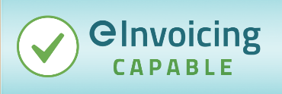
We prefer to receive eInvoices instead of PDFs. Our NZBN is xxxxxxxxx
If you can send eInvoices, add the following to your business’s email signature for relevant roles (such as accounts receivable and procurement team members) and add it into your PDF or paper invoices:
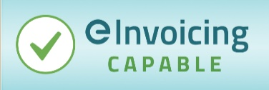
We prefer to send eInvoices instead of PDFs. It’ll make it faster and easier for you to process our invoices. Let us know your NZBN and if your business can receive eInvoices.

Helpful links and additional resources
Check our eInvoicing website, where you’ll find:
- This eInvoicing communication toolkit
- Supplier checklist
- How to get set up to send and receive eInvoices (PDF and video)
- How to get set with eInvoicing for Xero and MYOB users
- List of eInvoicing ready software providers including free eInvoicing portals available
- Government agencies’ eInvoicing status with NZBN numbers
- ‘How to’ guide – Identifying Xero and MYOB suppliers in Outlook
- A list of NZ businesses registered to receive eInvoices (updated monthly)
- Case studies of businesses adopting and using eInvoices
- Business case guidance document (for large businesses)
NZBN Business Match service – a free and secure government service to match a list of businesses to their New Zealand Business Numbers (NZBNs)
MYOB website – eInvoicing page: https://help.myob.com/wiki/display/myob/EInvoicing
Xero website – eInvoicing page: https://www.xero.com/nz/resources/eInvoicing/

