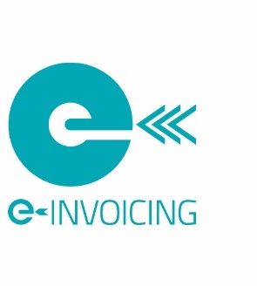

NZ Peppol e-Invoicing Ready
The New Zealand Peppol Authority assess, publish and promote a list of Peppol ready e-Invoicing software solutions. The purpose being to help businesses and Government agencies find industry practice software solutions that meet their invoicing needs. Peppol ready e-Invoicing solutions are software solutions that demonstrate the ability to send and/or receive Peppol e-Invoices.
Software providers that wish to be listed as Peppol e-Invoicing Ready must meet the following assessment criteria*:
Send solutions must be able to send e-Invoices on the Peppol network to any buyer that is registered on the Peppol network. In addition, they must be able to support the eight Best Practice business terms:
1. Invoice Payment Due Date
2. Supplier / seller GST identifier
3. Supplier / seller contact details
4. Payee financial Account
5. Payment ID / Remittance information
6. Additional description for item
7. Reference number (Purchase Order, Buyer Reference, Contract, Project, Tender)
8. Other supporting documents and attachments
Check - Industry Practice Statement – Invoice Content for further information.
Applicants should provide clear evidence of the capability to send e-invoices including the usage of the Industry practice fields. Valid examples are screen shots and Peppol format XML files.
Receive solutions must be able to ingest Peppol e-Invoices including those that contain the eight Best Practice business terms from suppliers on the Peppol network. Applicants should provide clear evidence of the capability to receive e-invoices including the ingestion of the Industry practice fields. Valid examples are screen shots or a demonstration.
Peppol ready e-Invoicing solutions must have the ability to connect to the Peppol network. Companies providing these solutions should either be a NZ accredited access point or should have a commercial partnership that facilitates end-users to connect to the Peppol network via a NZ accredited access point. Where applicants are not NZ accredited access points, they should provide evidence of their commercial relationship with other accredited access points to meet the assessment criteria.

Please be sure to provide the below details when requesting to be published.

Company Details
Company Name: NZBN:
Contact Person: Contact Phone:
Email:
Software Product: Version (if applicable):
Website URL:
Send Capable Receive Capable

Completed forms along with associated attachments should be emailed to support@nzpeppol.govt.nz.
*The PEPPOL Authority may also request sample files and/or live product demonstrations.

