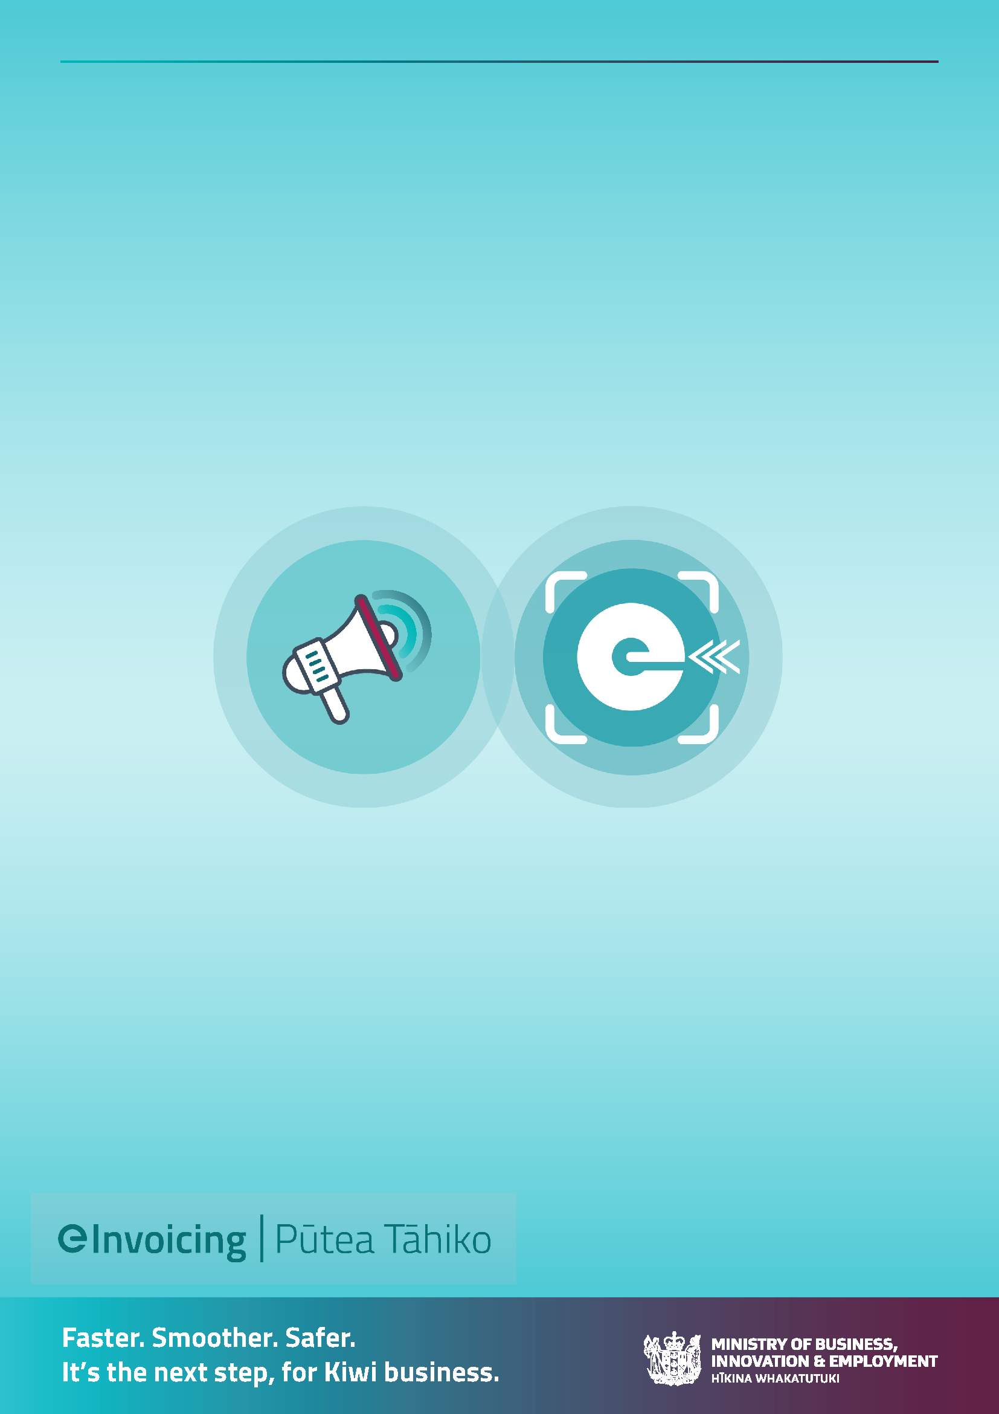
eInvoicing in
New Zealand:
Business case guidance material
Version 1.0
July 2023

How to use this document
This document provides information and guidance material to assist with developing your internal business case for eInvoicing, and gaining executive buy-in to prioritise eInvoicing in your organisation.
The MBIE eInvoicing team is here to help. Please reach out to us to discuss any aspect of your business case, positioning/benefits, implementation questions and customer/supplier onboarding.

Contents
1. Overview of eInvoicing 3
What is eInvoicing? 3
Background to eInvoicing 3
eInvoicing rollout in New Zealand 5
2. Objectives of adopting eInvoicing 9
Objectives 9
Tips for positioning eInvoicing 10
3. Benefits 11
Direct and secure 11
Reduced admin and processing costs 12
Better supplier and customer experience 13
Connect once, connect to all (data standardisation and open EDI) 14
Faster payment and improved cash flow 14
Improving financial visibility 15
4. Options 16
Do nothing 16
Sending and/or receiving eInvoices 16
Systems and software selection (implementation pathways) 17
5. Cost 19
6. Return on investment 20
Tangible benefits 20
Intangible benefits 21
7. Project delivery 22
8. Risks 25

1. Overview of eInvoicing

What is eInvoicing?
eInvoicing is the direct exchange of data between any two accounting systems, that makes doing business smoother, faster and safer. With eInvoicing, businesses no longer need to generate paper or PDF invoices that have to be printed, posted or emailed, and buyers no longer need to manually enter these into their financial system. That’s because an eInvoice is sent directly to the receiver’s finance system, even if businesses are using different systems. It improves accuracy and security, reduces processing time and can help to speed up payments.

eInvoicing
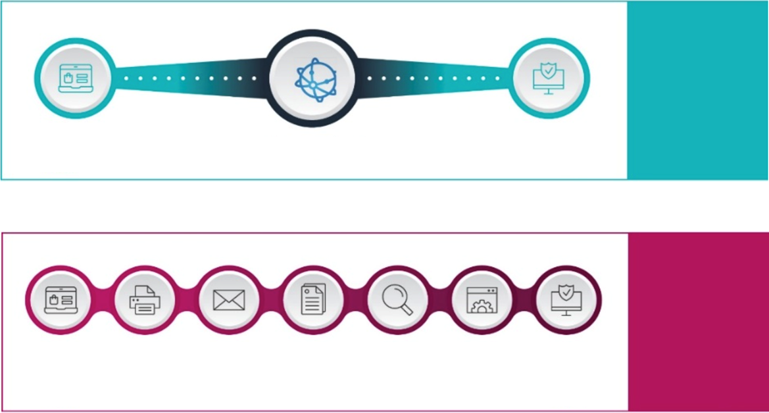
Paper/email invoicing
PROBLEMS
Manual
Error prone
Expensive
BENEFITS
Easier
Faster
Safer
Manual data input
Check
Delivery
Post or email
Print or PDF
Receive invoice
Create invoice
eInvoicing network
Receive invoice
Create invoice

Background to eInvoicing
The New Zealand and Australian governments have committed to a joint approach to eInvoicing using the Peppol interoperability framework. Peppol is a global standardised framework that enables businesses to exchange procurement documents electronically. Peppol is an international, government-backed standard for eInvoicing used in 42 countries.
eInvoicing is being rolled out across New Zealand to:
- Create an open market to enable all businesses to participate in digital trading
- Reduce accounts payable cost and inefficiencies associated with manual accounts payable
- Increase the speed of payments and move money around the economy faster.

With over 280 million business to business invoices exchanged in New Zealand each year, savings to the economy through eInvoicing are estimated to be $4.4 billion over 10 years.

The Peppol framework
The Peppol eInvoicing network incorporates an established set of common business processes and technical standards. This provides an interoperable and secure network using consistent electronic messaging protocol and formats, and digital signature technologies to secure message content. eInvoicing is the messaging channel in which an invoice is sent from a supplier’s financial system and received in a buyer’s financial system.
Peppol standards are based on a standardised XML format known as Universal Business Language (UBL). Invoice senders and receivers (and their invoicing software) communicate via an Access Point Provider – secure gateways that connect businesses to the eInvoicing network.
eInvoicing sends and receives structured eInvoice data. The invoice is validated and structured (based on the Peppol standard) by the sender, and comes through to the receiver’s financial system in a structured format with no extra processing required. This is different to receiving invoices through channels like optical character recognition (OCR), which takes an unstructured invoice and completes extra processing steps to provide the data in a structured format.

eInvoicing network
Peppol Access Point Providers
Peppol Access Point Providers
Send Invoice
Seller’s natural business software
(e.g. ERP, billing software, mailhouse)
Receive Invoice
Buyer’s natural business software (e.g. ERP, AP software, OCR/EDI software)
An eInvoice is sent using the buyer’s NZBN
(New Zealand Business Number) or organisational part.
Secure send
The eInvoice is sent securely over the Peppol network
Resources
- Peppol BIS Billing 3.0
- New Zealand/Australia Peppol extension – Github

eInvoicing rollout in New Zealand
As of July 2023, 10,000+ New Zealand organisations are registered for eInvoicing. You can check the latest eInvoicing registration figures here. The eInvoicing network continues to grow consistently across all sectors of the New Zealand economy.

Large business
CFOs from New Zealand’s most influential organisations have committed to implementing eInvoicing and are part of MBIE’s eInvoicing Adoption Leaders Group. Large influential businesses in New Zealand are already sending and/or receiving eInvoices, with many more in the planning stage for implementation.
Government
The New Zealand Government is taking a leadership role in adopting eInvoicing and onboarding its supplier base to send eInvoices. New Zealand Central Government agencies have been set the following eInvoicing implementation and supplier eInvoice volume targets:
- 20% of business to Central Government invoices are eInvoices by 1 July 2024
- 90% of business to Central Government invoices are eInvoices by July 2026.

To further promote government suppliers sending eInvoices, it is intended that an eInvoicing mandate for State Sector agencies will be given effect through a series of proposed changes to the Government Procurement Rules. The next consultation on revision to the rules is scheduled for early 2024, which is when the first set of guidance and requirements around eInvoicing will be proposed. The Government Procurement Rules apply to procurement worth over $100k and include a wide range of government agencies.

SMEs
Most SMEs in New Zealand have easy and free access to eInvoicing capability through accounting software like Xero (business editions) and MYOB (Essentials and AccountRight), or by using a free eInvoicing portal. Xero and MYOB are spearheading SME eInvoicing participation in New Zealand.
MBIE has invested in an advertising campaign throughout 2022 and 2023 and will continue into 2024, to raise awareness, understanding and drive eInvoicing registrations among SMEs.
Resources
- Case studies
- List of NZ businesses ready to receive eInvoices
- Government agencies’ eInvoicing status

Scope
Peppol eInvoicing is a channel for business-to-business (B2B) invoicing that uses standardised, structured data. eInvoicing can be a standalone initiative, or part of a wider organisational/procure to pay transformation initiative:
What eInvoicing is

Digital exchange of invoice information
between a buyer's and supplier's
accounting systems, using a common
agreed standard

Structured, computer readable data

Cleaner, standardised data faster, which
automates entry into systems and
enables automated processing

A standard for B2B invoicing

Sits alongside your existing P2P/PO
processes
SECURE
NETWORK
Receive
×
Invoices generated by software and
emailed as a PDF to buyers
×
Paper or emailed invoices which are
processed manually
×
Scanned/OCR invoices
×
A system that performs AP automation
checks, automatically reconciles or
automatically pays invoices
×
A standard for B2C invoicing
eInvoicing is not
eInvoicing can enable and provide a catalyst for enabling further invoicing automation and improving business processes (for example, payment times/straight through processing).
eProcurement message types
Peppol can provide standardised eProcurement messaging for the whole supply chain/P2P cycle. Globally, Peppol supports a wider suite of Procure to Pay (P2P) documents including Catalogue, Purchase Order, Dispatch Advice, Invoice, Invoice Response and Credit Note. In New Zealand, the current A-NZ Peppol BIS 3.0 covers Invoice, Credit Note and RCTI (Receiver Created Tax Invoice). In the future, MBIE – as the NZ Peppol Authority, would look to introduce wider eProcurement document types to meet customer demand.

eInvoicing vs EDI
eInvoicing on the Peppol network emphasises standardisation and increased interoperability with a wider range of trading partners. It is separate from electronic data interchange (EDI):
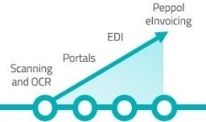
eInvoicing
Electronic Data Interchange (EDI)
Similarities
- Secure transfer of structured invoice data
Differences
- Peppol interoperability framework
- Standardised document formats
- Open network – ‘connect once, connect to all’
- Backed by government
- Trading partners use their natural business software to send/receive invoices
Similarities
- Secure transfer of structured invoice data
Differences
- Multiple proprietary networks
- Different standards and document formats across industries
- Closed networks
- Setting up EDI connections with multiple trading partners can be time-consuming, complex and often costly – especially for SMEs
- Trading partners are usually required to enter invoice information in a separate portal (outside of their natural business software). This can create more work and complexity for them
vs
Many EDI/VAN providers also offer Peppol as a channel, so you can stay with your existing provider
Processing maturity

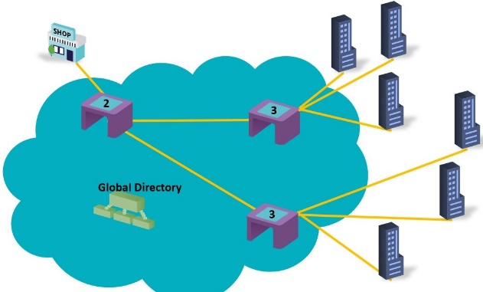
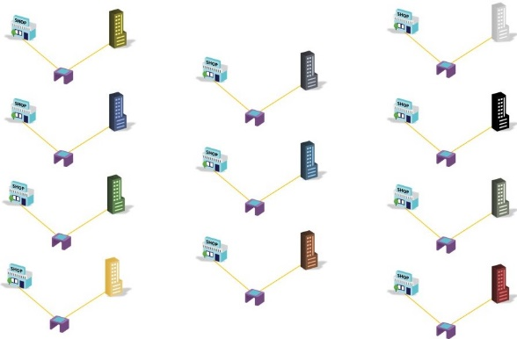
vs
One supplier, unlimited buyers via global directory (Peppol)
Multiple connections for multiple buyers
Electronic Data Interchange (EDI)
eInvoicing

Global Peppol adoption
The New Zealand and Australian governments have committed to a joint approach to eInvoicing using Peppol. Open Peppol has members in 42 countries including Asia, Europe and the Americas:
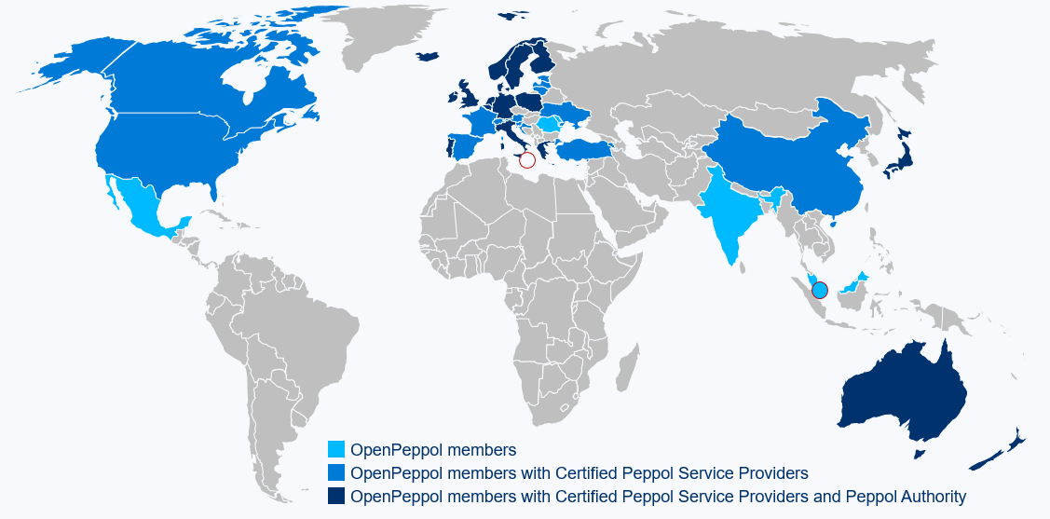

In New Zealand and Australian governments are promoting eInvoicing to deliver efficiency, productivity and digitalisation benefits for businesses and the wider economy.
Other countries globally are mandating the use of eInvoicing for trading with government, or for tax compliance/continuous transaction control purposes. In the European Union eInvoicing is expected to be mandatory for cross-border transactions by 2028. If your organisation exports to countries captured within the scope of this proposed change from the European Union, then this is something you should seek further understanding on.

2. Objectives of adopting eInvoicing

Objectives
Depending on your organisational context and priorities, objectives for implementing eInvoicing may include:

Sending eInvoices
- Keep up with changing Government procurement preferences to receive eInvoices from suppliers (for organisations that are suppliers to Government)
- Meet customer expectations for offering Peppol as an invoicing channel
- Improve invoice deliverability, security and privacy
- Reduce accounts receivable exception handling and reconciliation errors from incorrect payment amounts
- Improve customer experience
- Lead the way for New Zealand businesses and SME customers
- Future-proof and keep up with best practice for invoicing in New Zealand and globally.

Receiving eInvoices
- Streamline accounts payable processes to reduce delays, errors and exception handling
- Improve invoicing efficiencies and reduce errors from manual or semi-manual invoice processing practices
- Reduce invoice processing costs
- Minimise the fraud risk of fake or compromised invoices
- Mitigate the risk of failed invoices
- Improve supplier experience
- Free up your AP team to focus on higher value business tasks
- Improve payment times and reduce late payments to suppliers
- Meet supplier expectations for offering Peppol as an invoicing channel
- Reduce paper use by eliminating printed invoices
- Future-proof and keep up with best practice for invoicing in New Zealand and globally.

Tips for positioning eInvoicing
eInvoicing as a risk mitigation initiative
While there are many financial and non-financial benefits of eInvoicing, some large New Zealand organisations have gained executive sponsor/leadership buy-in to eInvoicing by focusing on eInvoicing as a risk mitigation initiative. Risk mitigation is a particular consideration for security/minimising invoice fraud risk, reducing privacy breaches with sensitive invoice information, reducing manual touchpoints, reducing loss of revenue due to undeliverability of sent invoices, organisational reputation and trading partner relationships (including government).

Future-proofed, additional channel
Think of eInvoicing as an additional, future-proofed channel that will be implemented alongside existing invoicing channels, which will grow over time. Keep your implementation simple – once fully operational, eInvoicing should be easier for your trading partners than current invoicing channels/practices.

eInvoicing and your organisational procurement strategy
Your business case for eInvoicing can be considered as part of a wider organisational procurement strategy. Consider any dependencies for feeding into planned/maximising return on investment on existing system upgrades (e.g. ERP). eInvoicing can be a catalyst for broader finance transformation and business process change.

The importance of an eInvoicing champion
Feedback from organisations that have successfully gained approval to roll out eInvoicing emphasises the need for a tenacious internal champion that is able to persistently advocate for eInvoicing at an organisation-wide level and bring the CFO/CEO along on the journey.

3. Benefits

Direct and secure
Sending eInvoices
- Real time, automated system confirmation gives peace of mind an eInvoice has been delivered, unlike emailed or posted invoices
- Improved deliverability compared to email and post channels. There are no email spam filters to worry about, and a customer’s NZBN does not change, unlike an email or physical address.

Receiving eInvoices
- Reduces processing delays – eInvoicing is a direct delivery channel so invoices are not lost, or missed in a busy email inbox.

Sending and receiving eInvoices
- Reduces fraud – eInvoicing minimises the risk of fake or compromised invoices, unlike paper or emailed (e.g. PDF file attachments) invoices that can be intercepted and tampered with
- eInvoices go directly into the buyer’s financial system, so buyers are assured they’re approving and paying genuine invoices that haven’t been compromised or tampered with
- Invoices remain private/confidential and can’t be forwarded by email – only people with FMIS access can see the invoice
- Sender and receiver details are validated, audit logs kept, and strict protocols are followed to ensure invoices remain secure while sent across the network.
- Data privacy is also enhanced, as invoice information can only be accessed via systems (with user login audits logs available) it makes it difficult to discretely or accidentally forward on any sensitive data to outside individuals compared to when using email as the channel invoice data sharing.

eInvoices are securely sent using the New Zealand Business Number (NZBN) as the address. A supplier or customer’s NZBN doesn’t change, unlike an email or physical address.

Case studies:
Bunnings Australia has seen sevenfold decrease in transmission failures since implementing eInvoicing and sending eInvoices to customers. Peppol is a stable channel with very few error rates/invoices not received by customers, unlike emailed PDF invoices.

Reduced admin and processing costs
Sending eInvoices
- Reduces reconciliation errors from incorrect payments. With eInvoicing there is no more risk of customers mis-keying payment amounts in their system
- Reduces admin headaches from costly accounts receivable exception handling.

Receiving eInvoices
- eInvoicing can be cheaper than other channels (OCR, EDI etc), especially when considering lifecycle costs
- Structured data is directly sent from one financial system to another – eInvoicing requires no manual data entry
- Eliminates human error, risk associated with manual touchpoints and reduces admin effort, meaning fewer errors and delays
- Saves time by not having to re-key or scan invoices, make corrections, or chase missing information
- Reduces failed invoices and associated risks (supplier relationships, reputation, compliance, supply chain impacts).

High level overview of potential eInvoicing savings from reducing manual handling:
 | Total cost | Sending eInvoices (AR) | Receiving eInvoices (AP)
Paper | $25.67 | $3.08 | $22.59
Emailed file (e.g. PDF) | $23.01 | $2.76 | $20.25
eInvoicing | $7.63 | $0.92 | $6.71

These savings are a guide and should be compared against your own organisational data for invoicing costs, as this can differ widely by organisation. Your organisations procure to pay process maturity, and finance systems landscape, should be taken into account when estimating the current and future state. For example, and organisation that has fully embedded Purchase Orders (three-way matching), with integrated finance processes and systems, are likely to have lower whole of life costs.

Failed invoice rates can be higher than you might think. Consider the tangible and intangible costs of a failed invoice – staff time and inefficiencies of double-handling and fixing errors, damaged supplier relationships and supply chain risk, staff morale, company reputation/trust and non-compliance risk.

Case studies:
Ricoh has seen cost savings, and a strong reduction in aged debt and payment cycles with eInvoicing.

Due to savings from automated data entry and matching, Woolworths have reduced their AP team requirements by nearly 50% since implementing Peppol and other EDI.

HammondCare has reduced their invoice processing costs and time in two months via eInvoicing.

Better supplier and customer experience
Sending eInvoices
- A growing number of Kiwi businesses prefer to receive eInvoices – from sole traders and SMEs to very large businesses and government agencies
- It is intended that an eInvoicing mandate for State Sector agencies will be given effect through a series of proposed changes to the Government Procurement Rules
- Customers will appreciate you reducing their admin burden of manually entering your invoice, and making it easier to do business with you. MYOB research shows that SMEs could reduce their invoicing time by around 5.7 hours per month using eInvoicing, resulting in a potential productivity cost saving worth approximately $1.7bn.

Receiving eInvoices
- Invoicing is changing – keep up with supplier preferences to send eInvoices
- Better supplier relationships by eliminating lost invoices, reducing delays and chasing suppliers for information.

Over time eInvoicing will be the way of sending and receiving B2B invoices in New Zealand. eInvoicing is already the preferred way of billing the New Zealand government.

Case studies:
Woolworths supplier queries have reduced by over 70% since implementing eInvoicing, reducing admin for both Woolworths and suppliers’ teams.⁷

For Bunnings Australia⁴ and BOC Gas, a key driver for sending eInvoices to customers was to make it as easy as possible for customers to do business with them. 80% of BOC Gas customers rated eInvoicing as either 4 or 5 stars (out of 5) in a customer satisfaction survey.

Connect once, connect to all (data standardisation and open EDI)
Sending and receiving eInvoices
- Peppol is a secure, open, government backed standard that enables organisations to exchange invoices with all trading partners on the Peppol network
- Setting up EDI connections with multiple trading partners can be time-consuming, complex and costly. There is a lack of standardisation with different EDI standards and document format across industries and geographies. eInvoicing on the Peppol network emphasises standardisation and increased interoperability with a wider range of trading partners
- No need to build and maintain complex (and often expensive) integrations with proprietary platforms that require different solutions for each trading partner
- Global, government-backed Peppol standards translate eInvoicing data seamlessly across different financial systems and markets
- Organisations use their natural business software to exchange eInvoices.

eInvoicing is an additional, future-proofed channel that sits alongside your existing invoicing channels (e.g. email, EDI and post). eInvoicing volumes will grow over time as more businesses and compatible software joins the network.

Case studies:
For Woolworths, Peppol provides an easy and cost effective solution for SME supplies over traditional closed EDI networks.⁷

For Bunnings Australia⁴ and BOC Gas¹⁰, Peppol offers a scalable solution to reach a large number of trading partners in a single implementation, rather than continuing to invest effort in bespoke integrations.

Faster payment and improved cash flow
Sending eInvoices
- eInvoices are sent directly into the buyer’s financial system without manual intervention.
- No need to wait for an invoice to be delivered and manually entered.
- All this means fewer errors and delays, allowing for speedier payments and fewer late payments. Businesses with high cashflow can benefit the most from faster payments.

Receiving eInvoices
- eInvoicing can enable you to improve payment times and reduce late payments to suppliers.

eInvoicing eliminates delays and errors as invoices are not being manually entered into a buyer’s financial system. This means buyers can pay the invoice quickly if they choose to, speeding up payment and improving cashflow for your suppliers.

Case studies
To date, BOC has seen a 50% improvement in on-time payments with eInvoicing, and an improved customer satisfaction rating¹⁰.

MBIE has been able to pay suppliers 3 days faster when receiving eInvoices straight into our FMIS (an average of 4.2 days vs 7.1 days for paper/PDF invoices).

Westpac has been able to pay eInvoices 2-3 days after being received, vs 20 days with traditional invoicing.

Improving financial visibility
Receiving eInvoices
- eInvoicing allows for a lot of invoice detail to be retained in your financial system, rather than a detailed invoice simply being coded as a single line item as buyers often do today
- This supports improved analysis, forecasting, planning and budgeting, enabling more accurate financial management
- As there’s full and complete information describing the goods or services going directly into the finance system, it’s easier to code and saves time
- Improves cashflow visibility – eInvoices are received into your financial system in real time, so you’ll know exactly how much you owe.

eInvoicing sends structured data from one finance system to another – this often includes richer information than what would normally be entered in a manual or semi-automated process.

4. Options

Do nothing
Do not implement eInvoicing - continue status quo AR/AP invoicing practices.
Pros
- No change or investment is required.

Risks
- Customer expectations to receive eInvoices are not met – including expectations/requirements for Government suppliers to send eInvoices
- Emailed/posted invoice deliverability issues continue – along with associated late payment/cashflow, exception handling, customer record management and customer relationship/reputation issues
- Supplier expectations to send you eInvoices are not met
- Continued security interception risks of paper/emailed invoices (e.g. PDF)
- Continued inefficiencies, errors and high cost in AP processing
- Investment in invoicing technology/channels is not future-proofed
- Continued investment in EDI/proprietary channels, which risk becoming less relevant over time as Peppol adoption grows
- Missed opportunity to keep up with global best practice for invoicing and be recognised as a leader among customers and suppliers in New Zealand.

Sending and/or receiving eInvoices
Do you plan to send eInvoices, receive eInvoices, or both?
Sending eInvoices
- Comply with changing Government procurement preferences to receive eInvoices from suppliers (for organisations that are suppliers to Government)
- Meet customer expectations for offering Peppol as an invoicing channel
- Improve invoice deliverability and security
- Reduce accounts receivable exception handling and reconciliation errors from incorrect payment amounts
- Improve customer experience
- Lead the way for New Zealand businesses and SME customers
- Keep up with best practice for invoicing in New Zealand and globally.

Receiving eInvoices
- Streamline accounts payable processes to reduce delays, errors and exception handling
- Improve invoicing efficiencies and reduce errors from manual or semi-manual invoice processing practices
- Reduce invoice processing costs
- Minimise the fraud risk of fake or compromised invoices
- Mitigate the risk of failed invoices
- Improve supplier experience
- Free up your AP team to focus on higher value business tasks
- Improve payment times and reduce late payments to suppliers
- Meet supplier expectations for offering Peppol as an invoicing channel
- Reduce paper use by eliminating printed invoices
- Keep up with best practice for invoicing in New Zealand and globally.

Systems and software selection (implementation pathways)
There is no single recommended pathway for implementing eInvoicing. eInvoicing can be implemented using a range of different software/systems, and is most effective when implemented using your natural business software and leverages existing systems and processes. Think about eInvoicing simply as an additional channel that sits alongside your existing invoice channels (e.g. email, post, EDI), within the system/s you currently use to send/receive invoices.
This may mean that an organisation chooses the same software for all forms of eInvoicing (send/receive), or that they choose to implement eInvoicing using different systems already in place within their organisation (i.e. to send and receive eInvoices).
Identify your business software options to send and receive eInvoices. Common options include:

Example 1: ERP (Sending/Receiving eInvoices)
- If you send/receive and process invoices via your ERP
- eInvoicing may require upgrading to a cloud version and additional invoice sending/processing modules – talk to your provider and IT team
Example 2: AR Automation/Billing Software/Mailhouse (Sending eInvoices)
- If you use additional software (outside of your ERP) to send B2B invoices
- If you send invoices/generate invoice PDFs using a mailhouse or billing provider
- eInvoicing becomes a customer channel preference
Example 3: AP Automation/OCR Provider (Receiving eInvoices)
- If you use additional software (outside of your ERP) to receive and process invoices
- eInvoicing becomes an additional channel to receive supplier invoices
Example 4: EDI/VAN Network (Sending/Receiving eInvoices)
- Many EDI/VAN networks offer Peppol as a channel

Consider any wider organisational plans to upgrade/migrate your ERP, or implement/change other invoicing software (e.g. AR/AP automation).

Is your chosen software already eInvoicing enabled?
Talk to your software provider/s to determine whether your chosen software is already eInvoicing capable, or whether you need an access point provider to connect you to the eInvoicing network.
Resource
- Check MBIE’s list of eInvoicing enabled software products

Access point connection
Most eInvoicing enabled software providers have an in-built access point connection to the eInvoicing network. However, some ERPs require you to also set up your own Peppol access point connection.
You need an access point provider to connect you to the Peppol eInvoicing network if:
- Your software (or its current version) is not yet eInvoicing enabled, or
- Your software is eInvoicing enabled but requires you to set up a separate access point connection.

You might also choose to use the services of an access point provider to integrate your finance system with eInvoicing – for example if implementing directly via your software requires a wider upgrade or to be on a particular version of the software.

Resource
- Check MBIE’s list of eInvoicing access point providers

Some organisations may choose to connect to an access point directly for strategic reasons, e.g. system complexity, wider project scope/value-added services e.g. additional accounts payable processing functionality or supplier onboarding services offered by some access points.

5. Cost
The costs to implement eInvoicing will vary depending on your finance system, software chosen, security requirements and related bespoke applications, as well as the volume of invoices you send and receive.
Medium to large organisations tend to have more complex environments and are expected to require more effort and cost to implement, but should also achieve higher overall benefits.
 | Implementation | Year 1 | Outyears
Software  Depending on your chosen provider/s, this may include upgrade charges, or charges for additional EPP modules | $ | $ | $
Access point provider  If you require a separate access point provider (some software products offer in-built access point services).  Average access point implementation costs may range from as little as a few thousand, through to $20,000+ | $ | $ | $
Business implementation  Internal/external cost to implement (e.g. project implementation/change management) | $ | $ | $
Trading partner onboarding  Internal/external cost to onboard trading partners | $ | $ | $

6. Return on investment
eInvoicing benefits (both tangible and intangible) will depend on:
- Whether you plan to send eInvoices, receive eInvoices, or both
- Systems and software chosen – particularly their associated AR/AP automation capability
- Your organisation’s current invoicing efficiency/processing capability and error rates
- The proportion of invoices sent/received as eInvoices (speed and extent of trading partner onboarding).

We recommend evaluating your current state baseline and performance levels, to track change and return on investment over time.

Tangible benefits
 | Implementation | Year 1 | Outyears
Costs  From previous page | $ | $ | $
Quantifiable benefits  Calculate using our Benefits calculator (Excel download). Note the figures in the calculator are averages and may differ for your organisational context.  You may wish to call out specific examples of quantifiable savings such as:  - Savings from improved invoice deliverability and reduction in associated follow-up of lost invoices  - Savings from reduced error rates  - DSO (days sales outstanding) or days paid earlier through eInvoicing  - Early payment discounts earned  - Late fees eliminated  - Increased interest income  - Eliminating duplicate payments  - Consolidation of integration partners, including reduced/ eliminated need to develop and maintain bespoke EDI connections. | $ | $ | $
Expected payback period  (months or years) | Costs ÷ quantifiable benefits

Intangible benefits
eInvoicing also offers significant intangible benefits:
- Mitigating the risk of security breaches such as intercepted or compromised invoices
- Improved supplier satisfaction and relationships, including from improved deliverability and reduction in lost invoices
- Improved customer experience - your customers will appreciate you reducing their admin burden and making it easier for them to do business with you, which may improve retention
- Better information for forecasting and planning purposes
- Future-proofing your organisation to do business with government and organisations preferring/requiring eInvoicing
- Improved team morale (once embedded) from fewer errors and time freed up to spend on higher value business tasks
- Reputation benefits – eInvoicing can position can your organisation as a good corporate citizen and organisation to do business with
- Industry leadership and potential promotional opportunities.

Your organisation may have data to quantify some of these benefits.

7. Project delivery

Project team
Consider the following expertise and roles within or advising your eInvoicing project team:
- Project sponsor (typically your CFO)
- Project lead/owner (ideally from your Finance team) – a tenacious individual to drive eInvoicing at all levels of your organisation
- Technical team – consider a Business/data analyst and Security analyst
- Finance team – including Systems accountant
- Specialist change manager/communications lead to ensure the end-to-end delivery of eInvoicing is a success
- Procurement advisor
- AR/customer onboarding lead (for sending eInvoices)
- AP/supplier onboarding lead (for receiving eInvoices).

Phasing
Typical phases of an eInvoicing implementation include:
Phase 1: Current state
Understand your organisation’s current state for invoicing (including AR/AP processes and broader procurement strategy), and gather any baseline data available.
Consider any broader organisational or technology dependencies such as planned system upgrades that may be relevant to considering different implementation pathways.

Phase 2: Planning
Evaluate your options, decide your approach to implementing eInvoicing, and plan your project. Like any new initiative, eInvoicing needs clear programme management and governance – consider your people, processes, data and technology. You will also want to consider whether eInvoicing will be delivered as a standalone initiative, or as part of a broader invoicing/organisational transformation initiative.

Phase 3: Implementation
Plan and execute your implementation with your chosen software partner(s). Consider any peak invoicing periods or processing times that you may wish to plan for.

Phase 4: Change management
Like any new technology or platform implementation, change management is required. Alongside eInvoicing, there are three primary change areas to consider:

Internal business processes
Consider if any wider business process change/updates may be required to maximise the benefits of eInvoicing, for example:
- Improvements to internal practices for purchase orders, goods receipting, centralising invoice receipt or approvals
- Ensure that eInvoices sent include the required invoice fields for customers to support the streamlined processing of invoices
- Consider paying eInvoices once they have been approved (rather than waiting a set number of days e.g. 20th of the month).

Staff communication and training
- eInvoicing is another channel to send/receive invoices and get invoice information into your finance system. Invoice approval processes remain unchanged
- The transition from emailed invoices (e.g. PDF) to eInvoices will take time. The speed of change is up to you and your plan to encourage trading partners to shift channels
- Identify and develop key internal contacts to champion eInvoicing within their business areas
- When receiving invoices, staff may be used to receiving invoice attachments (e.g. PDF) via email. With eInvoicing they’ll no longer get this, but should be able to view the invoice information in your finance system.

Supplier/customer communication and onboarding
- It is important to establish a deliberate focus on transitioning your suppliers/customers to eInvoicing to maximise benefits to your organisation
- Analysis of your suppliers will help you identify and group suppliers to prioritise those that should be approached first to be encouraged to send you eInvoices. Grouping suppliers also allows you to tailor the messages so they are relevant to that supplier group’s situation
- The easiest trading partners to bring on board to send and/or receive eInvoices are businesses that:
  - Already use eInvoicing enabled software. Most small businesses already have easy, affordable access to eInvoicing capability already (e.g. Xero, MYOB), with many business and accounting software products adding the functionality throughout 2023. It’s easy and quick for these suppliers to start eInvoicing. Even though these suppliers may send a low volume of invoices, there may be many suppliers so the volume of eInvoices can add up
  - Are already registered to receive eInvoices: this indicates they may be using software that can easily send eInvoices, too. Check the eInvoicing website for the latest list of NZ businesses registered to receive eInvoices.
  - Send/receive high volumes of invoices.
- For suppliers, eInvoicing should be a simple – or even simpler than existing methods of submitting an invoice. We recommend keeping your requirements for receiving eInvoices simple:
  - Avoid asking suppliers to include additional information on eInvoice that would not be required if they were to email you the same invoice as a PDF
  - Consider the interoperability principles of Peppol if requiring suppliers to include additional information on an eInvoice. The A-NZ Industry Content Practice Statement aims to provide a consistent interpretation of recommended fields to include on an eInvoice from both a SME and large enterprise perspective.

Resources
- List of NZ businesses ready to receive eInvoices
- New Zealand Peppol Directory
- Supplier communications toolkit
- Supplier readiness checklist
- How to identify businesses using Xero and MYOB
- A-NZ Industry Content Practice Statement (recommended invoice fields to assist in smoother invoice processing)
- Large sender communications toolkit (available on request)

8. Risks
Consider the following potential risks and their impact on the successful rollout of eInvoicing in your organisation.

Risk | Proposed Controls
Internal buy-in  Sponsors, business owners and relevant staff are not on board with the eInvoicing rollout and do not understand the objectives and benefits of implementation | - Internal change management and communication plan  - Adequate internal resourcing  - Get buy-in early from executive sponsors, business owners, ICT and security (if taking an integration approach)
Internal capability  Staff do not have adequate knowledge or training to buy into and execute the change required to implement eInvoicing | - Internal change management and communication plan  - Consider any training required
Supplier uptake and onboarding  Fewer suppliers send eInvoices than is needed to deliver the calculated cost savings of eInvoicing | - Supplier engagement and onboarding plan and consideration of wider organisational procurement strategy  - Appoint dedicated supplier onboarding resources in your team to communicate with high impact suppliers 1:1  - Use the ‘eInvoicing capable’ email badge to build awareness  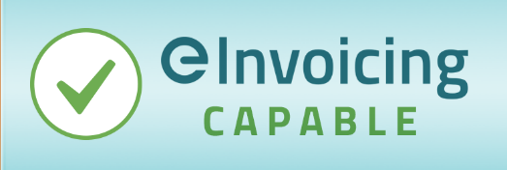
Customer uptake  Customer demand for receiving eInvoices is lower than projected | - Customer communication and engagement plan  - Focus initial efforts on SME customers that have existing easy access to eInvoicing (e.g. Xero and MYOB users)
eInvoicing network growth  Slow growth of the Peppol network in New Zealand hinders trading partner onboarding and benefits realisation | - Customer and/or supplier communication and engagement plan  - Focus initial efforts on trading partners that have existing easy access to eInvoicing (e.g. Xero and MYOB users)  - Positioning eInvoicing as an additional, future-proofed, complementary invoicing channel that will grow over time

Deloitte Access Economics (2016): The economic impact of eInvoicing.
https://ec.europa.eu/info/law/better-regulation/have-your-say/initiatives/13186-VAT-in-the-digital-age_en and https://taxation-customs.ec.europa.eu/taxation-1/value-added-tax-vat/vat-digital-age_en
It is intended that an eInvoicing mandate for State Sector agencies will be given effect through a series of proposed changes to the Government Procurement Rules. The next consultation on revision to the rules is scheduled for early 2024, which is when the first set of guidance and requirements around eInvoicing will be proposed.
ATO eInvoicing Fireside Chat with Bunnings and Our journey with eInvoicing (Credit Management in Australia, July 2023)
Deloitte Access Economics (2016): The economic impact of eInvoicing. The report used a 60% adoption rate over 5 years for businesses that currently use internet or desktop accounting solutions to estimate the expected benefit for New Zealand. Other research offers different savings calculations. For example, IBM Sterling Commerce White Paper (2010): The Business Value of e-Invoicing finds a 44% reduction in AR costs (sending eInvoices) and a 90% cost reduction in AP costs (receiving eInvoices). The total cost refers to the total average lifecycle processing cost of a single invoice, split between the sender and receiver.
https://www.pagero.com/customer-cases/ricoh/
Woolworths Group steps up for small business
Hammondcare Peppol eInvoice Implementation Case Study - Case Studies | Valtatech
ROI for improving business digitisation as much as 3:1 - MYOB Pulse
ATO eInvoicing Fireside Chat with BOC
MBIE proves value of eInvoicing by paying their suppliers faster | eInvoicing
Behind Westpac's latest step | eInvoicing
The first set of guidance and requirements around eInvoicing will be proposed in the next consultation on revision to the Government Procurement Rules, scheduled for early 2024).
Deloitte Access Economics (2016): The economic impact of eInvoicing. The report used a 60% adoption rate over 5 years for businesses that currently use internet or desktop accounting solutions to estimate the expected benefit for New Zealand.
Indicative failed invoice rates (invoices sent by suppliers but not received into your system) can be higher than you might think at around ~ 5%. Indicative comparison rates for eInvoicing so far show a significant improvement at around ~ 0.075%. This varies by organisation, industry and process maturity/system.

