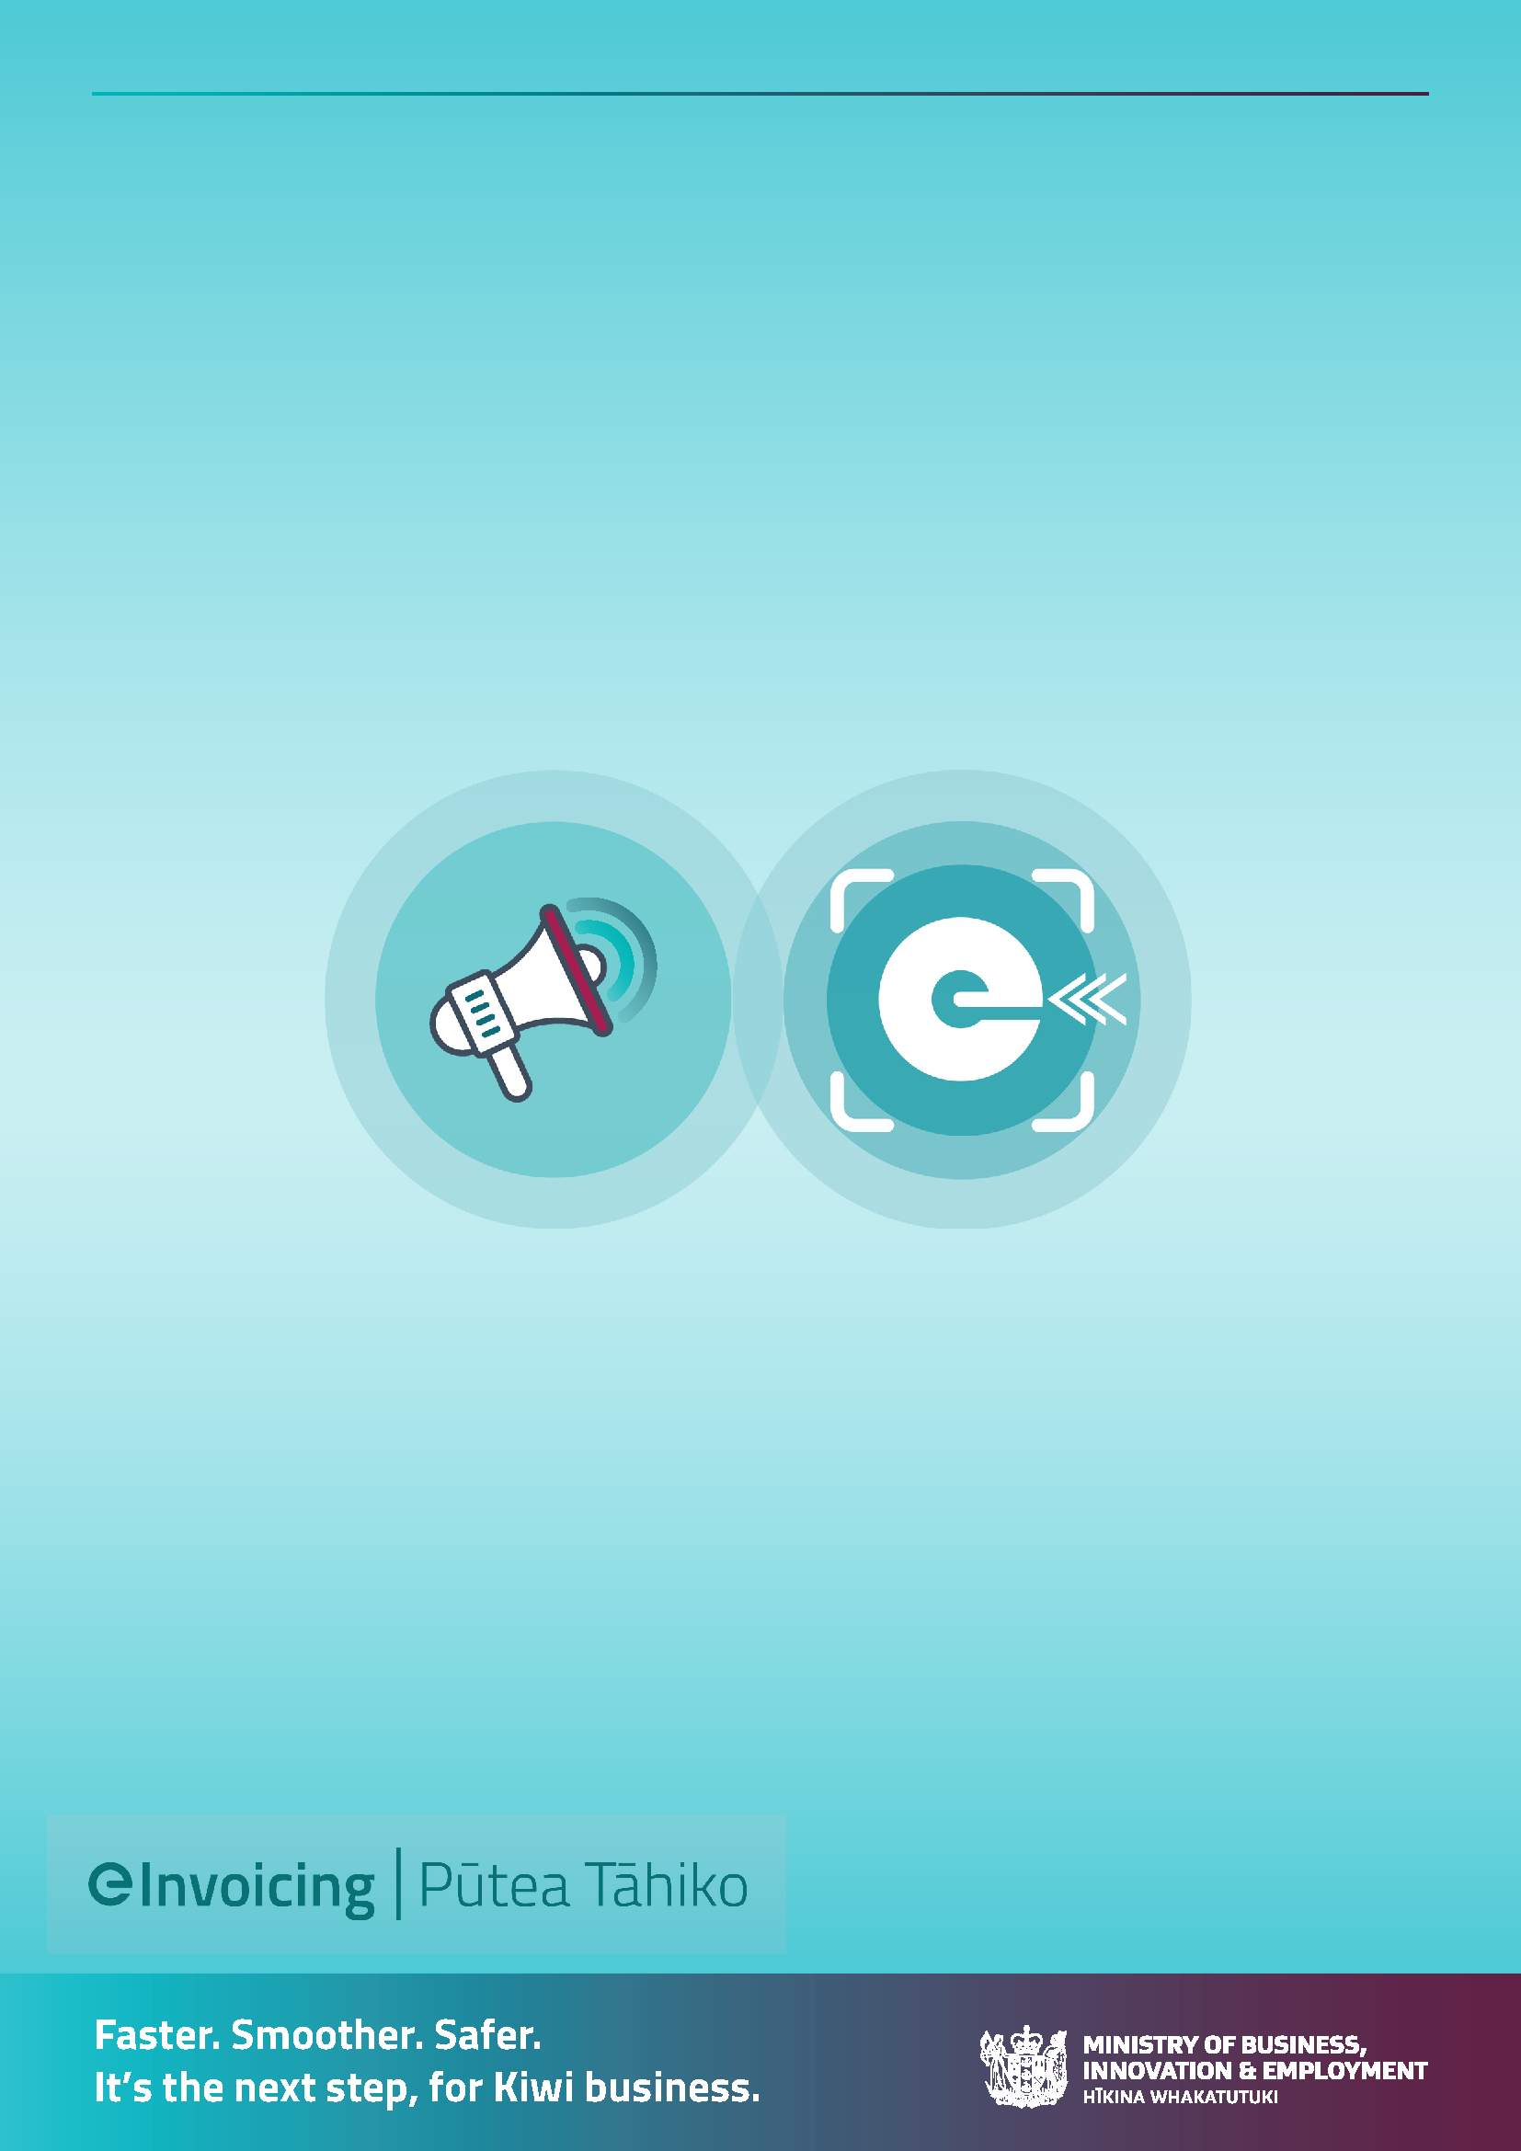
eInvoicing Communications Toolkit for invoice senders
Getting your business customers ready for eInvoicing
Table of Contents
How to use this toolkit 3
The Problem to solve 3
Business objectives 3
Preparing to send eInvoices 4
Lock in the customer experience 4
Determine your communication approach 4
Communication prior to eInvoicing being in place 4
Communication only when eInvoicing is available 4
Ongoing reminders as businesses gradually acquire eInvoicing capability 5
Choose which customers to target 5
Select business customers ready to receive eInvoices 6
Regular customers, high value or loyal customers, Xero and MYOB users 6
Choose or adapt your communications 6
1. Targeted letter/email to eInvoicing ready customers – opt out 7
2. Targeted letter/email to eInvoicing ready customers – opt in 8
3. Email to all customers 9
4. Messages on bill 10
5. eInvoicing factsheet (link to PDF)

How to use this toolkit
This communication toolkit aims to support large businesses to transition from sending paper (post) and/or PDF (via email) invoices to their business customers, to sending eInvoices instead. It presumes your business has, or plans to have, eInvoicing send capability.
There are benefits to both you and your business customers for sending and receiving eInvoices. You’ll get paid faster and your customers will appreciate you reducing their admin burden and making it easier for them to do business with you, improving your trading relationships.
Find out more on the eInvoicing website.
This toolkit includes communication material you can adapt and use, including transition approaches, customer segmentation options, and sample communication material.
The problem to solve:
Large businesses would like to send eInvoices to their customers instead of paper or PDFs via email. It’s another channel for sending invoices.
However, given eInvoicing is relatively new in New Zealand, businesses (senders of invoices) don’t know which of their buyers would like to – and can – receive eInvoices. Additionally, many of their business customers may be unaware of what eInvoicing is and the benefits for them, don’t have eInvoicing capability in their software, or need to register to receive eInvoices before their supplier (you) can send them.
Furthermore, your business customers, who do want to receive eInvoices, need to have some way to let your organisation know they prefer to receive eInvoices and provide you with their NZBN.
Business objectives:
Your business customers choose to receive eInvoices instead of a PDF (via email) or a paper invoice in the post. (You could set a target for a set period of time – eg 10% of customers receive eInvoices within in 6 months; 20% within 1 year and so on.)

Preparing to send eInvoices
eInvoicing is another channel alongside paper and PDFs. There are a few things to prepare for when it comes to getting ready to send eInvoices to business customers:
- Lock in the customer experience
- Determine your communication approach
- Select which customers you want to offer the eInvoice channel to receive their bills from you.
- Choose and adapt email or letter templates for your situation
- Implement your plan

Lock in the customer experience
To be able to receive eInvoices:
- Your business customer:
- Must have accounting or invoice software that can receive eInvoices.
- Will likely need to do one-off set up tasks, eg: register to receive eInvoices via their accounting or invoicing software package; and provide their NZBN and preference to receive eInvoices to you (if you don’t have this).

- You need to have a way for your customers to let you know that they would like to receive eInvoices instead of PDFs; and to provide or confirm their NZBN to you. Consider self-serve options such as some or all of the following:
- An online portal provided by you – does this need to be built before asking your customers to accept/receive eInvoices? Does your customer need a login?
- An online form (no login required)
- Dedicated phone line or email address your customers can call or email.

Determine your communication approach
Regardless of which approach your organisation takes, you will need to have the mechanisms in place for your customers to let you know their preference and capture their NZBN.
For the suggested approaches below, either your organisation communicates directly with your customers, or your billing provider could facilitate the communication to the business’ customers on your behalf. (The communication would still be ‘from’ your organisation.)
- Communicate prior to eInvoicing being in place
Give business customers a heads up that your business is intending to offer an alternative way – ie eInvoicing - for them to receive invoices from you. This allows your business customers to understand and prepare for the change ahead of the new option being in place. Then do active transitioning of your business customers when the ‘send eInvoices’ functionality is in place in your organisation.
- Communicate eInvoice option only when it is available
Only offer to send your buyers eInvoices when you are able to send them. This allows them to act on the change (ie transition to eInvoicing) straight way if they choose.
- Ongoing reminders as businesses gradually acquire eInvoicing capability
As eInvoicing functionality continues to roll out across various accounting and invoicing software, more of your business customers will be able to choose eInvoices over PDFs. Like any technology transition, customers will need to be reminded to adopt it.
Select which customers you want to target
Do you want to offer eInvoicing to all your business customers at once, or start with a small group to fine-tune the customer experience and internal processes? If you prefer to do the latter here are some options to consider.
Select business customers ready to receive eInvoices
Some of your customers may already be registered to receive eInvoices and therefore all set to receive eInvoices from your organisation. They could be a quick win as they’ll already understand eInvoicing and be ready to receive eInvoices.
MBIE publishes a list of businesses registered to receive eInvoices (with their NZBN) on the eInvoicing website, which you can match to your own customer records. This list is updated monthly.
New Zealand businesses registered to receive eInvoices [XLSX, 1.2 MB]
You can then either:
- Advise them you’ll automatically send them eInvoices from a future date unless they opt out by a specified date (before the first eInvoice is due to go out); or
- Ask them to opt into receiving eInvoices by a specified date or a specific date of the month.

The first option will need backend processes to upload and set the relevant customers’ preferences to ‘eInvoices’, as well as developing and implementing mechanisms for your customers to opt in or out of receiving eInvoices. You will also need to provide a way for your customers to confirm or provide their NZBN. Note, you can use the free and secure government NZBN Business Match service to quickly obtain the NZBNs of all your customers.
Regular customers, high value or loyal customers, Xero and MYOB users.
Most small businesses already have easy, affordable access to eInvoicing capability. Many business and accounting software products are already eInvoicing capable (eg Xero and MYOB) with many more progressively adding the functionality throughout 2023.
When considering pilot customer groups, you may want to choose customers who:
- You can trust to provide objective feedback
- Are more digitally inclined and therefore are likely to be receptive to eInvoicing.

Choose or adapt your communications
The following communication templates are provided on the following pages. Adapt for your circumstances or use as they are.
- Targeted letter/email to eInvoicing ready customers (ie registered on Peppol directory) - opt out option
- Targeted letter/email to eInvoicing ready customers (ie registered on Peppol directory) - opt in option
- Email to all customers advising of new available channel to receive invoices from your business. Option to add in content for Xero and MYOB users if you’ve been able to identify them
- Messages on the bills – paper or PDF: Ongoing encouragement to switch to eInvoices
- eInvoicing factsheet (PDF): a separate attachment or item to accompany 1, 2, 3 or above or with ongoing PDF or paper invoices

- Targeted letter/email to eInvoicing ready customers (ie registered on Peppol directory) - opt out option

Tēnā koe
eInvoices - a new way to receive your <name of organisation> bills
We understand your business is registered to receive eInvoices. From <date> onwards we’ll be sending your <name of organisation> bills as eInvoices, unless you tell us otherwise by <deadline date>.
So instead of receiving a PDF of the bill into your inbox, we’ll send you an eInvoice (including a PDF) that goes straight into your accounting system where all the necessary fields will be automatically populated. You will be able to verify them by reviewing the viewable PDF that we’ve sent as well.
Receiving eInvoices means they doesn’t go astray, and full and complete information goes straight into your system. This means time-savings and reduced manual data entry, it’s easier to code and your accountant will love you.
Let us know if you DON’T want to receive eInvoices
If you don’t want to receive eInvoices from us, please let us know by <deadline date> by <insert method for confirming preference>
This is the NZ Business Number (NZBN) we have for your business: <insert customer’s NZBN here>. This is the unique identifier that ensures our invoices reach you. Please let us know if this is not your NZBN.
Otherwise, we’ll send you eInvoices from <date> onwards.
Ngā mihi
<name, title>

- Targeted letter/email to eInvoicing ready customers (ie registered on Peppol directory) - opt in option
Tēnā koe
eInvoices - a new way to receive your <name of organisation> bills
From <date> we’re offering another way for you to receive your <name of organisation> bills from us.
Instead of receiving a PDF of the bill into your inbox, we’ll send you an eInvoice (including a PDF) that goes straight into your accounting system where all the necessary fields will be automatically populated. You will be able to verify them by reviewing the viewable PDF that we’ve sent as well.
We understand your business is already registered to receive eInvoices, so we can start sending eInvoices as soon as you want.
Receiving eInvoices means they don’t go astray, and full and complete information goes straight into your system. This means time-savings and reduced manual data entry, it’s easier to code and your accountant will love you.
Choose to receive eInvoices today
It’s easy to let us know you prefer to receive eInvoices instead of PDFs. Simply <insert way to choose eInvoices>
At the same time, please confirm we have the correct NZ Business Number for your business. This is the unique identifier that ensures our invoices reach you.

Ngā mihi
<name, title>

- Email to all customers advising of new available channel to receive invoices from your business.
Tēnā koe
eInvoices - a new way to receive your <name of organisation> bill
From <date> we’re offering another way for you to receive your <name of organisation> invoices from us.
Instead of receiving a PDF of the bill into your inbox, we’ll send you an eInvoice (including a PDF) that goes straight into your accounting system where all the necessary fields will be automatically populated. You will be able to verify them by reviewing the viewable PDF that we’ve sent as well.
eInvoicing is growing in NZ with thousands of businesses registered to receive eInvoices and growing every month.
eInvoicing is the digital exchange of invoice information directly between buyers’ and suppliers’ financial systems, even if these systems are different.
Receiving eInvoices means they don’t go astray, and full and complete information goes straight into your system. This means time-savings and reduced manual data entry, it’s easier to code and your accountant will love you.
Check the enclosed flyer to find out more, including how to get started.
Get ready in 2 easy steps:
- Register to receive eInvoices today – follow the instructions of your accounting software.
As many small businesses uses Xero and MYOB, we’ve included links to their websites for information on how to get started.
Xero users:
Get started with eInvoicing in a few simple steps if you’re on a Xero Starter, Standard or Premium plan. Check out their website for instructions or watch their handy video.
Register to receive eInvoices
Receiving eInvoices
Sending eInvoices
MYOB users:
It’s easy to get set up with eInvoicing if you use MYOB Essentials (also called MYOB Business) or you access your AccountRight company file in a web browser.
eInvoicing - MYOB Business - MYOB Help Centre

- Confirm your NZ Business Number and select eInvoices as your preference. Simply <insert ways to do this>

Once you’re registered to receive eInvoices, you’ll be able to receive them from any supplier who can send eInvoices - not just us.
Ngā mihi
<name, title>

Messages on the bills – paper or PDF: Ongoing encouragement to switch to eInvoices.
We’re going paperless, receive your bills as an eInvoice straight into your accounting system. Go to <url> and opt in today.

