

A-NZ Peppol eInvoicing Business Guide

July 2025



**Ministry of Business, Innovation and Employment (MBIE)**

**Hīkina Whakatutuki – Lifting to make successful**

MBIE develops and delivers policy, services, advice and regulation to support economic growth and the prosperity and wellbeing of New Zealanders.

**Australian Taxation Office (ATO)**

The Australian Taxation Office is the principal revenue collection agency of the Australian Government and acts as the Peppol Authority for eInvoicing in Australia.

**More information**

Information, examples and answers to your questions about the topics covered here can be found on our websites: [**www.mbie.govt.nz**](http://www.mbie.govt.nz) and [**www.ato.gov.au**](http://www.ato.gov.au)

**Disclaimer**

This document is a guide only. It should not be used as a substitute for legislation or legal advice. The Ministry of Business, Innovation and Employment and Australian Tax Office are not responsible for the results of any actions taken on the basis of information in this document, or for any errors or omissions.

February 2025

**@Crown Copyright**

The material contained in this report is subject to Crown copyright protection unless otherwise indicated. The Crown copyright protected material may be reproduced free of charge or media without requiring specific permission. This is subject to the material being reproduced accurately and not being used in a derogatory manner or in a misleading context. Where the material is being published or issued to others, the source and copyright status should be acknowledged. The permission to reproduce Crown copyright protected material does not extend to any material in this report that is identified as being the copyright of a third party. Authorisation to reproduce such material should be obtained from the copyright holders.

February 2025

**Contents**

[Purpose 3](#_Toc190345353)

[Summary Checklist 3](#_Toc190345354)

[Section 1 – eInvoicing and Peppol 101 4](#_Toc190345355)

[Peppol overview 4](#_Toc190345356)

[Anatomy of a Peppol eInvoice 6](#_Toc190345357)

[Security and Data Privacy 9](#_Toc190345358)

[Section 2 – Before you implement 10](#_Toc190345359)

[Scope considerations 10](#_Toc190345360)

[Implementation options 11](#_Toc190345361)

[Connecting to the Peppol Network 12](#_Toc190345362)

[Getting ready 13](#_Toc190345363)

[Credit note handling 14](#_Toc190345364)

[Tips from early adopters 15](#_Toc190345365)

[Peppol documentation 16](#_Toc190345366)

[Section 3 – Implementing 18](#_Toc190345367)

[Invoice content and mapping 18](#_Toc190345368)

[Other implementation considerations 26](#_Toc190345369)

[Tips from early adopters 29](#_Toc190345370)

[Implementation task checklist 30](#_Toc190345371)

[Section 4 - Testing 30](#_Toc190345372)

[Testing considerations 30](#_Toc190345373)

[Testing checklist 31](#_Toc190345374)

[Appendix 1 – Troubleshooting 32](#_Toc190345375)

[Appendix 2 – Known issues and constraints 33](#_Toc190345376)

[Appendix 3 – BIS and PINT 34](#_Toc190345377)

# Purpose

This document provides information and guidance material to assist with the technical side of an eInvoicing implementation project for businesses and government agencies.

#### Intended Audience

|  |  |
| --- | --- |
| **Sections** | **Audience** |
| Section 1 – eInvoicing and Peppol 101 | CFOs, CIOs and other C-suite executives  AP/AR team members and managers, project managers, IT staff |
| Section 2 – Before you implement  Section 3 – Implementing  Section 4 – Testing  Appendix 1 – Troubleshooting  Appendix 2 – Known issues and constraints | AP/AR team members and managers, project managers, IT staff |

|  |
| --- |
| **The MBIE eInvoicing team and Australian Peppol Authority (part of the Australian Taxation Office) is here to help for implementation and customer/supplier onboarding advice**  In New Zealand, contact us at [eInvoicing@mbie.govt.nz](mailto:eInvoicing@mbie.govt.nz)  In Australia, contact us at [[eInvoicing@ato.gov.au](mailto:eInvoicing@ato.gov.au)](mailto:eInvoicing@ato.gov.au) |

# Summary Checklist

| Executive Summary – Key Tasks | Done ü | |
| --- | --- | --- |
| **Section 1 – eInvoicing and Peppol 101**  ¨ Understand eInvoicing and Peppol, and how it is different to your current ways of invoicing  ¨ Familiarise yourself with Peppol documentation and Industry Practice Statements |  |
| **Section 2 – Before you implement**  ¨ Plan your implementation:   * Project scope * Implementation pathway/s and vendor selection * Credit note handling * Other Peppol eProcurement/P2P documents   ¨ Review and update current processes for eInvoicing  ¨ Capture NZBN or ABN data (the eInvoice ‘address’) for customers and/or suppliers  ¨ Plan Crown invoices and organisational part numbers (NZ only) |  |
| **Section 3 – Implementing**  ¨ Implement your invoice content and mapping:   * Mandatory fields * Best practice fields * Attachments   ¨ Implement any invoice validation and business rules  ¨ Understand interoperability trade-offs  ¨ Configure message acknowledgements/error messages |  |
| **Section 4 – Testing**  ¨ Develop and implement your testing plan - refer to detailed testing checklist |  |

# Section 1 – eInvoicing and Peppol 101

This section introduces eInvoicing and Peppol ‘must knows’ and walks you through the documentation available.

### Peppol overview

eInvoicing is the messaging channel where invoice data is sent from a supplier’s (seller’s) financial system and received in a customer’s (buyer’s) financial system.

The New Zealand and Australian governments have committed to a joint approach to eInvoicing using the Peppol framework; a secure network with widespread use globally. Peppol has an established set of standards that enables businesses to exchange invoice and procurement documents electronically.

Invoice senders and receivers (and their financial systems) communicate via an Access Point Provider – secure gateways that connect businesses to the eInvoicing network.

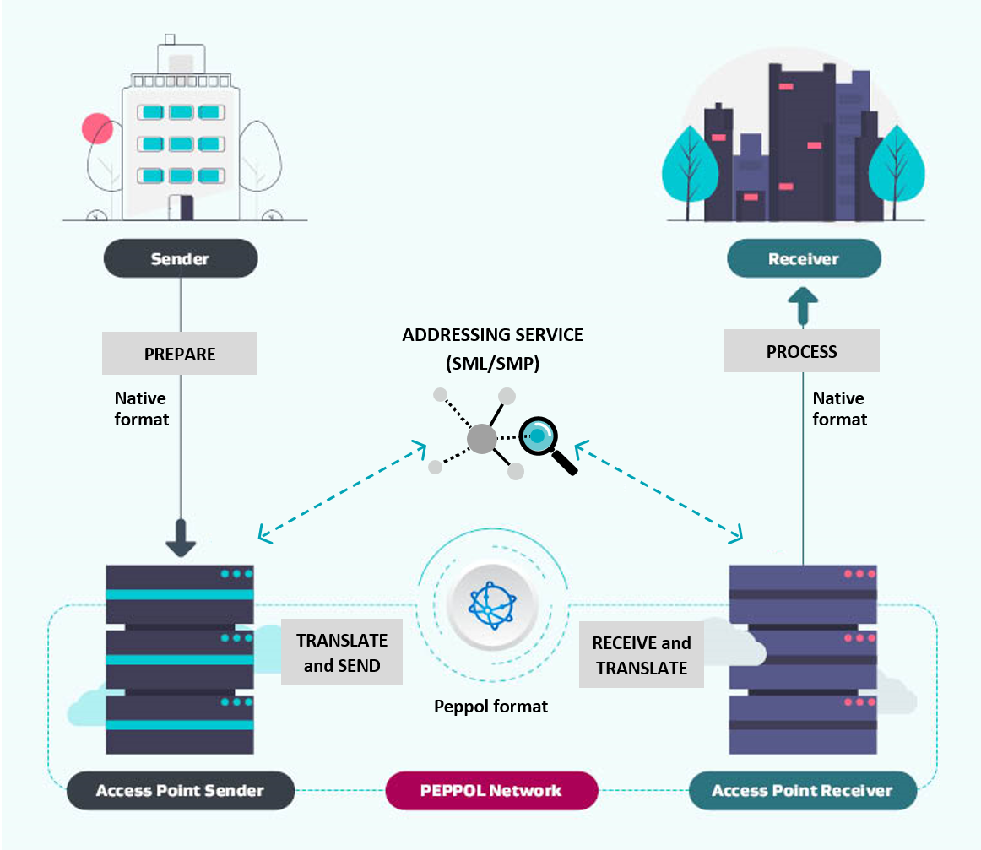

Corner 1: Sender (Supplier)

The supplier generates an invoice in their accounts receivable software, which is then sent to their Access Point Provider. The customer’s Australian Business Number (ABN) or New Zealand Business Number (NZBN) is included as the ‘address’ of the eInvoice.

Corner 2: Sender’s (Supplier’s) Access Point Provider

The supplier’s Access Point Provider performs validation checks including Peppol network checks, invoice format and validity checks, confirming the legitimacy of the invoice sender and whether the receiver can receive the eInvoice (checking the customer’s NZBN or ABN in the Peppol Addressing Service. They then send the eInvoice to the customer’s Access Point Provider via the Peppol network.

Corner 3: Receiver’s (Customer’s) Access Point Provider

The customer’s Access Point Provider receives the validated eInvoice from the supplier’s Access Point Provider and sends it electronically to the customer’s accounts payable software. They may first perform validation checks on the eInvoice using any business rules provided by the receiver.

Corner 4: Receiver (Customer)

The eInvoice is received by the customer’s accounts payable software. Further business rules can be applied and define the stage to which the eInvoice is processed in the software. Where further information is to be confirmed, the business processes for exceptions on accounts payable invoices, whether received as eInvoices, PDFs or via OCR, may be instigated. For example, there may be an exception queue that is managed by accounts payable staff.

| Roles and definitions |  |
| --- | --- |
| 1. Sender (Supplier) | The supplier of the goods/services   * Accounts receivable team * Business software used by the supplier |
| 2. Sender’s Access Point Provider | The service provider that translates and sends the supplier’s eInvoice data |
| 3. Receiver’s Access Point Provider | The service provider that receives and translates the eInvoice data for the customer |
| 4. Receiver (Customer) | The customer/buyer of the goods/services   * Accounts payable team * Business software used by the customer |

### Anatomy of a Peppol eInvoice

A Peppol eInvoice is machine readable, structured data in XML format. eInvoices are comprised of structured data which is mapped to fields in an organisation’s sending and receiving finance systems. These fields correspond to normal invoice data.

Implementing eInvoicing can be summarised by changing the way your finance system inputs/outputs invoices, from traditional PDF invoices to structured XML eInvoices.

The XML view provides a technical view of the same eInvoice as XML (the data format used for eInvoicing). Most software systems also provide a ‘natural view’ of an eInvoice for easy readability – usually either a rendered invoice mock-up of the XML eInvoice or a rendered PDF invoice. Refer to the Technical Self-service resource on the New Zealand eInvoicing website for an interactive comparison.

**PDF invoice**

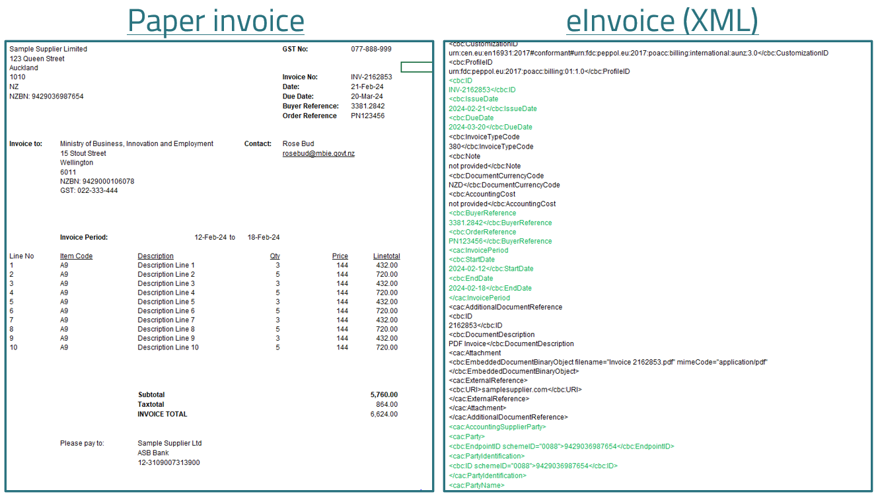

**Peppol eInvoice (XML)**

Note that the whole invoice is not shown here.

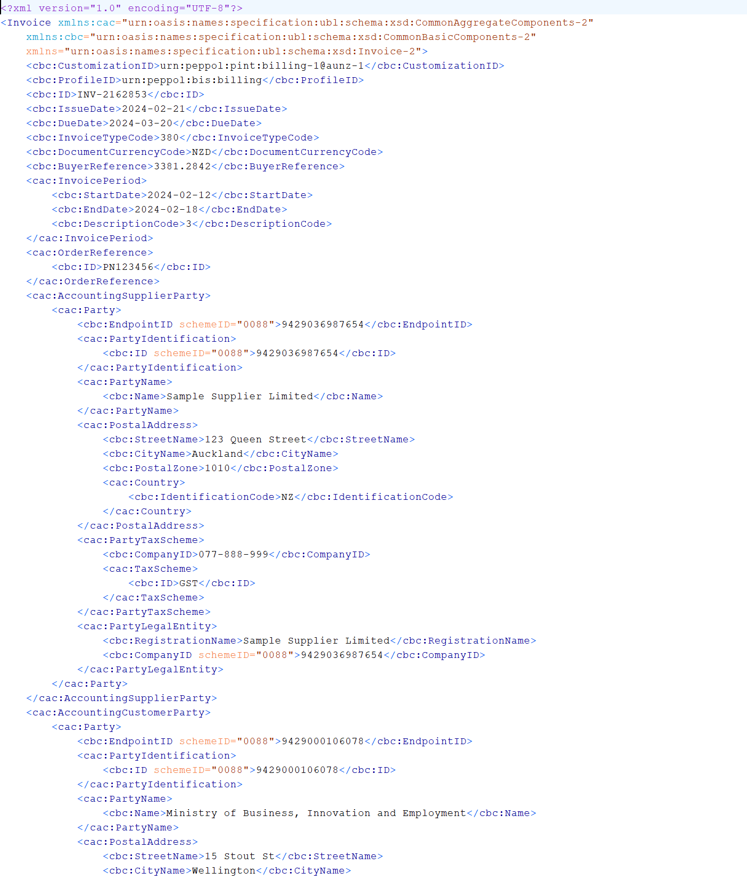

### Security and Data Privacy

#### Network and Service Provider Security

A key benefit of eInvoicing is the secure transmission, receipt and validation of data. eInvoices are impossible to lose, minimise the risk of fake or compromised invoices, and reduce the chance of paper or PDF invoices being intercepted.

eInvoices are sent and received directly from the customer’s and supplier’s software systems in a similar way to how they are now – just more efficiently and securely. eInvoicing automates the data coming into your financial system, so you’ll still need to perform your standard checks and business processes for confirming, approving and paying legitimate invoices like you do now for emailed and posted invoices.

The Australian and New Zealand Peppol Authorities accredit Access Points and assess requirements such as encryption, separation of duties, security monitoring practices and multifactor authentication of the service providers in the network. Service providers also ensure security of the Peppol network by:

* Using secure AS4 for transmission of asynchronous messages between Access Points
* Using Public key infrastructure that establishes a trusted network
* Complying with ISO27001 or ASD/NZISM best practice security certifications
* Vetting customers using Know Your Customer (KYC) compliance requirements.

OpenPeppol, the organisation overseeing the entire network, has an international security committee that is responsible for ensuring the security standards used in the network keep pace with international best practices.

#### Data Privacy

Invoice data (including metadata) is not held by Access Point providers - data is only passed through the Peppol network. Customer data (e.g. for Know Your Customer purposes) may be held by an Access Point provider, but this must be specified in a contract.

Service Providers ensure data security by ensuring data is encrypted in transit, meaning when the invoice messages are sent over the network, they are not able to be read. If data is held by your service provider it will be encrypted at rest, so it cannot be read either and is secure.

This ensures:

* That unlike email, interception is impossible, making eInvoicing a safer method
* Manipulation of invoices is minimised

Third parties will not have visibility of eInvoices sent/received via the Peppol network.

OpenPeppol does collect information on transactional statistics from Access Point providers, but this does not include invoice data itself and is anonymous.

# Section 2 – Before you implement

This section introduces key scope considerations for an eInvoicing project.

### Scope considerations

#### eInvoicing send vs receive capability

Many large organisations choose to separate sending and receiving eInvoices into separate implementation projects, though they can choose to implement simultaneously. Separate implementation projects can be useful if the systems the organisation uses for sending and receiving invoices are different. The organisation would typically choose to implement the capability giving the most benefit first – usually based on volumes of invoices.

eInvoicing is an additional channel that an organisation can add to their existing invoicing system/s. The diagrams below show how eInvoices can exist alongside current invoice processing systems.

Sending invoices

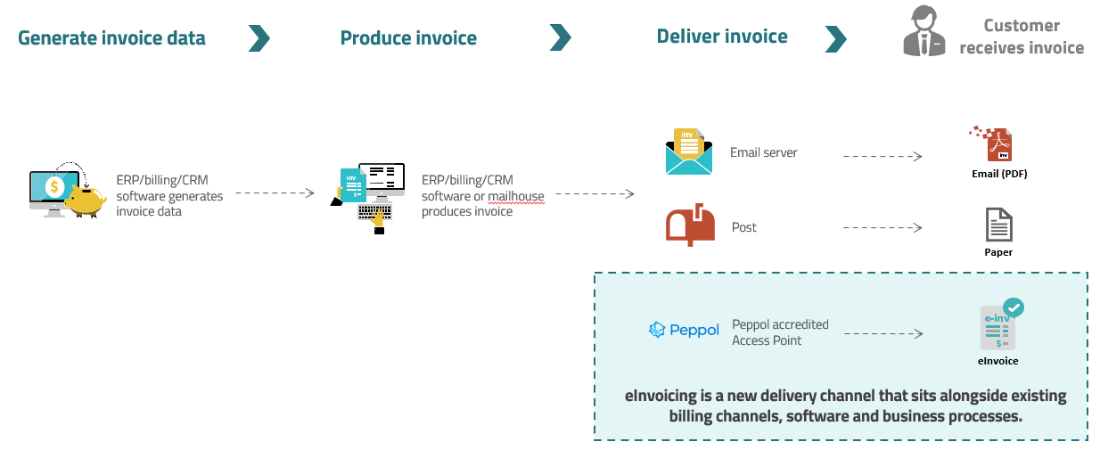

Receiving invoices

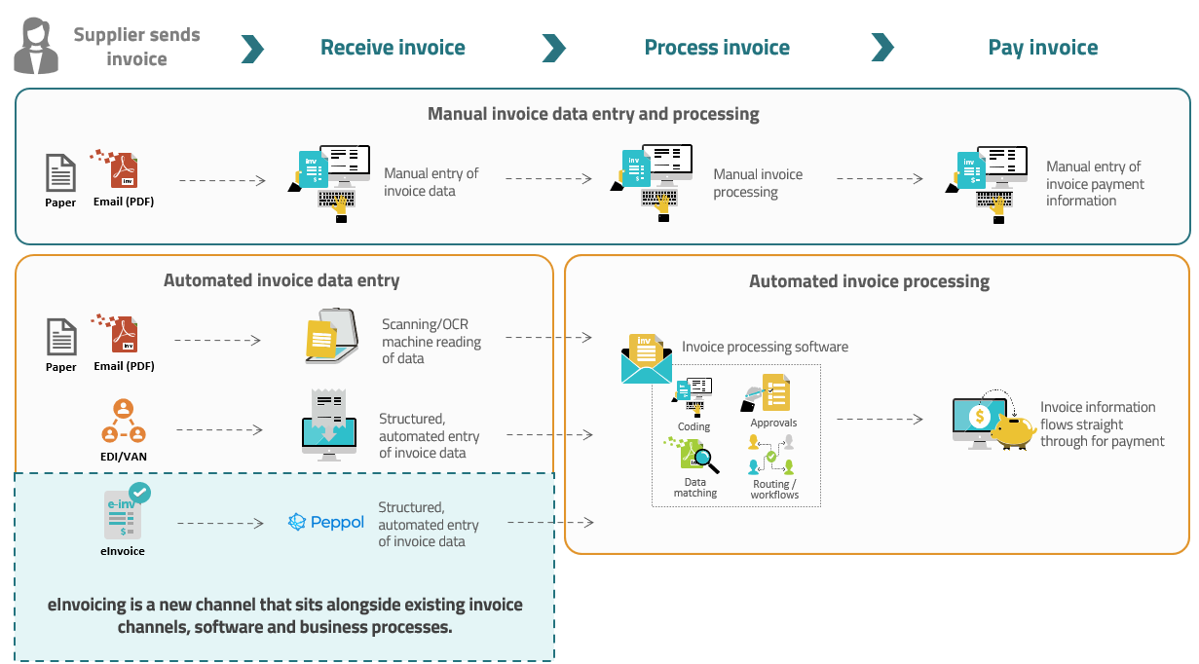

### Implementation options

eInvoicing can be implemented using a range of different software/systems and is most effective when implemented using natural business software and integrates with existing systems and processes. There is no single recommended pathway for implementing eInvoicing. Think about eInvoicing simply as an additional channel that sits alongside existing invoice channels (e.g. email, post, EDI), within the system/s you currently use to send/receive invoices.

This may mean that the same software is used for all forms of eInvoicing (send/receive), or that eInvoicing is implemented using different systems that are already in place within the organisation (i.e. to send and receive eInvoices).

Every business is unique. Not everything here will apply to you or there may be other things you need to consider.

This guidance assumes that your business has experience or access to project and change management capabilities, and you'll get advice on these aspects of your [eInvoicing](https://www.ato.gov.au/businesses-and-organisations/einvoicing/what-is-einvoicing) project through these channels.

When developing your business case, consider the costs and benefits of each implementation option. Consider your business’s current invoice management practices to determine how [Peppol](https://www.ato.gov.au/businesses-and-organisations/einvoicing/peppol) eInvoicing may benefit your organisation.

#### Prioritise current state

Identify and prioritise your eInvoicing implementation scope, such as:

* focus on sending eInvoices or receiving eInvoices, or both
* consider whether your trading partners use additional documents, for example purchase orders.

Knowing these details will help you adopt eInvoicing and prioritise effort and expenditure against other business priorities.

Consider the following:

* How many invoices do you send and receive, and how often?
* How do you send and receive invoices (through what channels and in what formats)?
* What is the effort to onboard suppliers and customers currently?
* What information do you and your suppliers and buyers need on an invoice?
* Do you use purchase orders (PO)? Do you provide the PO number to your suppliers?
* How do you process invoices? Do you use 2 or 3-way cross-referencing of your purchase orders, goods receipt notes and supplier invoices, exception handling, workflows and approvals?
* What approval mechanisms, systems, tools or applications do you use?
* How do you pay invoices (what enterprise resource planning (ERP) and financial management information systems do you use)?
* Who are your top suppliers and buyers based on invoice volume?
* What are your customer and supplier expectations for transacting digitally through the [Peppol network](https://www.ato.gov.au/businesses-and-organisations/einvoicing/peppol#ThePeppolnetwork)?

To help assess your current operations and determine the eInvoicing value case for your business, complete the ATO’s [eInvoicing value assessment questionnaire](https://www.ato.gov.au/businesses-and-organisations/einvoicing/einvoicing-for-businesses/getting-started-with-einvoicing-for-medium-and-large-businesses/einvoicing-value-assessment-questionnaire).

To get an overview, read the [costs and benefits for business case development](https://www.ato.gov.au/businesses-and-organisations/einvoicing/einvoicing-for-businesses/getting-started-with-einvoicing-for-medium-and-large-businesses/costs-and-benefits-for-business-case-development) associated with Peppol eInvoicing on the ATO website.

#### Benefits assessment

Use the information from your current state assessment to consider how eInvoicing may help you address any gaps or pain points.

eInvoicing may help:

* achieve further efficiencies by transitioning all suppliers to a digital channel
* consolidate your less-efficient electronic channels by shifting to Peppol
* reduce onboarding effort and cost, and residual manual intervention. For example, transition webforms to Peppol
* enable your SME trading partners to exchange invoice data directly from their software and help them reduce admin costs
* remove friction points and improve your relationships with suppliers and customers.

### Connecting to the Peppol Network

There are two options to connect to the Peppol network:

* **Option 1:** Use eInvoicing capable software (which has a connection to the Peppol network built in)
* **Option 2:** Connect with an eInvoicing Access Point Provider.

#### Option 1 – Use eInvoicing capable software

eInvoicing works best using the organisation’s natural business software.

Many invoicing software products support eInvoicing:

* Check the lists of eInvoicing capable software products on the Australia and New Zealand Peppol Authority websites. If the software you use to send/receive invoices is on these lists, contact your account manager for details about how to enable eInvoicing.
* If the software you use isn’t on these lists, it’s still possible that there is eInvoicing functionality, so it’s worth checking with your software provider.

Implementation instructions vary by software, so check with your provider for details.

|  |
| --- |
| **Resource**  * List of [eInvoicing capable software products](https://www.einvoicing.govt.nz/software/software-products) in New Zealand * List of eInvoicing capable [software products](https://softwaredevelopers.ato.gov.au/eInvoicing-Ready-product-register) in Australia |

#### Option 2 – Integrate with an eInvoicing Access Point provider

Access Point providers are secure gateways that connect businesses and software to the eInvoicing network. You need an access point provider to connect you to the Peppol eInvoicing network if:

* Your software (or its current version) is not yet eInvoicing capable, or
* Your software is eInvoicing capable but requires you to set up a separate access point connection (most eInvoicing capable software providers have an in-built access point connection to the eInvoicing network. However, some ERPs require you to also set up your own Peppol access point connection).

Refer to the diagram and role of an Access Point provider in Section 1.

Choosing an Access Point

Access Point providers offer a wealth of eInvoicing expertise and many offer additional value-add services. If you’re working with an Access Point, their contribution will be significant in covering the implementation steps required by both parties to ensure the end-to-end process is fit for purpose.

Below are some things to consider for when engaging a provider:

* Strategic fit, capability and experience​
* Technical considerations: do you require data mapping/translation services? Are you planning to send or receive additional document types such as invoice response or purchase order?​
* Pricing model: this may be based on the number of customers, the number of invoices sent/received, or the amount of data consumed​
* International capabilities (if you require commercial and technical capabilities outside of New Zealand/Australia)​
* Additional value-add services required e.g. customer or supplier onboarding assistance, data translation, validation, message level response

Some organisations may choose to connect to an Access Point provider directly for strategic reasons, e.g. system complexity, wider project scope/value-added services such as additional accounts payable processing functionality or supplier onboarding services offered by some Access Point providers.

|  |
| --- |
| **Resources**  * List of [eInvoicing accredited Access Point providers](https://www.einvoicing.govt.nz/software/einvoicing-access-point-providers) in New Zealand * List of [[ATO accredited Access Point providers](https://softwaredevelopers.ato.gov.au/accreditation-Peppol-service-provider-register)](https://softwaredevelopers.ato.gov.au/accreditation-Peppol-service-provider-register) in Australia * New Zealand Government agencies can use the [open syndicated procurement panel](https://www.procurement.govt.nz/about-us/news/open-syndicated-panel-available-to-facilitate-adoption-of-einvoicing/) for eInvoicing Access Point providers. |

### Getting ready

#### Review current processes

Consider what wider business processes will change as a result of eInvoicing, or to maximise the benefits from eInvoicing.These typically include:

* Ensure that you can send the required eInvoice fields your key customers may require to support the streamlined processing of invoices. Further benefit can be obtained by facilitating workshops with these external stakeholders.
* Improvements to internal practices for purchase orders, goods receipting, centralising invoice receipt or approvals
* Consider exploring opportunities to balance cashflow with rapid supplier payment. Transitioning to eInvoicing provides an opportunity to re-position as a preferred customer through early payment of low risk eInvoices. Furthermore, frequent payment runs for all eInvoices that are simply in the system and ready to pay at a point in time (as opposed to cherry picking a selection) can provide efficiencies in reducing processing times.
* Determine any new business rules required to support eInvoice processing.

Refer to eInvoicing change management guide on the eInvoicing website for more information.

#### Unique Identifiers in Peppol

#### New Zealand Business Numbers

In New Zealand, the New Zealand Business Number (NZBN) is used as the unique identifier to ensure that eInvoices are sent to and received by the right trading partners. Accordingly, this key identifier for your customers or suppliers must be stored in your accounting system.

If you’re planning to **send eInvoices** to customers, you’ll need to know their NZBN and include this on the eInvoice:

* This means your team will need to review your existing customer records, and collect any customer NZBNs you don’t already record in your system
* You can ask your customers for their NZBN directly or gather their NZBN via
  + the search function on the [NZBN website](https://www.nzbn.govt.nz/)
  + the NZBN [data match service](https://www.nzbn.govt.nz/using-the-nzbn/nzbn-services/business-match/)
  + the NZBN [API service](https://www.nzbn.govt.nz/using-the-nzbn/nzbn-services/api/) – an integration between your business systems and NZBN data (available for businesses with high volumes of customer records).

If you’re planning to **receive eInvoices** from suppliers, you’ll need to let them know your NZBN, so they can include this on their eInvoice to you.

#### Crown invoices and organisational part numbers in New Zealand

* If your agency receives supplier invoices for the Crown, then these will usually be sent to an organisational part number (OPN) that is registered on the NZBN directory to your government agency specifically for Crown suppliers.
* Review whether existing customer or supplier OPNs are already stored or will need to be stored/managed in your FMIS.
* Generally, your FMIS and/or access point will need to be configured to direct an OPN to the correct recipient.

#### Australian Business Numbers

The Australian Business Number (ABN) is used to send invoices to Australian buyers or recipients on the Peppol network. A supplier will need to know their customer’s ABNs and can use the following services to obtain them:

* [ABN Lookup](https://abr.business.gov.au/) website
* The [ABN Lookup API](https://abr.business.gov.au/Tools/WebServices) can be used in your software as well, check with your Digital Service Provider (DSP) to see if you can use this directly from your software

### Credit note handling

Consider how credit note functionality will be implemented. There are two separate syntaxes: one for invoices and one for credit notes. Both can be accessed from the [Peppol BIS Billing 3.0](https://docs.peppol.eu/poacc/billing/3.0/) homepage.

When considering the options listed below, it is important to note that:

* The adoption of Credit Notes and Negative Invoices is understandably slower than standard Peppol Invoice capabilities. While many businesses are able to receive these documents, some software solutions may not be capable yet.
* It is recommended that your trading partner’s capabilities are checked (at the time of sending) which documents can be received by the customer. If you have a requirement to send credit notes or negative invoices, it is recommended that you confirm how your preferred software handles these scenarios.

The following sub-sections describe these two scenarios in further detail:

Option 1: Send using credit note document type

Peppol credit notes are handled as a separate document type within the A-NZ specification:

* To exchange Peppol credit notes, both the sender and receiver need to support the credit note document type. Some eInvoicing software products (including common SME accounting products) are unable to support (send or ingest) credit notes. Check with your provider as to whether the solution you’re planning on using will support credit notes.
* You must register to receive Peppol credit notes (in the same way that you register to receive eInvoices).
* The credit note syntax can be found [here](https://docs.peppol.eu/poacc/billing/3.0/syntax/ubl-creditnote/tree/)
* We recommend you also support negative invoices, as outlined in Option 2 below.

Option 2: Send as negative invoices

The Peppol specification allows the use of the Peppol invoice syntax for sending of invoices with positive or negative (credit note) values. This removes the need for the sender to check first that the receiver can support the credit note document type and allows all invoices, positive or negative, to be received.

* Using the invoice syntax involves subtle changes where the quantities are required to be negative, but the values remain positive.
* The document type used for a negative invoice is the same as for a usual invoice.

For specific advice on the use of credit notes, contact the Australian Peppol Authority at [eInvoicing@ato.gov.au](mailto:eInvoicing@ato.gov.au) or the NZ Peppol Authority at [supportnz@peppol.govt.nz](mailto:supportnz@peppol.govt.nz)

#### Other Peppol eProcurement/Procure to Pay (P2P) Documents

Peppol has an existing range of procurement documents to support Ordering, Despatch Advice, Catalogue, and Punch Out. These may augment your eInvoicing implementation or assist you in your P2P journey. Further information can be found [here](https://peppol.org/documentation/technical-documentation/post-award-documentation/).

We encourage access point providers to work with their customers to build solutions that meet customers’ business needs, utilising the flexibly of the Peppol Interoperability Framework and the wide range of business document types it supports.​

When considering whether to implement additional Peppol document types, it is important to note that the use of these will be limited to the capabilities of your customers.

### Tips from early adopters

¨ Familiarise yourself with the resources and Industry Practice Statements available on [GitHub](https://github.com/A-NZ-PEPPOL/A-NZ-Industry-Practice-Statements).

¨ Find an internal champion for your eInvoicing implementation.

¨ Keep your initial implementation simple. Once fully operational, eInvoicing should be easier for your trading partners (and for your organisation!) than current invoicing channels/practices.

¨ Ensure your business processes are fit for purpose for your move to eInvoicing and a digital-first environment.

¨ Connect with other organisations that are implementing or have already implemented eInvoicing. Look to other organisations using the same software provider/Access Point provider, and to others within your industry and trading partner networks.

### Peppol documentation

Review Peppol documentation and industry practice statements before you start your implementation project.

#### Global Peppol BIS billing specifications​

The Peppol Business Interoperability Specification 3.0 (BIS) provides a set of specifications (syntax, rules, and code lists) for implementing a Peppol business process. The BIS 3.0 determines the structure and format of Peppol documents. ​

|  |
| --- |
| Refer to the official Peppol documentation at [Documentation - OpenPeppol](https://peppol.org/documentation/) |

#### PINT – The Australia and New Zealand Peppol standard

The New Zealand and Australian Peppol community are the first to transition to Peppol PINT. PINT is an international invoice specification based on BIS 3.0 but built to increase global interoperability.

If your organisation has previously used the BIS specification for sending or receiving, your service provider will handle the transition to PINT A-NZ. More detail on the transition can be found in Appendix 3.

|  |
| --- |
| Resource - Github  The joint [A-NZ Peppol Github repository](https://github.com/A-NZ-PEPPOL/A-NZ-PEPPOL-BIS-3.0) contains:   * The A-NZ extension to the Peppol specification. * Guidance documents called ‘industry practice statements’ (see below) * A range of artefacts relating to the A-NZ extension to the Peppol specification, including [Peppol UBL sample message examples](https://github.com/A-NZ-PEPPOL/A-NZ-PEPPOL-BIS-3.0/tree/master/Message%20examples) (XML payloads). |

#### Industry practice statements

[**A-NZ industry practice statements**](https://github.com/A-NZ-PEPPOL/A-NZ-Industry-Practice-Statements) contain guidance, recommendations, business considerations and use cases to support Peppol implementation and interoperability in New Zealand and Australia. ​

There are five industry practice statements to review:​

| Industry Practice Statement | Scope |
| --- | --- |
| 1. [Invoice Content Industry Practice Statement](https://github.com/A-NZ-PEPPOL/A-NZ-Industry-Practice-Statements/blob/main/Invoice_content_A-NZ_Industry_Practice_Statement.docx) | Guidance on additional invoice content fields to include in eInvoices you send and receive, to maximise interoperability. |
| 2. [Consistent data mapping industry practice statement](https://github.com/A-NZ-PEPPOL/A-NZ-Industry-Practice-Statements/blob/main/A-NZ%20ASWG_Consistent%20Data%20Mapping%201.0.docx)​ | Guidance on invoice data mapping to assist with consistent interpretation and implementation of the A-NZ invoice specification and avoid processing issues (delays or rejections).​ |
| 3. [Communicating invoice status industry practice statement](https://github.com/A-NZ-PEPPOL/A-NZ-Industry-Practice-Statements/blob/main/A-NZ%20Industry%20Practice%20Statement_Communicating%20Invoice%20Status_v1.0.docx)​ | Guidance for communicating invoice status via the Peppol network, including business scenarios and UBL examples.​ |
| 4. [Attachments industry practice statement](https://github.com/A-NZ-PEPPOL/A-NZ-Industry-Practice-Statements/blob/main/A-NZ%20Industry%20Practice%20Statement_Understanding%20and%20managing%20attachments%20in%20eInvoices%20and%20eCredit%20Notes_v1.docx)​ | Guidance on attachments supported by Peppol, how attachments can support different use cases, and the varying capabilities of solutions to support attachments.​ |
| 5. [Billing use cases industry practice statement](https://github.com/A-NZ-PEPPOL/A-NZ-Industry-Practice-Statements/blob/main/A-NZ%20Industry%20Practice%20Statement_specific%20billing%20use%20cases_V1.0.docx)​ | Essential reading for any sender​. Guidance, implementation options and use cases for billing scenarios. This includes billing to a third party, opening balances, conditional discounts, consolidated invoices, adjusting a previous bill, and payment arrangements. |

# Section 3 – Implementing

This section introduces the key technical elements to include in an eInvoicing implementation project.

### Invoice content and mapping

A key part of implementing eInvoicing is to ensure all necessary information currently included on your customer or supplier invoices is available on an eInvoice.

Most implementation ‘teething issues’ stem from:

* Mismatching/incorrect mapping of invoice data fields
* Receiving organisations stipulating highly customised/unrealistic requirements for invoice data they expect suppliers to provide on an eInvoice
* Commonly required invoice data fields missing from a supplier eInvoice

So, it’s worth taking the time to get your invoice content and mapping right. It is recommended that you:

* Assess and understand current invoice fields used in your existing systems
* Identify what reference field/s works best to help your organisation automate invoice processing without putting an unnecessary burden on your suppliers
* Pick a preferred reference field noting that more than one may prove more difficult for suppliers and impact uptake
* What data can be sourced from other methods and may not be required (e.g. master data, contracts, purchase order number can lead organisation to richer data found in purchase order itself)
* As a supplier, consider the requirements of the majority of your enterprise customers and seek to include as much invoice data in your eInvoices as possible. The more data you can provide, the easier it will be for your customers to automate the way they process your invoices and pay them faster.

#### Mandatory invoice elements

The mandatory data fields that must be included on a valid Peppol eInvoice (per the Peppol [A-NZ invoice specification](https://github.com/A-NZ-PEPPOL/A-NZ-PEPPOL-BIS-3.0)) are (note your service providers can access a full [list of mandatory and rated elements](https://github.com/A-NZ-PEPPOL/A-NZ-Industry-Practice-Statements/raw/refs/heads/main/Invoice_content_IPS_Appendix%E2%80%93Mandatory_and_rated_element.xlsx) via the A-NZ Github):

|  | Name | Description | Example Value |
| --- | --- | --- | --- |
| [IBT-024](https://docs.peppol.eu/poac/aunz/pint-aunz/trn-invoice/syntax/cbc-CustomizationID/) | Specification identifier | An identification of the specification containing the total set of rules regarding semantic content, cardinalities and business rules to which the data contained in the instance document conforms. | urn:oasis:names:specification:ubl:schema:xsd:CommonBasicComponents-2 |
| [IBT-023](https://docs.peppol.eu/poac/aunz/pint-aunz/trn-invoice/syntax/cbc-ProfileID/) | Business process type | Identifies the business process context in which the transaction appears, to enable the Buyer to process the Invoice in an appropriate way. | urn:oasis:names:specification:ubl:schema:xsd:CommonBasicComponents-2 |
| [IBT-001](https://docs.peppol.eu/poac/aunz/pint-aunz/trn-invoice/syntax/cbc-ID/) | Invoice number | A unique identification of the Invoice. | INV-2162853 |
| [IBT-002](https://docs.peppol.eu/poac/aunz/pint-aunz/trn-invoice/syntax/cbc-IssueDate/) | Invoice issue date | The date when the Invoice was issued. | 2024-02-12 |
| [IBT-003](https://docs.peppol.eu/poac/aunz/pint-aunz/trn-invoice/syntax/cbc-InvoiceTypeCode/) | Invoice type code | A code specifying the functional type of the Invoice. | 380 |
| [IBT-005](https://docs.peppol.eu/poac/aunz/pint-aunz/trn-invoice/syntax/cbc-DocumentCurrencyCode/) | Invoice currency code | The currency in which all Invoice amounts are given, except for the Total TAX amount in accounting currency. | NZD |
| [IBT-010](https://docs.peppol.eu/poac/aunz/pint-aunz/trn-invoice/syntax/cbc-BuyerReference/) | Buyer reference | An identifier assigned by the Buyer used for internal routing purposes.  This field is not often validated on and may contain free text, such as a purchaser’s name or coding information.  (Must populate either OrderReference OR BuyerReference, but both can be populated) | 3381.2842 |
| [IBT-013](https://docs.peppol.eu/poac/aunz/pint-aunz/trn-invoice/syntax/cac-OrderReference/cbc-ID/) | Purchase order reference | An identifier of a referenced purchase order, issued by the Buyer.  Reference used for purchase order functionality in FMIS systems.  This field is often validated on for correct format and value.  (Must populate either OrderReference OR BuyerReference, but both can be populated) | PN123456 |
| [IBG-04](https://docs.peppol.eu/poac/aunz/pint-aunz/trn-invoice/syntax/cac-AccountingSupplierParty/) | Seller | A group of business terms providing information about the Seller. |  |
| [IBT-034](https://docs.peppol.eu/poac/aunz/pint-aunz/trn-invoice/syntax/cac-AccountingSupplierParty/cac-Party/cbc-EndpointID/) | Seller electronic address | Identifies the Seller's electronic address to which a business document may be delivered. | Sales@samplesupplier.co.nz |
| [IBG-05](https://docs.peppol.eu/poac/aunz/pint-aunz/trn-invoice/syntax/cac-AccountingSupplierParty/cac-Party/cac-PostalAddress/) | Seller postal address | A group of business terms providing information about the address of the Seller. |  |
| [IBT-040](https://docs.peppol.eu/poac/aunz/pint-aunz/trn-invoice/syntax/cac-AccountingSupplierParty/cac-Party/cac-PostalAddress/cac-Country/cbc-IdentificationCode/) | Seller country code | A code that identifies the country. | NZ, AU |
| [IBT-027](https://docs.peppol.eu/poac/aunz/pint-aunz/trn-invoice/syntax/cac-AccountingSupplierParty/cac-Party/cac-PartyLegalEntity/cbc-RegistrationName/) | Seller name | The full formal name by which the Seller is registered in the national registry of legal entities or as a Taxable person or otherwise trades as a person or persons. | Sample Supplier Limited |
| [IBT-030](https://docs.peppol.eu/poac/aunz/pint-aunz/trn-invoice/syntax/cac-AccountingSupplierParty/cac-Party/cac-PartyLegalEntity/cbc-CompanyID/) | Seller legal registration identifier | An identifier issued by an official registrar that identifies the Seller as a legal entity or person. The NZBN in NZ and the ABN in Australia. | 0088>9429036987654 |
| [IBG-07](https://docs.peppol.eu/poac/aunz/pint-aunz/trn-invoice/syntax/cac-AccountingCustomerParty/) | Buyer | A group of business terms providing information about the Buyer. |  |
| [IBT-049](https://docs.peppol.eu/poac/aunz/pint-aunz/trn-invoice/syntax/cac-AccountingCustomerParty/cac-Party/cbc-EndpointID/) | Buyer electronic address | Identifies the Buyer’s electronic address to which the invoice is delivered. | Rose.bud@mbie.govt.nz |
| [IBT-055](https://docs.peppol.eu/poac/aunz/pint-aunz/trn-invoice/syntax/cac-AccountingCustomerParty/cac-Party/cac-PostalAddress/cac-Country/cbc-IdentificationCode/) | Buyer country code | A code that identifies the country. | NZ, AU |
| [IBT-044](https://docs.peppol.eu/poac/aunz/pint-aunz/trn-invoice/syntax/cac-AccountingCustomerParty/cac-Party/cac-PartyLegalEntity/cbc-RegistrationName/) | Buyer name | The full name of the Buyer. | Ministry of Business, Innovation and Employment |
| [IBT-047](https://docs.peppol.eu/poac/aunz/pint-aunz/trn-invoice/syntax/cac-AccountingCustomerParty/cac-Party/cac-PartyLegalEntity/cbc-CompanyID/) | Buyer legal registration identifier | An identifier issued by an official registrar that identifies the Buyer as a legal entity or person. The NZBN in NZ and the ABN in Australia. | 0088>9429000106078 |
| [IBT-110](https://docs.peppol.eu/poac/aunz/pint-aunz/trn-invoice/syntax/cac-TaxTotal-1/cbc-TaxAmount/) | Invoice total tax amount | The total TAX amount for the Invoice. | 864 |
| [IBG-23](https://docs.peppol.eu/poac/aunz/pint-aunz/trn-invoice/syntax/cac-TaxTotal-1/cac-TaxSubtotal/) | Tax breakdown | A group of business terms providing information about TAX breakdown by different categories, rates and exemption reasons. |  |
| [IBG-22](https://docs.peppol.eu/poac/aunz/pint-aunz/trn-invoice/syntax/cac-LegalMonetaryTotal/) | Document totals | A group of business terms providing the monetary totals for the Invoice. |  |
| [IBG-25](https://docs.peppol.eu/poac/aunz/pint-aunz/trn-invoice/syntax/cac-InvoiceLine/) | Invoice line | A group of business terms providing information on individual Invoice lines. |  |
| [IBT-126](https://docs.peppol.eu/poac/aunz/pint-aunz/trn-invoice/syntax/cac-InvoiceLine/cbc-ID/) | Invoice line identifier | A unique identifier for the individual line within the Invoice. | 1, 2, 3 |
| [IBT-129](https://docs.peppol.eu/poac/aunz/pint-aunz/trn-invoice/syntax/cac-InvoiceLine/cbc-InvoicedQuantity/) | Invoiced quantity | The quantity of items (goods or services) that is charged in the Invoice line. | 3 |
| [IBT-130](https://docs.peppol.eu/poac/aunz/pint-aunz/trn-invoice/syntax/cac-InvoiceLine/cbc-InvoicedQuantity/unitCode/) | Invoiced quantity unit of measure code | The unit of measure that applies to the invoiced quantity. | A9 |
| [IBT-131](https://docs.peppol.eu/poac/aunz/pint-aunz/trn-invoice/syntax/cac-InvoiceLine/cbc-LineExtensionAmount/) | Invoice line net amount | The total amount of the Invoice line (before tax). | 432 |
| [IBG-31](https://docs.peppol.eu/poac/aunz/pint-aunz/trn-invoice/syntax/cac-InvoiceLine/cac-Item/) | Item information | A group of business terms providing information about the goods and services invoiced. |  |
| [IBT-153](https://docs.peppol.eu/poac/aunz/pint-aunz/trn-invoice/syntax/cac-InvoiceLine/cac-Item/cbc-Name/) | Item name | A name for an item. | Description Line 1 |
| [IBG-30](https://docs.peppol.eu/poac/aunz/pint-aunz/trn-invoice/syntax/cac-InvoiceLine/cac-Item/cac-ClassifiedTaxCategory/) | Line tax information | A group of business terms providing information about the TAX applicable for the goods and services invoiced on the Invoice line. |  |
| [IBG-29](https://docs.peppol.eu/poac/aunz/pint-aunz/trn-invoice/syntax/cac-InvoiceLine/cac-Price/) | Price details | A group of business terms providing information about the price applied for the goods and services invoiced on the Invoice line. |  |

An interactive resource showing the context of key invoice fields can be found [here](https://www.einvoicing.govt.nz/assets/eInvoicing/technical-self-service-resource.xlsx).

#### Additional invoice fields: Required for Interoperability and Recommended

In addition to the mandatory fields above, the Industry Practice Statement for Invoice Content provides guidance on additional invoice fields for senders to include on invoices where possible, to meet the most common invoice/contract information processing requirements that large organisations typically have in place.

If you **send invoices** to large organisations, ensure you understand the minimum invoice information fields they require. Just like with PDF invoices, some organisations may require specific additional invoice fields (commonly those outlined below) to process your invoice. As a general principle – when the seller has the data, it should be provided in an eInvoice.

When you plan to **receive invoices**, we recommend you do not require additional invoice fields beyond those outlined below. Most senders will not be able to support bespoke invoice fields, which hinders network interoperability. Instead, we recommend:

* Working with your suppliers to find a balance in the information you require on an eInvoice, while minimising the burden on suppliers to provide bespoke information
* Considering other business rules that can help your processing without impacting on supplier experience or interoperability
* Searching for required information on an eInvoice that may not be mapped to the correct field.

Often, we observe that specific information requirements were designed to support paper-based invoicing processes, and there is an opportunity via eInvoicing to streamline the information you require. For example, additional information, such as timesheets, may be included with the eInvoice as an attachment.

For more information, refer to the [Industry Practice Statement for Invoice Content.](https://github.com/A-NZ-PEPPOL/A-NZ-Industry-Practice-Statements)

|  |
| --- |
| **Interoperability of the Peppol network** Wide interoperability between trading partners is key to the value of Peppol.  As a rule of thumb, we recommend the fields outlined below should be considered as best practice, to ensure maximum network interoperability:   * A minimum set of invoice fields for senders to provide on an eInvoice * A maximum set of fields for receivers to require on an eInvoice. |

|  |
| --- |
| **Sending eInvoices to government agencies** In New Zealand, guidance for businesses trading with government can be found on the [eInvoicing website](https://www.einvoicing.govt.nz/get-set-up/advice-for-government-agencies/advice-for-businesses-trading-with-government), including a Central government agencies invoice reference requirements guide. For their own business requirements, most agencies require either a Purchase Order number or other Reference number to be provided on an eInvoice to facilitate processing.  In Australia, a list of Peppol enabled [Australian Government entities](https://www.ato.gov.au/businesses-and-organisations/einvoicing/einvoicing-for-government/einvoicing-enabled-agencies) is on the ATO website. Similar to New Zealand, these government entities may also require a Purchase Order or other reference number. Several state government agencies and local governments are eInvoicing enabled as well. |

Elements required for interoperability

These are the most common invoice fields that large organisations require on an eInvoice to enable automatic invoice processing. If these fields are not provided, the invoice could be rejected, or payment delayed.

Therefore, senders should include information in all ten ‘Required for interoperability’ fields if your software supports this.

Invoice receivers should note that some suppliers may not be able to provide all ‘Required for interoperability’ fields due to limitations in their accounting software’s sending capability. Ensure you work with your suppliers to understand what invoice fields they are able to send and the potential impacts of any additional invoice fields you require.

| Name | Description | Example Value |
| --- | --- | --- |
| DueDate (preferred over PaymentTerms) | 1. Payment due date | 2024-03-20 |
| AccountingSupplierParty>PartyTaxScheme>CompanyID | 2. Seller GST identifier | 077-888-999 |
| AccountingSupplierParty>Contact>ElectronicMail  (Seller contact name and telephone also recommended – see #14) | 3. Seller contact email | creditteam@samplesupplier.com |
| AccountingCustomerParty>Contact>>ElectronicMail  (Buyer contact name and telephone also recommended – see #15) | 4. Buyer contact email | rosebud@mbie.govt.nz |
| PaymentMeans>PayeeFinancialAccount | 5. Payee financial account | 12-3109007313900 |
| InvoiceLine>Item>Description | 6. Item description | Contractor XYZ |
| OrderReference BuyerReference  ContractDocumentReference  ProjectReference  OriginatorDocumentReference | 7. Reference numbers  - Purchase Order  - Buyer Reference  - Contract  - Project  - Tender | PN123456  3318.2842  123ContractRef  PID33  PPID-123 |
| PaymentMeans>PaymentID | 8. Remittance information | INV-2162853 |
| AdditionalDocumentReference | 9. Invoice attachments | “Timesheet2162853.pdf’ “Timesheet2162853.xlsx” |
| Note | 10. Invoice note | Free text information relevant to whole invoice |

Recommended fields

These fields can assist with easier/quicker processing but are less commonly required for automation.

| Name | Description | Example Value |
| --- | --- | --- |
| InvoiceLine>Price>PriceAmount>AllowanceCharge>ChargeIndicator | 11. Discount or  charge | To represent $10.00 discount on $69.99 price:  ChargeIndicator>false  PriceAmount>59.99  ChargeIndicator>Amount>10.00  BaseAmount>69.99  To represent a $10.00 charge on $59.99 price:  ChargeIndicator>true  PriceAmount>69.99  ChargeIndicator>Amount>10.00  BaseAmount>59.99 |
| AccountingSupplierParty>PostalAddress>StreetName/CityName/PostalZone | 12. Seller postal address | 123 Queen St/Auckland/1010 |
| AccountingSupplierParty>Party>PartyName>Name | 13. Seller trading name | MBIE |
| AccountingSupplierParty>Contact>Name  AccountingSupplierParty>Contact>Telephone | 14. Seller contact name and telephone | Steven Stephens  0800 502 384 |
| AccountingCustomerParty>Contact>Name  AccountingCustomerParty>Contact>Telephone | 15. Buyer contact name and telephone | Rose Bud  021 123 456 |

Conditional fields

These fields may only be relevant in some circumstances. Senders should consider including this information if your software supports this. However, it should be noted that not all eInvoicing software will support the fields.

| Name | Description | Example Value |
| --- | --- | --- |
| InvoiceLine>OrderLineReference | 16. Purchase Order Line Reference | 1 or 2 or 3 |
| AccountingCustomerParty>Name | 17. Buyer’s other business / trading name | Ministry of Business, Innovation and Employment |

Note that many SME accounting software providers (including Xero and MYOB) do not support multi-line purchase order functionality e.g. line sequence numbers. It is strongly recommended that a field that is **not** categorised as ‘Required for interoperability’ or ‘Recommended’ (above) is not used as basis for rejecting an otherwise valid eInvoice.

#### Supported Peppol attachments

These may include information additional to the invoice such as detailed invoice charges, timesheets/billable hours, job summaries, guidance documents, or additional marketing material.

Invoice attachments are intended to support an eInvoice rather than simply be a pdf representation of the invoice data being sent. However, we recognise that including a copy of the invoice can be helpful for users/approvers in the early stages of adoption.

* Supported formats include PDF, text/CSV, image​.
* Peppol messages may be up to 100MB – including both the XML message and embedded attachment/s, but this should be checked with the Access Point and software providers.
* Multiple attachments may be permitted per invoice​, but the support of this should be confirmed with the software provider.
* Note that while many eInvoicing software products can send attachments, some are not able to. It is recommended that care is taken if you are considering requiring this of your suppliers.

For more information and use cases, refer to the [industry practice statement on attachments](https://github.com/A-NZ-PEPPOL/A-NZ-Industry-Practice-Statements/blob/main/A-NZ%20Industry%20Practice%20Statement_Understanding%20and%20managing%20attachments%20in%20eInvoices%20and%20eCredit%20Notes_v1.docx).

#### Invoice validation and business rules

Like other invoicing channels, you may wish to consider implementing validation rules and/or business rules to preserve business invoice process with the change to eInvoicing. This can smooth the curve of learning and change management within your organisation. Validation rules and business rules are commonly implemented via an Access Point provider over the Peppol network, though an invoice management or ERP system may handle further business rules during Accounts Payable processing

However, excessive validation and business rules can hinder eInvoicing interoperability and ease of adoption for your suppliers. Therefore, it’s important to strike the right balance between requiring certain invoice information and formats, while minimising the burden placed on senders to tailor their eInvoices to the bespoke format of each receiver.

In addition to the advice above on recommended invoice fields, below are some common considerations:

Invoice validation and rejections

* Look at your current business rules and any automated validations in place
* What are your current business processes for managing invoices that do not meet business rules? Where accounts payable processing is concerned, after receiving the eInvoice from your Access Point into your invoice workflow or ERP system, an eInvoice should be treated in the same way as a PDF or paper invoice would be when being processed for payment. The processing time may be faster but the underpinning business rules should be the same.
* Consider the overall benefits to be derived from adopting eInvoicing, but keep in mind that there is no silver bullet and there will always be exceptions to be managed. An error in the the description, or the agreed price of goods or services can still occur.
* Rejection of eInvoices that comply with the Peppol invoice specification, but do not meet additional validation preferences of your organisation (e.g. PO format checks or requiring an attachment) can significantly impact customer experience. Supplier education around such rules is strongly encouraged.
* **Do** communicate directly with your suppliers if an eInvoice does not meet your business rules or you can’t find the required information on an eInvoice. Use this opportunity to educate suppliers on your requirements. Education is key and will yield better mutual results for everyone in the long run.
* **Don’t** assume that your supplier can send optional fields such as purchase order line numbers, or attachments, in an eInvoice.
* **Don’t** assume that your supplier can receive a system rejection message (e.g. invoice response) – you’ll need to consider building email response templates and processes. Suppliers may not be aware of a rejection, the reasons for it, or know how to fix it for next time.
* **Do** search for required data elsewhere on an eInvoice if it does not appear in the expected data field. Ideally this process should be automated. If it’s not possible to automate this process, your system needs to be able to display the full set of data that your supplier sends you so that your processing team can get all the information they need to process and pay the eInvoice.
* **Do** explore automation/data transformation capabilities as a way to meet your specific business requirements (e.g. populating a PO number on each line item or requiring attachments to be below a certain size). Many Access Point providers offer this type of service.
* The ATO website also has further information on eInvoice [Automated Processing Exceptions Management.](https://www.ato.gov.au/businesses-and-organisations/einvoicing/einvoicing-for-government/guide-to-receiving-and-processing-einvoices/exception-management)

Whitelisting

* Whitelisting is creating a scenario where only certain suppliers can send you eInvoices. While acceptable as a short-term transition measure, long-term use of whitelisting hinders user experience, interoperability and eInvoicing adoption. It is strongly recommended that the cleansing and update of your master data is included as a critical (and early) step in your implementation. This will allow you to manage issues by exception.
* **Do** put in place descriptive error messages with clear instructions to suppliers (who are not on your whitelist) about your whitelisting process if you plan to whitelist eInvoicing suppliers as a temporary transition measure.

Supplier experience

* **Do** consider how to make it easy for your suppliers to move to eInvoicing:
  + Provide the details of how a supplier is expected to invoice you with respect to expected references, multiple vs single invoice lines, line types and purchase orders
  + Provide the details of an eInvoicing champion within your organisation
  + Prepare an easily shared template that outlines your organisation’s requirements for invoice references and business rules
* **Do** consider what eInvoice information you really need to be checked when it is received. For example, does it serve a purpose to validate on the supplier’s GST number, given the NZBN is the key identifier?
* **Don’t** implement excessive requirements that make it more difficult for suppliers to send you an eInvoice – this can hinder interoperability and eInvoicing adoption.

#### Routing

In Australia and New Zealand, large organisations, like a large business or a large government entity, may need to route invoices they receive internally to the correct contract manager, or business unit for two-way or three-way matching and approval. When introducing eInvoicing to your organisation, and designing the accounts payable workflow, ideally, contracts or relationships between the buyer (financial approver or goods receipter) in the organisation and the supplier are also entered into your ERP or invoice ingestion and workflow system.

This will enable two things:

1. the invoice to be sent to the correct person in your organisation for approval and matching with funding source of the invoice, be it a contract, work order or purchase order, and

2. three-way matching using a goods receipting process as part of automated process to be achieved, if desired.

Using the cac:*BuyerReference* field of the eInvoice, sometimes referred to as ‘Your Reference’, the contract number, work order, cost centre or simply the buyer’s email address can be entered. This can allow the automation of appropriate routing for a smoother accounts payable process to match with the funding source and the goods receipt, if appropriate.

The *cac:OrderReference/ID* field can be used for any purchase order numbers where these are used between Buyer and Supplier and the supplier’s systems can enter it into an invoice in their software.

As not all these solutions may be possible in supplier systems, working with suppliers when onboarding them is essential to ensure eInvoices are routed correctly when your organisation receives them.

* **Do** consider the appropriate reference to give to your suppliers to allow the invoice to be routed successfully for validation and approval in your organisation but check with your suppliers to see what is available in their software.

#### 

#### GST and eInvoices in New Zealand

The GST rates are held on the eInvoice lines, in the same way it’s managed on any other invoice. This supports scenarios such as zero-rated GST eInvoices and eInvoices with differing GST rates per line.

For information about what is required on an eInvoice for GST, refer to the IR website ([Electronic invoicing (eInvoicing)](https://www.ird.govt.nz/managing-my-tax/record-keeping/einvoicing)).

#### Tax invoices as eInvoices in Australia

Peppol eInvoices can be used to meet the requirements of Tax Invoices in Australia. For [further information](https://www.ato.gov.au/businesses-and-organisations/gst-excise-and-indirect-taxes/gst/tax-invoices#ato-eInvoicinganddigitalinvoices) see the ATO website.

#### Rendering

#### When eInvoicing is implemented in an organisation, staff may need a more traditional rendering of the code-like eInvoice into a PDF, image, or an on-screen version to approve the invoice. The more human-friendly rendering makes it easier for processing staff to find issues when automated two- or three-way matching rules fail, without needing to interrogate the XML of the Peppol eInvoice. Usually, an organisation will either have an invoice workflow system or an ERP system for workflow and invoice approval. Some organisations, before starting an eInvoicing implementation may even perform workflows and approvals off-system via email.

#### An organisation implementing eInvoicing as a buyer should consider at what stage of the process to create the human readable render of the eInvoice to support the approval process. Rendering the Peppol invoice data into a human readable version should be performed and supplied by either by the receiver's Access Point in the network providing the translation from the Peppol format to the receiver’s system’s proprietary format or by the ERP system or Invoice ingestion and workflow tool.

#### It is recommended that a supplier is not asked to attach the invoice PDF or a link to a copy of the invoice to the eInvoice as this is against the Peppol network rules for sending eInvoices. The eInvoice is considered the only source of invoice data, though the two can be used together during a transition to eInvoicing if absolutely necessary. Attachments, or links to another representation of the data make it difficult to determine which one is the true and correct version. Corner 1 suppliers or senders and their access points only need to supply the invoice data, and it is the responsibility of the corner 4 receiver to ensure that the invoice is readable where needed for their own organisation.

#### Don’t ask suppliers to attach the invoice to the eInvoice; but

* **Do** render an invoice in your ingestion system or in your ERP system to support those needing to view it for approval

### Other implementation considerations

#### Reporting and payment times

When organisations implement eInvoicing, it is often adding a new channel to receive invoices alongside traditional channels such as email and OCR. Once all these invoices enter the ERP, it can be difficult to determine which channel they arrived through. Invoices that arrive via the Peppol network may attract different payments terms (e.g., for Australian Government entities) or be called out in contractual arrangements. Even reporting on eInvoice volumes and uptake by suppliers can be difficult. In Australia, determining how quickly invoices are paid could be required under the Payment Times Reporting Act 2020.

|  |
| --- |
| **Example**  Business A has an OCR and email channel for invoices that are received into their invoice ingestion and workflow system. Invoices are approved by contract managers using this workflow system before being paid in the ERP system. Business A decides to introduce eInvoicing, but the new Peppol eInvoices are transformed into a PDF and ingested into the workflow system, like an OCR invoice would be, without tracking them any further throughout the process. So, while the invoices are processed correctly, they cannot determine which ones were received as Peppol eInvoices and which ones as true OCR eInvoices. The eInvoices, with data validation performed in the Peppol network have a lower cost per invoice to process. This makes it difficult for Business A to report on volumes of eInvoices received and report on the lower processing time and costs for eInvoices versus other channels explicitly. |

In New Zealand, per Government Procurement Rule 51A:

1. Government agencies must pay 95 percent of:

* Domestic eInvoices within five business days
* Other domestic invoices within 10 business days

1. Agencies must report on domestic eInvoice and domestic trade invoice payment time to MBIE quarterly, so these can be made publicly available.
2. Agencies must encourage their suppliers to pay their subcontractors promptly.
3. Agencies should encourage suppliers to offer subcontractors no less favourable payment terms than the ones they receive from agencies.

Staggered transition:

* From 1 January 2025, agencies must pay 90 percent of domestic trade invoices within 10 business days.
* By 1 January 2026, agencies must pay 95 percent of domestic trade invoices and eInvoices with 10 and five business days respectively.

Reporting on the uptake, volumes and payment times of eInvoices may be needed to help an organisation track the return on investment for an eInvoicing and accounts payable automation project, or to comply with regulations (e.g. [Payment Times Reporting Scheme](https://treasury.gov.au/small-business/PTRS)). It may be beneficial to use a distinguishing identifier to track eInvoices. This will help you determine the payment time of eInvoices versus other channels. This could be as simple as adding a flag to the document in your invoice workflow or ERP system.

#### ****Late Payment of invoices****

Some organisations have differing interpretations of what is considered a ‘late’ paid invoice, and there may be a delay between sending an invoice, the buyer receiving it and verifying the contents before approval and payment. When an invoice is considered late can differ between organisations which may use business days or calendar days, invoice issue date or date of invoice received by the buyer, or from when the invoice is correctly rendered, and its contents are not in dispute. Contract terms with suppliers may also determine this definition. Interest charges for late payment may be incurred. These definitions should be made clear and made in accordance with best practice, and this should be factored into your reporting on invoicing especially if preferencing shorter payment terms for eInvoices through Peppol. Systems should be able to be flexible enough to be able to calculate late payment and interest calculations in these different scenarios.

#### **Payment Times Reporting Scheme**

For Australian entities with an annual consolidated revenue of $100 million or more you may have obligations to report on payment times to small businesses under the Payment Times Reporting Act 2020. For more information on this act, see the [Payment Times Reporting Scheme](https://paymenttimes.gov.au/) website. eInvoicing using its structured data format in combination with Accounts Payable automation capability uplift can potentially improve your payment times to small businesses.

Australian Federal government non-commercial entities (NCEs) will have additional requirements under the Supplier Pay on-Time or Pay Interest Policy, please see the [ATO website](https://www.ato.gov.au/businesses-and-organisations/einvoicing/einvoicing-for-government/guide-to-receiving-and-processing-einvoices/appendix-1-government-payment-terms-rmg-417) for this additional content

#### Do consider reporting of eInvoice processing improvements, volumes, and cost compared to other channels (ROI) at the start of your implementation as well as payment times or other legislative reporting

#### 

#### Message acknowledgements

Technical acknowledgements​

The following technical acknowledgements​ are in place to confirm message delivery:

* AS4 delivery receipt is sent from the Access Point Receiver to the Access Point Sender at a system level, to confirm that the eInvoice message has been received successfully.
* Message level response is sent from Access Point Providers to the sender’s software at a system level, to confirm the eInvoice has been sent.​ Please note, MLR is only between Access Point Providers (APPs), and it is optional. If sent, it confirms the receiver’s Access Point Provider (APP) received the message and either the data complies with the spec (in which case it is forwarded to corner 4 for further business validation/processing), or does not (in which case it is rejected and not sent to corner 4)
* Work is currently underway to address decimal and GST rounding issues that have been raised in specific scenarios. Please contact your Peppol authority for more information.

Displaying error messages​

Your provider will work with you to determine whether/how you will display invoice response messages and any error messages. Each provider will have their own notification process for cases where messages/invoices cannot be delivered.​ Note that a key dependency here is the inclusion of a supplier email address on the eInvoice.

​ 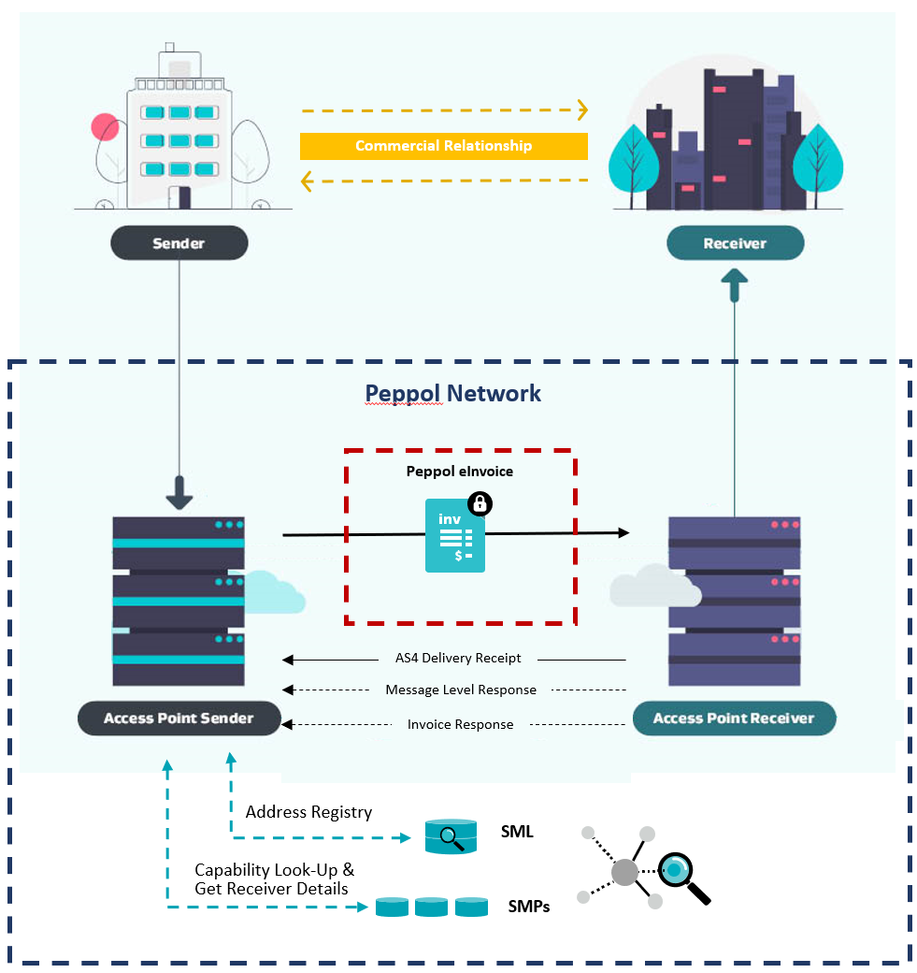

#### Change management

Sending eInvoices

* Consider how you will remember customer eInvoicing preferences (e.g. a tick box to remember customers’ eInvoicing preference and trigger this as the default future send channel)​
* How will your organisation manage the re-sending of an eInvoice if required? Refer to the [Communicating invoice status industry practice statement](https://github.com/A-NZ-PEPPOL/A-NZ-Industry-Practice-Statements/blob/main/A-NZ%20Industry%20Practice%20Statement_Communicating%20Invoice%20Status_v1.0.docx" \t "_blank)​. Note, some software products do not support the re-sending of an eInvoice. This should be checked with your chosen software provider so that any business process workarounds can be implemented.
* Implement any required process changes.

Receiving eInvoices

* Consider how you will communicate any specific requirements to suppliers (e.g. PO required).
* Peppol does not prevent the same eInvoice being sent twice - business processes should be built to work around this or FMIS should check for validations on duplicate invoice numbers.
* Implement any required process changes.

### Tips from early adopters

¨ The goal of Peppol is interoperability between senders and receivers. Think carefully about which data fields you plan to require in supplier eInvoices. It may seem appealing to request specific data fields (e.g. requiring PO line numbers, or attachments) to aid your invoice processing – but not all suppliers will be able to provide this on an eInvoice (due to their software) so you will need to be flexible.

¨ Ensure you’re using the [A-NZ Peppol International Invoice specification](https://docs.peppol.eu/poac/aunz/pint-aunz/) and not the previous A-NZ extension to the European BIS Billing 3.0 invoice specification, for more information see [Appendix 3](#_Appendix_3_–) about the migration to PINT by May 2025 or talk to your Access Point Provider.

¨ Invest time in data mapping and be familiar early on with how the eInvoicing solution in your accounting system/common supplier systems work. Systems manage the mapping of references in different ways – for example, [Xero users](https://central.xero.com/s/article/Send-an-e-invoice-NZ) have a single reference field where users must denote reference number/s with a prefix (PO: for purchase order, CN: for contract number, PN: for project number and TN: for tender number).

¨ Ensure your business processes have been updated to support Peppol eInvoicing.

¨ Like any technology change, change management and customer/supplier onboarding is key to successful implementation. Refer to eInvoicing change management guide on the eInvoicing website for more information.

### Implementation task checklist

| Task | Done ü |
| --- | --- |
| Review current processes |  |
| Capture NZBN or ABN data   * Ask your customers for their NZBN or ABN * Search the [NZBN Register](https://www.nzbn.govt.nz/) or ABN Lookup * Consider the [Business Match service](https://www.nzbn.govt.nz/using-the-nzbn/nzbn-services/business-match/) or [NZBN API](https://www.nzbn.govt.nz/using-the-nzbn/nzbn-services/api/), or [ABN Lookup API](https://abr.business.gov.au/Tools/WebServices) if you have lots of customers * Do you need to update other documentation, supplier/customer onboarding processes and forms to capture the NZBN or ABN? |  |
| Crown invoices and organisational part numbers (NZ only) |  |
| Credit note handling   * Negative invoices vs credit notes |  |
| Peppol data to be passed through   * Understand what invoice content fields are available in your billing or finance system’s eInvoicing solution * Mandatory data fields * Recommended data fields (best practice, good practice and optional) * Attachments |  |
| Invoice validation and business rules |  |
| Message acknowledgements |  |

# 

# Section 4 - Testing

Testing your eInvoicing solution is different for each organisation and your provider. Below are some key considerations. Your software and Access Point providers are key components of a robust testing phase.

### Testing considerations

#### Work with your testing partners (suppliers/customers)

Identify key customers/suppliers for your eInvoicing implementation – some of these stakeholders will become your testing partners. A strong champion to work with can make this process much faster and more efficient – so it’s worth investing the time upfront. Becoming familiar with the billing or FMIS software used by your suppliers can also assist with forming test cases later.

#### Test or production environment

One thing to consider is whether you/your partner will be sending test eInvoices to a test environment or piloting in your production environment:

* Receiving in the production environment has the benefits of being able to test how your real process and systems react to the eInvoice. You may wish to consider transmitting low value invoices with a purchase order number created specifically for testing.
* A test environment can be useful to protect existing systems but in some cases users do not have full interface access to the FMIS, meaning the life cycle of the eInvoice may not be fully visible.

#### Monitor eInvoices

Real time monitoring of eInvoices coming in (their content/timing etc) is critical to testing efficiently. Work with your provider to ensure access to a real time view of an inbound Peppol payload (e.g. via a monitoring or gateway portal).

This will also allow you to review the contents of XML data sent and effectively troubleshoot issues.

### Testing checklist

It’s important to capture a cross section of invoices currently received by ensuring test cases include a combination of BAU and edge cases where adjustments to processes have been required.

Among the areas that should be tested are:

| Task | Done ü |
| --- | --- |
| Purchase order numbers on eInvoices (if applicable)  This is important where the supplier and/or the customer have mandatory purchase ordering in place |  |
| Mapping of references  Do the required references land in the correct place? |  |
| Manually checking details such as amounts, dates, descriptions, attachments |  |
| Invoices with single lines as well as those with multiple lines and multiple schedules |  |
| Receipt of credit notes/negative invoices |  |
| Scenarios where processes to be updated to enable eInvoicing |  |
| Different billing software  The receipt of eInvoices from the main billing or FMIS software used by your suppliers and ensuring test cases cover a range of these products. For example, many smaller suppliers may use Xero or MYOB; recruitment suppliers may use Invoxy, FastTrack360 or Envisage. It can be helpful to start by choosing a supplier using each product so that any intricacies with the product can be ironed out early, before widening the scope |  |
| Duplicate invoices  It’s important to note that the Peppol network will allow an eInvoice to be sent more than once with the same invoice number (ID). It is common for FMIS software to have built in validations to check for this. However, it is beneficial to be familiar with the functionality available. |  |
| Finance users/approvers  Checking whether your finance users/approvers identify any issues with test transactions sent, to identify any potential operational impacts ahead of time |  |

You can also ask your implementation provider for recommendations on what to test based on their experience and the systems they’ve integrated with.

# Appendix 1 – Troubleshooting

On occasion, an eInvoice does not flow through the steps as expected. At each point on its journey, an eInvoice will go through validations. Below are tips in troubleshooting these issues.

| **Issue** | **Approach** |
| --- | --- |
| eInvoice​ hasn’t arrived with receiver. Sender reports eInvoice has been sent from their accounting system and has confirmation with their access point provider that the transmission was successful. | Receiver to check tools available in Access Point Provider gateway dashboard   * Review the Invoice Line Report if one is available. This is a list of invoices received through the gateway that have made it through the standard Peppol checks e.g., mandatory fields are populated.   + If “successful”, the invoice will have progressed to the next phase, being validations/checks implemented by the customer/access point, such as the value in the Order Reference field   + If “rejected”, a validation has failed on a field at the gateway. More investigation will likely be required by the access point provider.   *Note,* *your access point provider can implement message responses where the sender and/or receiver are advised of transmission issues at the gateway.*   * If the invoice does not appear on the Invoice Line Report, ascertain the date and time on which the invoice was sent, and review the inbound messages to identify if the XML file arrived.   + If the XML file can be located, review the file contents for any obvious errors. Alternatively, have your access point provider review it for you.   + If the XML file cannot be located, pass the available information on to your access point provider for further investigation. |
| Invoice has arrived at the gateway successfully, but it has not flowed through to the supplier record in the customer’s accounting system. | As the eInvoice passes to the receiver’s accounting system, it will likely be subject to further validations.  An example of a validation at this stage, is where the sender’s NZBN is not loaded against the supplier record in the receiver’s accounting system, hence a match cannot be found. The user should check the supplier record for the NZBN and update as necessary, and manually process the invoice. |
| Exception Queues | When the eInvoice fails validations in the receiver’s accounting system, then it will likely land in an exception queue where users will need to troubleshoot the cause and correct before manually pushing it through the approval process. The queue/s should be regularly monitored by users to maintain efficient processing of supplier invoicing. |

# Appendix 2 – Known issues and constraints

While eInvoicing can lead to cost and time savings, and many benefits in automation, there are a number of known issues and constraints worth considering before embarking on your eInvoicing journey.

|  |  |
| --- | --- |
| **Issue** | **Description** |
| 1 | The Peppol Directory consists mostly of receivers in the Peppol network, in the case of an eInvoice this would be a Buyer. Senders can register into the Peppol Directory but without the receiving capabilities (e.g. eInvoice document), but there are only a few senders registered this way. It is important to note that receivers can also register without listing their receiving capability as well. An end user ABN or NZBN listed in the Peppol Directory without receiving capabilities published may be a sender only, may be a receiver only that has chosen to not publish their receiving capabilities, or may be a combination of both. Businesses and government agencies that identify a trading partner published in the Peppol Directory with no receiving capabilities may find it helpful to reach out to their trading partner to confirm their sending and receiving capabilities. |
| 2 | Peppol eInvoicing is a Business to Government (B2G) and Business to Business (B2B) solution. It is not used to invoice consumers or individuals. |
| 3 | When sending to some large businesses or government entities the use of a reference like a contract, purchase or work order number is needed. Not all sending software caters for these. |
| 4 | PDF invoices are not encouraged to be included as attachments with eInvoices as this can cause confusion over which version, the eInvoice or the attachment, is the true and correct version – for further detail see the [Rendering](#_Rendering) section. |
| 5 | Peppol eInvoicing includes Tax Invoices, Credit Notes, Recipient Created Tax Invoices (AU)/Buyer Created Tax Invoices (NZ) and Invoice Response documents. Peppol also supports other procurement documents such as Purchase Orders, but some suppliers and sellers are not capable of receiving any these documents in the network, so check with your trading partners. Some out of band communication by phone or email may be required between some suppliers and their buyers in a complete Procure to Pay process. |
| 6 | Integration between a supplier and their access point and a buyer and their access point will incur a cost. |
| 7 | Many government agencies in Australia at Federal, State, and local level prefer payment via a credit card for low-value purchases. eInvoicing can still be used in these situations but requires the seller to include a credit card as a payment option on their invoice, and the paying officer to note the payment has been made in the finance system. |
| 8 | In the AU-NZ extension of the Peppol BIS Billing and PINT A-NZ specifications there is only a tax total for GST allowed at invoice (document) level, but not at the invoice line level. Some receivers may need to have their ERP system calculate a tax amount at the line level to process the invoice. Sometimes depending on the number of lines in the invoice, this may result in the document GST total not matching the tax total of the calculated line tax amounts. |
| 9 | In Australia, receivers of eInvoices, who are usually the buyer, have their ABN used as their electronic address in the Peppol network. For large entities processing eInvoices in multiple systems, the buyer’s ABN may not be granular enough to route eInvoices internally to different systems for processing. Instead, these invoices may need to be routed using a buyer reference potentially but consult your Access Point or DSP for solution options. |

# Appendix 3 – BIS and PINT

#### Australia and New Zealand Peppol standard

The New Zealand and Australian Peppol community is in the first phase of a two-part planned migration from the current [A-NZ extension to the Peppol specification](https://github.com/A-NZ-PEPPOL/A-NZ-PEPPOL-BIS-3.0), to Peppol PINT. PINT is an international invoice specification based on BIS 3.0 and built to increase global interoperability.

A-NZ extension to the Peppol specification (until May 2025)

In Australia and New Zealand the [A-NZ extension to the Peppol specification](https://github.com/A-NZ-PEPPOL/A-NZ-PEPPOL-BIS-3.0) **must** be used until 15 May 2025, as a transition measure during the move to PINT. This extension has built in syntax to manage country specific GST and multiple payment means in New Zealand and Australia. The A-NZ extension supports the Invoice, Credit Note and Self-Billing Invoice document types. The documentation contains detailed technical specifications, validation documents and message examples.

PINT

The PINT A-NZ extension is now mandatory for receivers:

* Peppol service providers must have the capabilities to support the receipt of PINT A-NZ invoices and PINT A-NZ credit notes.
* Receivers should also support the [A-NZ extension to the Peppol specification](https://github.com/A-NZ-PEPPOL/A-NZ-PEPPOL-BIS-3.0).
* PINT A-NZ is optional (but recommended) for senders.

**May 15th, 2025:** PINT A-NZ becomes mandatory for both senders and receivers:

* Peppol service providers must support the sending and receipt of PINT A-NZ invoices and credit notes
* The current A-NZ BIS specification will no longer be supported.

Where your organisation has previously used the BIS specification for sending or receiving, your service provider will handle the transition to ANZ-PINT as outlined above.