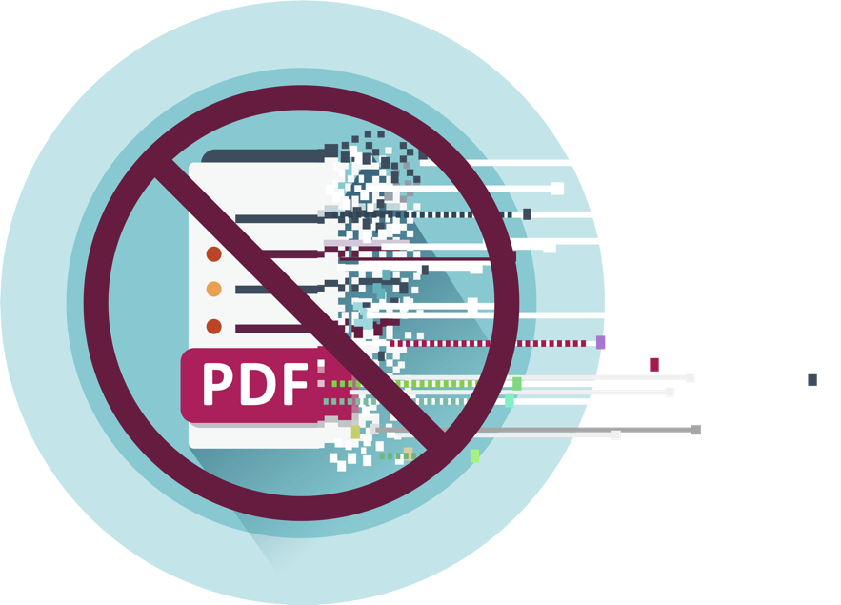
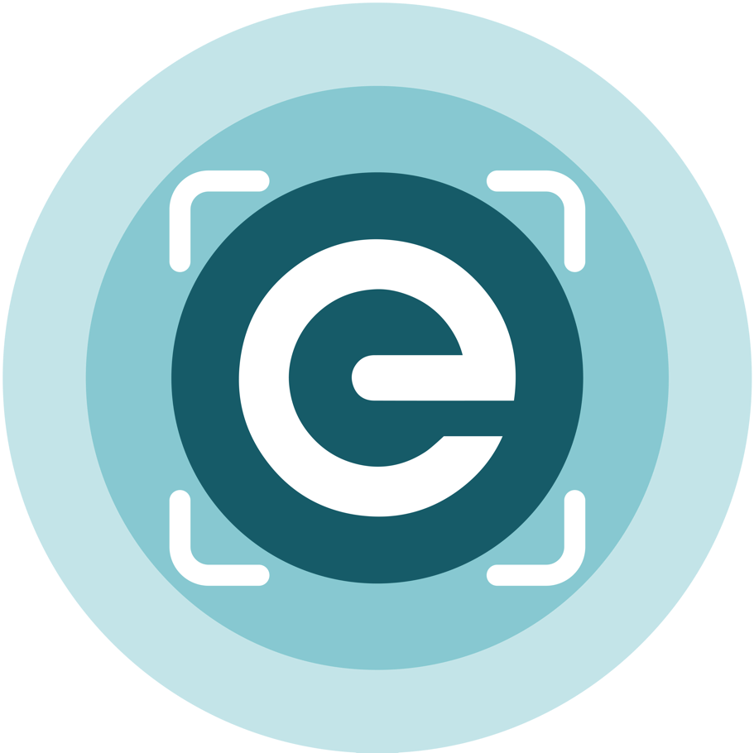
Supplier onboarding
Supplier engagement email templates for government agencies
August 2026
Table of Contents
Email content to large suppliers 3
Long version 3
Short version 4
Email content to 3 other supplier segments 6
Suppliers already sending eInvoices to other government agencies 6
Those that use Xero or MYOB to send PDF invoices 8
Where you have identified the supplier is already on the Peppol (eInvoicing) directory 9

Email content to large suppliers
Under Government Procurement Rules government agencies must require their large suppliers to send them eInvoices from January 2027.
The following emails will help you kick off engagements with your large suppliers to prepare them to meet the deadline:
- A long version
- Short version
Long version:
Subject: Important: transition to eInvoicing – what suppliers to government need to know
Kia ora,
We are getting in touch to let you know about an upcoming change to the way we expect to receive invoices from you.
As outlined in the Government Procurement Rules, from January 2027 we require our large suppliers to send us eInvoices (rather than emailed PDF invoices).
We have classified your organisation as a large supplier based on your Financial Reporting Act reporting requirements as a proxy for the large business definition outlined in the rules. If you are not, or are no longer, a large company, please let us know.
Advice for businesses trading with government | eInvoicing
eInvoicing is the digital exchange of invoice information directly between suppliers’ and buyers’ financial systems, using Peppol, the international standard for secure eInvoicing.
Why this change is being made
Moving to eInvoicing offers several important benefits:
- Faster payment - in most cases we aim to pay eInvoices within 5 business days as required under the Rules
- Smoother and more accurate processing - eInvoices go directly into our financial systems, reducing manual handling and errors (allowing us to process and pay your invoice quicker)
- Reduced risk of fraud - Unlike emailed PDF invoices, eInvoices cannot be intercepted or tampered with
- Greater efficiency for your finance team - No need to follow up on lost invoices.

What this means for your organisation
From January 2027, you are expected to send eInvoices for all goods and services provided to us. We will begin including this requirement through our procurement and contract management processes. For example, when:
- New contracts are established
- Existing contracts are renewed or significant contract variations occur
- Contracts are retendered.
eInvoicing requirements will not be retrospectively applied to existing contracts. However, we encourage you to begin preparing now so your systems and processes can support eInvoicing ahead of the deadline.
Peppol eInvoicing capability can provide benefits beyond government. Once set up, you can also use the same capability to send eInvoices to your other business customers. It is increasingly becoming part of modern digital business infrastructure and may support invoicing with your other trading partners, helping maximise the return on your investment in Peppol eInvoicing over time.
When you’re ready to send us eInvoices
- To ensure we can receive and process your eInvoices, add our New Zealand Business Number (NZBN) into your contact records. This will ensure any eInvoices you send reach us.
- <agency name>’s NZBN is: <enter NZBN here>
If there are any specific details you need on the invoices (like PO numbers or formats), please include those as well:
[Insert any additional instructions here]
Support and guidance
MBIE’s eInvoicing team provides comprehensive information, guidance, and step-by-step support to help you get started. You can find resources, provider options, and implementation guidance on their website:
einvoicing.govt.nz
Please let us know your plans for transitioning to eInvoicing and when you expect to be able to start sending eInvoices to us. If it would be helpful, we are happy to arrange a meeting to discuss your transition plans or answer any questions you may have.

Ngā mihi,
[Your name]
CFO?
[Agency name]
[Contact details]
……………………………..
Short version:
Subject: Action required: Switch to eInvoicing by January 2027
Kia ora,
As outlined in the Government Procurement Rules, from January 2027 we require our large suppliers to send us eInvoices (rather than emailed PDF invoices).
Advice for businesses trading with government | eInvoicing
What this means for you
- While formal requirements will be included in our procurement and contract processes going forward, we encourage you to ensure your systems can send eInvoices.
- eInvoices means smoother processing in our system, improving accuracy and reducing fraud risk.
- We will aim to pay eInvoices within 5 business days, helping improve your cashflow.
- We will start including this requirement in our procurement and contract processes.
When you’re ready to send us eInvoices
- To ensure we can receive and process your eInvoices, add our New Zealand Business Number (NZBN) into your contact records. This will ensure any eInvoices you send reach us.
- <agency name>’s NZBN is: <enter NZBN here>
If there are any specific details you need on the invoices (like PO numbers or formats), please include those as well:
[Insert any additional instructions here]

Support available
MBIE provides clear guidance on how to get started with eInvoicing, including provider options and setup steps: einvoicing.govt.nz
Please let us know your plans for transitioning to eInvoicing and when you expect to be able to start sending eInvoices to our agency. If it would be helpful, we are happy to arrange a meeting to discuss your transition plans or answer any questions you may have.

Ngā mihi,
[Your name]
CFO
[Your agency]

Email content to 3 other supplier segments
Three quick win supplier segments to receive eInvoices now:
- Those sending eInvoices to other government agencies
- Those identified to be using Xero or MYOB (many will be a subset of group 3 below)
- Those registered to receive eInvoices (likely able to send too)

To suppliers already sending to other government agencies.
There’s no need to include information about what eInvoicing is to this group as they’re already up to speed on this.
Check if any of your suppliers are on the published list. MBIE updates this list at least every quarter and publishes it on the eInvoicing website. Download the list of active eInvoice senders to government
Alternatively, you can use MBIE’s data matching service. This service will match your list of suppliers with organisations who can send you eInvoices now. We will cross reference your data to the Peppol eInvoicing Directory and the list of active eInvoice senders to government.
Send your list of active suppliers to:
eInvoicing@mbie.govt.nz

Email content:
Subject line: [Department/Business Name] Prefers eInvoices instead of PDFs
Kia ora
We prefer to receive eInvoices instead of PDFs
This is to let you know that [Department/Business Name] prefers to receive eInvoices instead of PDFs.
Why? Because eInvoices help us process and pay your invoices faster and more efficiently. In most cases, we’ll aim to make payment within 5 business days.
We understand you’re already sending eInvoices to other government agencies, so we hope switching to eInvoices for us will be nice and easy too.
To make sure your eInvoices reach us, please add our New Zealand Business Number (NZBN) to your contact records:
NZBN: [Enter NZBN here]
If there are any specific details you need on the invoices (like PO numbers or formats), please include those as well:
[Insert any additional instructions here]
So next time you send us an invoice, we’d really appreciate it if you could send it as an eInvoice instead of a PDF.
If you have any questions or need a hand getting set up, feel free to get in touch - we’re happy to help.

Regards
<name>
<title>

………………………………………….

For those that use Xero or MYOB to send PDF invoices.
They can easily switch to eInvoices as the functionality is free and available today.
- Use MBIE’s data matching service to help identify these, or
  - Ask your OCR or scanning service Provider if they can provide you a list.
  - Or use this ‘how to’ guide to find them in your accounts payable inbox.
  - Use your ‘remittance advice’ email address to contact them
- You can link to or download and attach the relevant ‘getting started’ guide to the email.
- These guides are also useful for your accounts payable team - to give them an understanding of the customer experience for those suppliers using Xero or MYOB.
  - Getting set up for eInvoicing: Xero Business Edition - November 2024 [PDF, 697 KB]
  - Getting set up for eInvoicing: MYOB Business Essentials / AccountRight - November 2024 [PDF, 681 KB]

Email content:
Subject line: [Department/Business Name] Prefers eInvoices Over PDFs
Kia ora
This is to let you know that [Department/Business Name] prefers to receive eInvoices instead of PDFs.
Why? Because eInvoices help us process and pay your invoices faster and more efficiently. In most cases, we’ll aim to make payment within 5 business days.
What is eInvoicing and how does it benefit you?
eInvoicing is the digital exchange of invoice information directly between buyers’ and suppliers’ financial systems, even if these systems are different.
No emails, no PDFs, and no lost invoices. With eInvoicing your business can benefit from reduced admin and invoice fraud risk, increased security and accuracy, and improved cashflow.
When you’re ready to send us eInvoices
To ensure we can receive and process your eInvoices, add our New Zealand Business Number (NZBN) into your contact records. This will ensure any eInvoices you send reach us.
<agency name>’s NZBN is: <enter NZBN here>
It’s easy to get started if you’re using Xero
Our records indicate your business may currently be using Xero to generate and email PDF invoices. The good news is Xero has made the ability to send and receive eInvoices available to their Xero Business Edition customers for free.
Check out their website for instructions or see the getting set up guide.
- Send an eInvoice - Xero Central
- Register to receive eInvoices - Xero Central
- Getting set up for eInvoicing: Xero Business Edition - November 2024 [PDF, 697 KB]

It’s easy to get started if you’re using MYOB
Our records indicate your business may currently be using MYOB to generate and email PDF invoices. The good news is MYOB has made the ability to send and receive eInvoices available to their users of MYOB Business or access your AccountRight company file in a web browser.
Check out their website for instructions or see the getting set up guide.
Read about eInvoicing at MYOB
Getting set up for eInvoicing: MYOB Business Essentials / AccountRight - November 2024 [PDF, 681 KB]
Read more about eInvoicing - eInvoicing | Pūtea Tāhiko
So next time you send us an invoice, we’d really appreciate it if you could send it as an eInvoice instead of a PDF.
If you have any questions or need a hand getting set up, feel free to get in touch - we’re happy to help.

Regards
<name>
<title>
…………………..

Where you have identified the supplier is already registered on the Peppol (eInvoicing) Directory.
Not always, but chances are they can also send eInvoice.
- A list of eInvoicing registered businesses is published on the eInvoicing website and updated monthly. New Zealand businesses registered to receive eInvoices [XLSX, 12 MB]. Match them with your supplier list.
- Or use MBIE’s data matching service
Email content:
Subject line: [Department/Business Name] Prefers eInvoices Over PDFs
Kia ora
This is to let you know that [Department/Business Name] prefers to receive eInvoices instead of PDFs.
Why? Because eInvoices help us process and pay your invoices faster and more efficiently. In most cases, we’ll aim to make payment within 5 working days.
We understand you’re already registered to receive eInvoices. So, chances are you may also be able to send eInvoices. Just make sure you record our NZBN in your contact records and then send any future invoices to us as eInvoices.
<your agency name> NZBN is <enter NZBN here>
Include other instructions if relevant – e.g. if PO numbers must be included and what format etc…
So next time you send us an invoice, we’d really appreciate it if you could send it as an eInvoice instead of a PDF.
If you have any questions or need a hand getting set up, feel free to get in touch - we’re happy to help.
Regards
<name>
<title>

